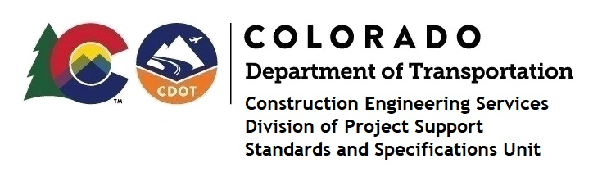

MEMORANDUM

DATE: December 9, 2022

TO: All holders of Standard Special Provisions

FROM: Shawn Yu, Standards and Specifications Unit Manager

SUBJECT: New standard special provision: Revision of Section 109 – Measurement and

Payment

On December 9, 2022, our unit has issued the new standard special provision, Revision of Section 109 – Measurement and Payment, with 1 page, and dated December 9, 2022. This Standard Special Provision applies to all projects that will be advertised on or after January 9, 2023.

This specification replaced Subsection 109.06(b).

For those of you who keep a book of Standard Special Provisions, please include this new standard special provision. For your convenience, this specification and the latest SSP Index are attached in the email. You can also find these in our Construction Specifications web pages: Standard Special Provisions and the Recently Issued Special Provisions.

If you have any questions or comments, please contact this office.

