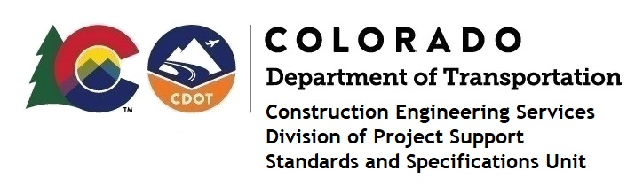

MEMORANDUM

DATE: March 22, 2023

TO: All holders of Standard Special Provisions

FROM: Shawn Yu, Standards and Specifications Unit Manager

SUBJECT: New standard special provision: Revision of Section 614 – Galvanized Steel Poles

As of March 22, 2023, this unit has issued the new standard special provision, Revision of Section 614 – Galvanized Steel Poles, with 1 page, and dated March 22, 2023. This Standard Special Provision applies to projects that have Electrical Equipment requiring painting and will be advertised on or after April 24, 2023. Earlier use is permissible.

This specification revised subsection 614.10 (h) - Painting.

For those of you who keep a book of Standard Special Provisions, please include this new standard special provision. For your convenience, this specification and the latest SSP Index are attached in the email. You can also find these in our Construction Specifications web pages: Standard Special Provisions and the Recently Issued Special Provisions.

If you have any questions or comments, please contact this office.

