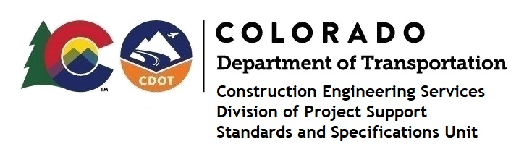

MEMORANDUM

DATE: April 3, 2023

TO: All holders of Standard Special Provisions

FROM: Shawn Yu, Standards and Specifications Unit Manager

SUBJECT: Revised standard special provision: Revision of Section 105 – Dispute Review

Board and Claims for Unresolved Disputes

As of April 3, 2023, this unit has issued the revised standard special provision, Revision of Section 105 – Dispute Review Board and Claims for Unresolved Disputes, with 8 pages, and dated April 3, 2023.

This specification replaced the previous specification with the same name and issued on March 22, 2023.

This standard special provision is to be used on all projects that will be advertised on or after May 1, 2023. Earlier use is permissible.

This specification added more steps to the “Dispute and Claims Flow Chart” (Figure 105-1), which widened each page margins, thus reducing the number of pages from 11 to 8. These are the only two changes.

For those of you who keep a book of Standard Special Provisions, please include this revised standard special provision. For your convenience, this specification and the latest SSP Index are attached in the email. You can also find these in our Construction Specifications web pages: Standard Special Provisions and the Recently Issued Special Provisions.

If you have any questions or comments, please contact this office.

