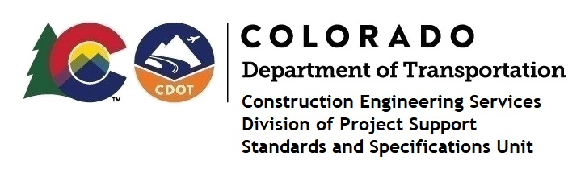

Memorandum

DATE: June 2, 2023

TO: All holders of Standard Special Provisions

FROM: Shawn Yu, Standards and Specifications Unit Manager

SUBJECT: The Minimum Wages on Federal Aid Projects

Effective this date, our unit has issued the revised Minimum Wages, Colorado, U.S. Department of Labor, General Decision Number CO20230006 MOD 2 standard special provision. This revised standard special is 10 pages long, and is dated June 2, 2023. It is to be included in all federal aid projects beginning with projects that have bid openings on June 12, 2023 or later. Use this standard special provision on all federal-aid projects with contracts exceeding $2000, except for non-ARRA projects on roadways classified as local roads or rural minor collectors, which are exempt. Projects on local roads, rural minor collectors, and enhancement projects funded with ARRA funds are not exempt.

MOD 2 made only a small change in the layout for one the tables in the spreadsheet from DOL​. There were no changes to any of the wages or fringe benefits for any job classifications. But is still considered as a new modification.

Project Managers: Please check to see if your projects are affected and take appropriate action.

If you have any questions or comments, please contact this office.

