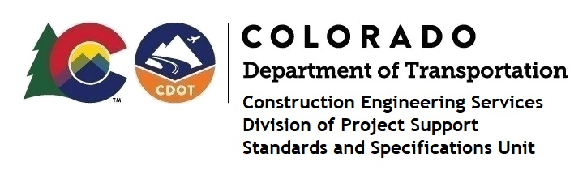

MEMORANDUM

DATE: July 7, 2023

TO: All holders of Standard Special Provisions

FROM: Shawn Yu, Standards and Specifications Unit Manager

SUBJECT: New standard special provision: Revision of Sections of 107 and 503 –

Performance of Safety Critical Work and Submittals

As of July 7, 2023, this unit has issued the new standard special provision, Revision of Sections of 107 and 503 - Performance of Safety Critical Work and Submittals, with 1 page, and dated July 7, 2023. This standard special provision is to be used on all projects with 503 Drilled Shaft Pay Items, and that will be advertised on or after August 7, 2023. Earlier use is permissible.

This provision revised subsections 107.06 - Performance of Safety Critical Work and 503.02 - Submittals.
For those of you who keep a book of Standard Special Provisions, please include this new standard special provision. For your convenience, this specification and the latest SSP Index are attached in the email. You can also find these in our Construction Specifications web pages: Standard Special Provisions and the Recently Issued Special Provisions.

If you have any questions or comments, please contact this office.

