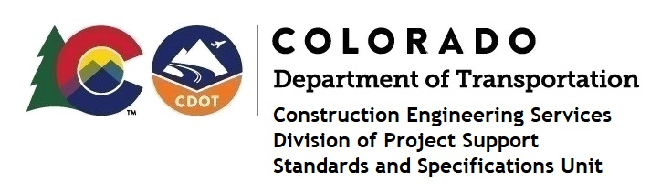

Memorandum

DATE: July 14, 2023

TO: All holders of Standard Special Provisions

FROM: Shawn Yu, Standards and Specifications Unit Manager

SUBJECT: The Minimum Wages on Federal Aid Projects

Effective this date, our unit has issued the revised Minimum Wages, Colorado, U.S. Department of Labor, General Decision Number CO20230011 MOD 3 standard special provision. This revised standard special is 6 pages long, and is dated July 14, 2023. It is to be included in all federal aid projects beginning with projects that have bid openings on July 24, 2023 or later. Use this standard special provision on all federal-aid projects with contracts exceeding $2000, except for non-ARRA projects on roadways classified as local roads or rural minor collectors, which are exempt. Projects on local roads, rural minor collectors, and enhancement projects funded with ARRA funds are not exempt.

MOD 3 changed the wages and fringe benefits for Dump Truckers in Kit Carson only. Also, the fringe benefits for Power Equipment Operators under collectively bargained rates.

Project Managers: Please check to see if your projects are affected and take appropriate action.

If you have any questions or comments, please contact this office.

