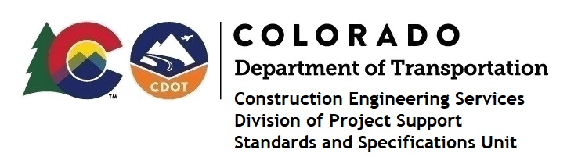

Memorandum

DATE: December 23, 2022

TO: All holders of Standard Special Provisions

FROM: Shawn Yu, Standards and Specifications Unit Manager

SUBJECT: The Minimum Wages on Federal Aid Projects

Effective December 23, 2022, our unit has issued the revised Minimum Wages, Colorado, U.S. Department of Labor, General Decision Number CO20220013 MOD 3 standard special provision. This revised standard special is 9 pages long, and is dated December 23, 2022. It is to be included in all federal aid projects that will have bid openings on or after January 3, 2023. Use this standard special provision on all federal-aid projects with contracts exceeding $2000, except for non-ARRA projects on roadways classified as local roads or rural minor collectors, which are exempt. Projects on local roads, rural minor collectors, and enhancement projects funded with ARRA funds are not exempt.

MOD 3 raised the Fringe Benefits only for Structural Ironworkers in Garfield county.

If you have any questions or comments, please contact this office.

