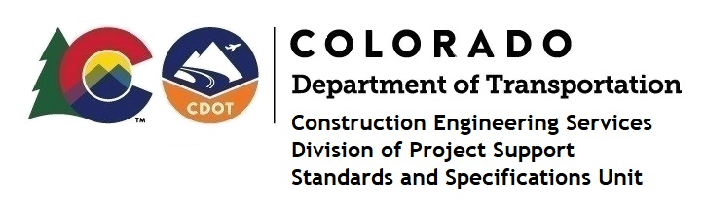
Memorandum

Date: January 8, 2024

To: All holders of Standard Special Provisions

From: Shawn Yu, Standards and Specifications Unit Manager

Subject: New standard special provision: Revision of Section 101 – Definitions and

Section 106 - Control of Materials

As of January 8, 2024, this unit has issued the new standard special provision, “Revision of Section 101 – Definitions and Section 106 - Control of Materials”, with 2 pages, and dated January 8, 2024.

This standard special provision is to be used on all projects advertised on or after February 8, 2024. Earlier use of it is acceptable.

This provision revised subsections 101.02 and 106.01.

For those of you who keep a book of Standard Special Provisions, please include this revised standard special provision. For your convenience, this specification and the latest SSP Index are attached in the email. You can also find these in our Construction Specifications web pages: Standard Special Provisions and the Recently Issued Special Provisions.

If you have any questions or comments, please contact this office.

