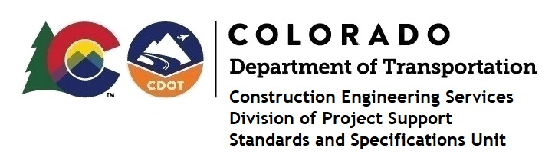
Memorandum

Date: January 8, 2024

To: All holders of Standard Special Provisions

From: Shawn Yu, Standards and Specifications Unit Manager

Subject: New standard special provision: Revision of Sections 101 and 106 –

Buy America and Build America, Buy America Requirements for Projects

Containing Federal-Aid Highway Funding in the Amount Less Than $500,000

As of January 8, 2024, this unit has issued the new standard special provision, “Revision of Sections 101 and 106 – Buy America and Build America, Buy America Requirements for Projects Containing Federal-Aid Highway Funding in the Amount Less Than $500,000”, with 8 pages, and dated January 8, 2024.

This standard special provision is to be used on all federal-aid highway (FHWA) funded (CDOT and Local Agency administered) Infrastructure projects that have a federal funding Construction Phase authorization date that has occurred on or after October 23, 2023, and that contains federal-aid funding, but the total federal-aid highway funding is less than $500,000. The less than $500,000 threshold is to be based on the aggregate (total amount) of federal aid funding used or to be used in all phases of the project including Construction and any preliminary engineering phases (e.g., Right-of-way, Utilities, Design, Environmental, or Miscellaneous).

Please note, the October 23rd date is a federal compliance date. It is not tied to the project advertisement date, but rather is tied to the federal funding obligation date for the construction phase of the project.

This provision revised subsections 101.02 and 106.11.

The Buy America Requirements website.

For those of you who keep a book of Standard Special Provisions, please include this revised standard special provision. For your convenience, this specification and the latest SSP Index are attached in the email. You can also find these in our Construction Specifications web pages: Standard Special Provisions and the Recently Issued Special Provisions.

If you have any questions or comments, please contact this office.

