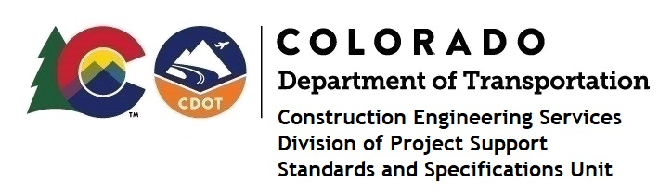
Memorandum

Date: January 8, 2024

To: All holders of Standard Special Provisions

From: Shawn Yu, Standards and Specifications Unit Manager

Subject: Revised standard special provision: Revision of Sections 101 and 106 – Buy

America and Build America, Buy America Requirements – No Federal Aid

As of January 8, 2024, this unit has issued the revised standard special provision, “Revision of Sections 101 and 106 - Buy America and Build America, Buy America Requirements – No Federal Aid”, with 4 pages, and dated January 8, 2024. This standard special provision is to be used on all state only funded (CDOT and Local Agency administered) infrastructure projects advertised on or after January 8, 2024, that contain no federal-aid highway funding.

This specification replaces “Revision of Section 106 – Buy American Requirements Non-Federal Aid Highway (FHWA)”, and dated October 1, 2023.

This provision revised subsections 101.02 and 106.11.

Project Managers: Please check to see if your projects are affected and take appropriate action. A Revision Under Ad is required for projects that have already been advertised.

The Buy America Requirements website.

For those of you who keep a book of Standard Special Provisions, please include this revised standard special provision. For your convenience, this specification and the latest SSP Index are attached in the email. You can also find these in our Construction Specifications web pages: Standard Special Provisions and the Recently Issued Special Provisions.

If you have any questions or comments, please contact this office.

