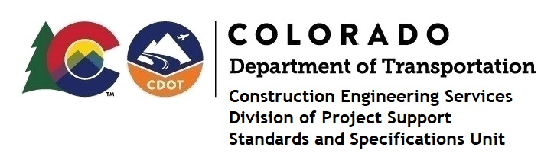

MEMORANDUM

DATE: July 7, 2023

TO: All holders of Standard Special Provisions

FROM: Shawn Yu, Standards and Specifications Unit Manager

SUBJECT: Revised standard special provision: Revision of Section 106 - Buy America

Requirements Non-Federal Aid Highway (FHWA)

As of July 7, 2023, this unit has issued the revised standard special provision, Revision of Section 106 - Buy America Requirements Non-Federal Aid Highway (FHWA), with 1 page, and dated July 7, 2023. This standard special provision is to be used on all Non-Federal Aid projects, and that will be advertised on or after August 7, 2023. Earlier use is permissible.

This specification replaced the previous provision with the same name and dated October 1, 2022.

This provision revised subsections 106.11(a), (b), (d), and (e).
For those of you who keep a book of Standard Special Provisions, please include this revised standard special provision. For your convenience, this specification and the latest SSP Index are attached in the email. You can also find these in our Construction Specifications web pages: Standard Special Provisions and the Recently Issued Special Provisions.

If you have any questions or comments, please contact this office.

