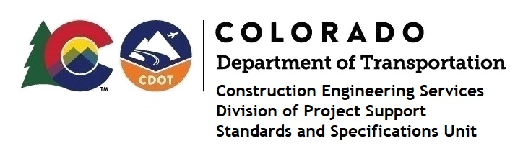

MEMORANDUM

DATE: July 7, 2023

TO: All holders of Standard Special Provisions

FROM: Shawn Yu, Standards and Specifications Unit Manager

SUBJECT: New standard special provision: Revision of Section 108 - Liquidated Damages

As of July 7, 2023, this unit has issued the new standard special provision, Revision of Section 108 - Liquidated Damages, with 1 page, and dated July 7, 2023. This standard special provision is to be used on all projects, and that will be advertised on or after August 7, 2023.

This provision revised subsection 108.09 - Failure to Complete Work on Time, Table 108-2.

For those of you who keep a book of Standard Special Provisions, please include this new standard special provision. For your convenience, this specification and the latest SSP Index are attached in the email. You can also find these in our Construction Specifications web pages: Standard Special Provisions and the Recently Issued Special Provisions.

If you have any questions or comments, please contact this office.

