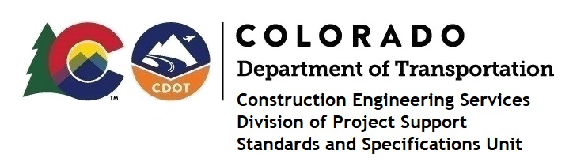

MEMORANDUM

DATE: July 7, 2023

TO: All holders of Standard Special Provisions

FROM: Shawn Yu, Standards and Specifications Unit Manager

SUBJECT: New standard special provision: Revision of Section 213 - Mulching

As of July 7, 2023, this unit has issued the new standard special provision, Revision of Section 108 - Liquidated Damages, with 2 pages, and dated July 7, 2023. This standard special provision is to be used on all projects furnishing and applying mulch and tackifier, and that will be advertised on or after August 7, 2023.

This provision revised various parts of subsection 213-02.

For those of you who keep a book of Standard Special Provisions, please include this new standard special provision. For your convenience, this specification and the latest SSP Index are attached in the email. You can also find these in our Construction Specifications web pages: Standard Special Provisions and the Recently Issued Special Provisions.

If you have any questions or comments, please contact this office.

