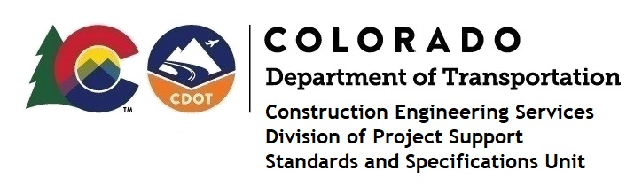
Memorandum

DATE: October 25, 2023

TO: All holders of Standard Special Provisions

FROM: Shawn Yu, Standards and Specifications Unit Manager

SUBJECT: Revised standard special provision: Required Contract Provisions Federal-Aid

Construction Contracts

Effective today, October 25, 2023, our unit has issued revised standard special provision, Required Contract Provisions Federal-Aid Construction Contracts, with 15 pages, and dated October 23, 2022.

This revised provision replaces the previous provision with the same name and dated October 1, 2023.

It replaced the previous FHWA Form 1273 (dated July 5, 2022), with revised FHWA Form 1273, and dated October 23, 2023.

Further information about the revised FHWA Form 1273 can be found here:
https://www.fhwa.dot.gov/construction/cqit/form1273.cfm

This SSP is effective on all federal-aid construction projects advertised after October 23, 2023.

Project Managers: Please check to see if your projects are affected and take appropriate action.

For those of you who keep a book of Standard Special Provisions, please include this revised standard special provision.

For your convenience, this specification, cover letter, and the latest SSP Index are attached in the email. You can also find these in our Construction Specifications web pages: Standard Special Provisions and the Recently Issued Special Provisions.

If you have any questions or comments, please contact this office.

