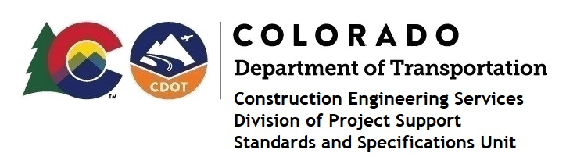
Memorandum

Date: April 9, 2024

To: All holders of Standard Special Provisions

From: Shawn Yu, Standards and Specifications Unit Manager

Subject: Revised standard special provision: Revision of Section 709 – Steel Welded
Wire Fabric

As of April 9, 2024, this unit has issued the revised standard special provision, “Revision of Section 709 – Steel Welded Wire Fabric”, with 1 page and dated April 9, 2024.

This standard special provision is to be used on all projects with Steel Welded Wire Fabric.

This provision replaced the previous “Revision of Section 709 – Steel Welded Wire Fabric” provision issued on April 2nd, 2024. The only change was in the Instructions on the Notice page, deleting the sentence “CDOT’s Subject Matter Expert on the SSP will decide its use for projects.”

It will become effective on projects advertised on or after May 7, 2024. Earlier use is permissible.

For those of you who keep a book of Standard Special Provisions, please include this revised standard special provision. For your convenience, this specification and the latest SSP Index are attached in the email. You can also find these in our Construction Specifications web pages: Standard Special Provisions and the Recently Issued Special Provisions.

If you have any questions or comments, please contact this office.

