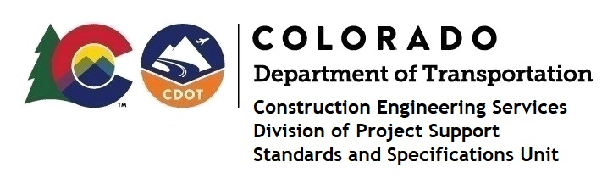
Memorandum

Date: April 2, 2024

To: All holders of Standard Special Provisions

From: Shawn Yu, Standards and Specifications Unit Manager

Subject: New standard special provision: Revision of Section 601 – Concrete

Acceptance

As of April 2, 2024, this unit has issued the new standard special provision, “Revision of Section 601 Concrete Acceptance”, with 4 pages and dated April 2, 2024.

This standard special provision is to be used on all projects with concrete. CDOT’s Subject Matter Expert on the SSP will decide its use for projects.

This provision replaced subsections 601.17 (c) and 601.17 (d).

It will become effective on projects advertised on or after April 30, 2024. Earlier use is permissible.

For those of you who keep a book of Standard Special Provisions, please include this revised standard special provision. For your convenience, this specification and the latest SSP Index are attached in the email. You can also find these in our Construction Specifications web pages: Standard Special Provisions and the Recently Issued Special Provisions.

If you have any questions or comments, please contact this office.

