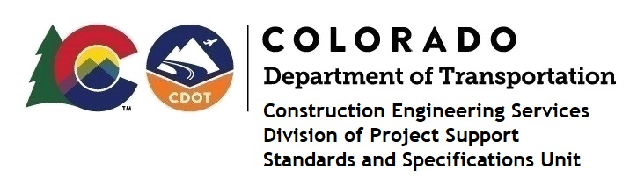
Memorandum

Date: April 2, 2024

To: All holders of Standard Special Provisions

From: Shawn Yu, Standards and Specifications Unit Manager

Subject: New standard special provision: Revision of Section 627 – Pavement Marking

Paint (Temporary)

As of April 2, 2024, this unit has issued the new standard special provision, “Revision of Section 627 – Pavement Marking Paint (Temporary)”, with 1 page and dated April 2, 2024.

This standard special provision is to be used on all projects that have Pavement Marking Paint (Temporary).

This provision revised the application bead rate for Pavement Marking Paint High Build (Temporary) in Table 627-1 of Subsection 627.04.

It will become effective on projects advertised on or after April 30, 2024. Earlier use is permissible.

For those of you who keep a book of Standard Special Provisions, please include this revised standard special provision. For your convenience, this specification and the latest SSP Index are attached in the email. You can also find these in our Construction Specifications web pages: Standard Special Provisions and the Recently Issued Special Provisions.

If you have any questions or comments, please contact this office.

