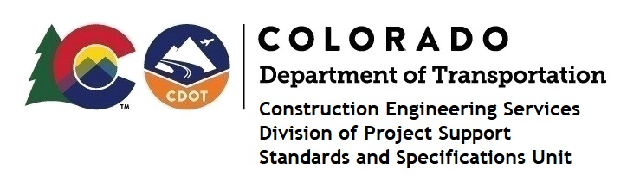

Memorandum

Date: January 5, 2024

To: All holders of Standard Special Provisions

From: Shawn Yu, Standards and Specifications Unit Manager

Subject: The Minimum Wages on Federal Aid Projects

Effective this date, our unit has issued the new Minimum Wages, Colorado, U.S. Department of Labor, General Decision Number CO20240011 standard special provision. This revised standard special is 6 pages long, and is dated January 5, 2024. It is to be included in all federal aid projects beginning with projects that have bid openings on January 15, 2024 or later. Use this standard special provision on all federal-aid projects with contracts exceeding $2000, except for non-ARRA projects on roadways classified as local roads or rural minor collectors, which are exempt. Projects on local roads, rural minor collectors, and enhancement projects funded with ARRA funds are not exempt.

This new decision did not change any wages or fringe benefits for any job classification. It only changed the General Decision Number from CO20230011 to CO20240011.

If you have any questions or comments, please contact this office.

