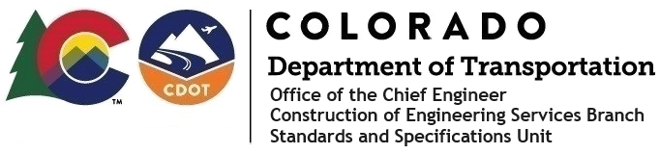

**Memorandum**

**Date**: May 16, 2025

**To**: All holders of Standard Special Provisions

**From**: Bill Cornelius, P.E., Standards and Specifications Unit Manager,

Construction Engineering Services Branch

**Subject**: The Davis-Bacon Minimum Wages on Federal-Aid Projects

Effective this date, our unit has issued the new **Minimum Wages, Colorado, U.S. Department of Labor, General Decision Number CO20250011, MOD 1,** standard special provision. This revised standard special is 5 pages long and is dated

**May 16, 2025**. It is to be included in all federal-aid projects beginning with projects that have bid openings on **May 26, 2025,** or later. Use this standard special provision on all federal-aid projects with contracts exceeding $2,000, except for non-ARRA projects on roadways classified as local roads or rural minor collectors, which are exempt. Projects on local roads, rural minor collectors, and enhancement projects funded with ARRA funds are not exempt.

**Modification 1** changed the wage and fringe benefits for Dump Truck Drivers in Kit Carson County.

**Project Managers**: Please check to see if your projects are affected and take appropriate action.

This revised Standard Special Provision, its Issuance Letter, and an updated Index of Standard Special Provisions are attached.

They are also posted in the 2025 Construction Specifications Miscellaneous and Recently Issued Special Provisions websites

For those of you who keep a book of revised Standard Special Provisions, please replace the previous CO20250011, dated January 3, 2025, minimum wages provision with this one.

If you have any questions or comments, please contact this office.