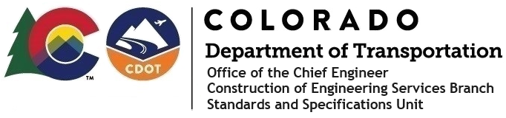

Memorandum

Date: January 3, 2025

To: All holders of Standard Special Provisions

From: Bill Cornelius, Standards and Specifications Unit Manager

Subject: The Davis-Bacon Minimum Wages on Federal-Aid Projects

Effective this date, our unit has issued the new Minimum Wages, Colorado, U.S. Department of Labor, General Decision Number CO20250010 standard special provision. This revised standard special is 5 pages long and is dated
January 3, 2025. It is to be included in all federal-aid projects beginning with projects that have bid openings on January 13, 2025 or later. Use this standard special provision on all federal-aid projects with contracts exceeding $2000, except for non-ARRA projects on roadways classified as local roads or rural minor collectors, which are exempt. Projects on local roads, rural minor collectors, and enhancement projects funded with ARRA funds are not exempt.

This new decision did not change any wages or fringe benefits for any job classification. It only changed the General Decision Number from CO20240010 to CO20250010.

Project Managers: Please check to see if your projects are affected and take the appropriate action.

If you have any questions or comments, please contact this office.

