 |  | MATERIALS BULLETIN
 | Materials and Geotechnical Branch | 2023 Field Materials Manual Update  Number 3, Page 1 of 3  Date: November 10, 2022

2023 Field Materials Manual Update
The purpose of this Bulletin is to notify all project personnel working on projects using the current 2023 CDOT Field Materials Manual of the following updates.
The CDOT Form 1600 Contractors Certificate of Compliance for Materials & Manufactured Products will be added to the CDOT Forms webpage and the CDOT Materials & Geotechnical, Buy America Requirements for Iron and Steel webpage. The CDOT Form 1600 is also an attachment to the 2023 FMM.
The 2023 FMM OA Schedule, Item 627, was updated to read as follows.
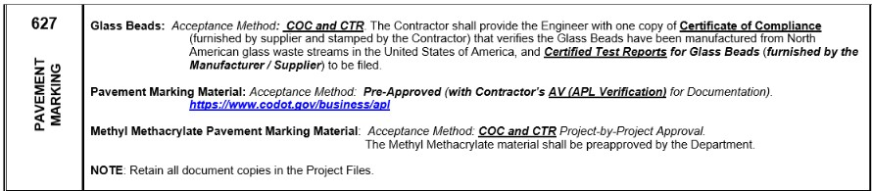

The 2023 FMM Contractor, Special Notice chapter, Sections 4, 4.2, 5, 5.2, 5.3 (Glass Beads) have been added or revised with the following.

Effective November 10, 2022, All Suppliers and Manufacturers who supply products or materials to Colorado Department of Transportation (CDOT) Federal-Aid projects. With the passage of the Infrastructure Investment and Jobs Act (“IIJA”), Pub. L. No. 117-58, which includes the Build America, Buy America Act (“the Act”). Pub. L. No. 117-58, §§ 70901-52 (published November 15, 2021): All manufacturing processes on eligible construction materials permanently incorporated into the work must have occurred in the United States. All manufacturing processes shall include at least the final manufacturing process and the immediately preceding manufacturing stage for the construction material.

Eligible construction materials are those that are or consist primarily of:
● Non-ferrous metals.
● Plastic and polymer-based products (including polyvinyl chloride [PVC]);
● Glass.
● Lumber; or
● Drywall.

Items that consist of two or more of the listed materials that have been combined together through a manufacturing process, and items that include at least one of the listed materials combined with a material that is not listed through a manufacturing process, should be treated as manufactured products, rather than as construction materials.

Per FHWA’s 1983 published general waiver for manufactured products, manufactured products not containing iron or steel are excluded from Buy America requirements. However, CDOT does require that manufactured products consisting of 90% or more of steel and/or iron by weight shall be Buy America compliant.

Raw materials such as cement and cementitious materials; aggregates such as stone, sand, or gravel; or aggregate binding agents or additives are excluded from Buy America requirements.

Before the permanent incorporation into the project for all eligible construction materials, the
Contractor shall obtain a certification from each supplier. This certification must identify where the construction material was manufactured and attest specifically to Buy America compliance.

The Contractor shall maintain and submit on a monthly basis, CDOT Form #1600, Contractor’s Certificate of Compliance summarizing the Item Description, CDOT Bid Item #, Manufacturer Name, Identifier, Date and Quantity Received, Date and Quantity Installed, and Bid Item Unit of all eligible construction materials.

The COC does not relieve the Contractor of providing the necessary Buy America supplier certifications for any eligible construction material prior to permanent incorporation into the project. Upon request, the Contractor shall allow the State, FHWA, and their representatives access to the Buy America certifications they have received from the construction material suppliers. The lack of these certifications will be justification for rejection of the construction material.

Implementation of these additional Buy America requirements for Construction Materials will take effect on projects that CDOT will advertise for bid on or after November 10, 2022. CDOT is currently in the process of updating our Buy America specification (Section 106.11) and will issue this update as a Standard Special Provision when complete - Standard Special Provision - Revision of Sections 101 and 106 – Buy America Requirements which will be included on all projects subject to the new requirements. We are also preparing an update to the 2023 CDOT Field Materials Manual, Special Notice to Contractors, which will be issued via a CDOT Materials Bulletin upon completion. Once those documents are published, they will be posted to the CDOT Buy America webpage at the following link:
https://www.codot.gov/business/designsupport/buy-america-requirements

Please note that the new Buy America guidance for Construction Materials does not alter or change the current Buy America documentation requirements for iron and steel per CDOT Specifications Section 106.11.

Should you have any questions, please contact CDOT_BuyAmerica@state.co.us.

