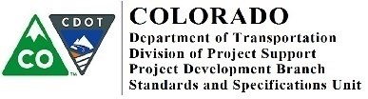
MEMORANDUM
DATE: April 1, 2019

TO: All Holders of Standard Plans

FROM: Shawn Yu, Standards and Specifications Unit Manager

SUBJECT: Revision of Standard Plan M-208-1

The Project Development Branch has issued revised CDOT Standard Plan M-208-1, Temporary Erosion Control, with 11 sheets, effective April 1, 2019.

This revision supersedes the M-208-1, Temporary Erosion Control standard with 11 sheets, dated August 10, 2017.

The revisions to this standard were made to stay in compliance with the revised Stormwater Construction Permit (SCP) requirements.

Please use this revised standard on all applicable projects advertised on or after April 8, 2019.

An electronic copy of M-208-1 is available on the CDOT Design and Construction Project Support, M Standard web site here: https://www.codot.gov/business/designsupport/standard-plans/copy_of_2012-m-standards-plans.

New and revised standard plans are to be marked in their box on the Standard Plans List sheet and inserted into the plan set for projects requiring its use.

If you have any questions or comments, please contact this office.
2829 W. Howard Pl., 3rd floor, Denver, CO 80204 P 303.757.9474 F 303.757.9820 www.codot.gov |

