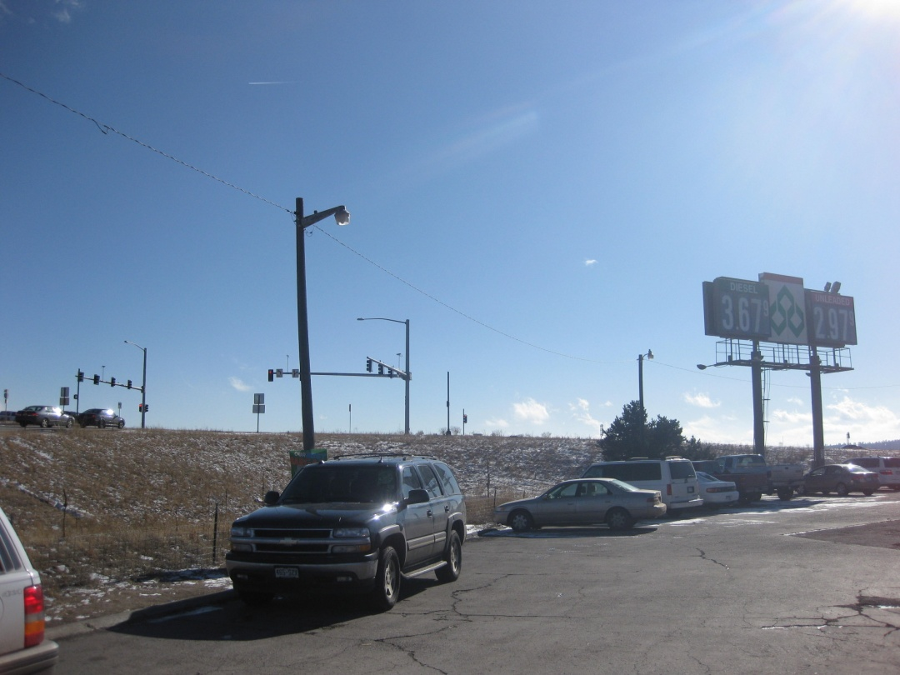
Photograph No. 1.
Diamond Shamrock, 1310 West Baptist Road, Monument, Colorado – FINDS, LUST, LUST TRUST, UST, AST. View looking south/southeast towards Baptist Road intersection.
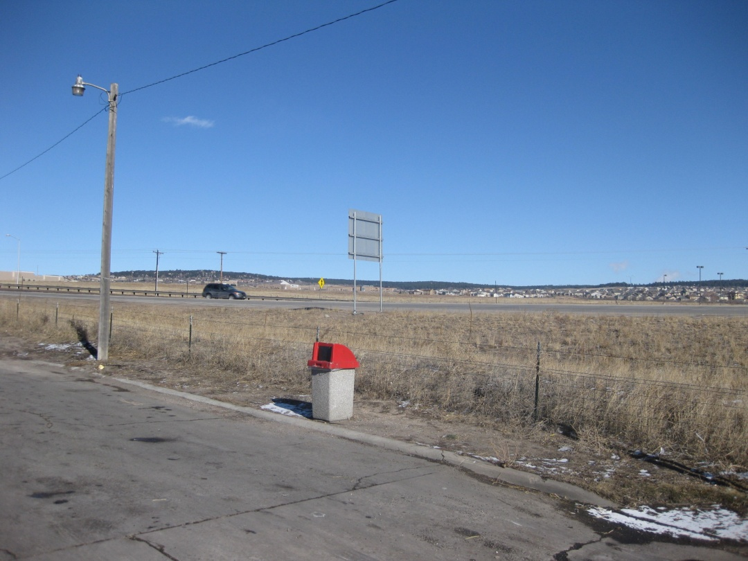
Photograph No. 2.
Diamond Shamrock, 1310 West Baptist Road, Monument, Colorado – FINDS, LUST, LUST TRUST, UST, AST. View looking northeast towards I-25. CDOT ROW fence visible directly behind trash can.

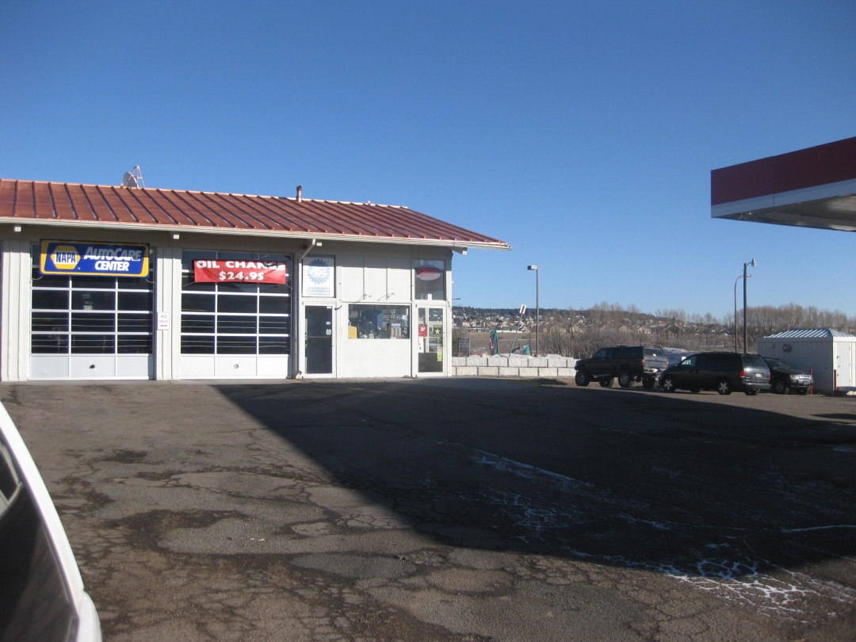
Photograph No. 3.
Amoco Gas Station (currently Conoco), 1949 Woodmoor Drive, Monument, Colorado – LUST, LUST TRUST, FINDS, UST. Looking east at front of building.
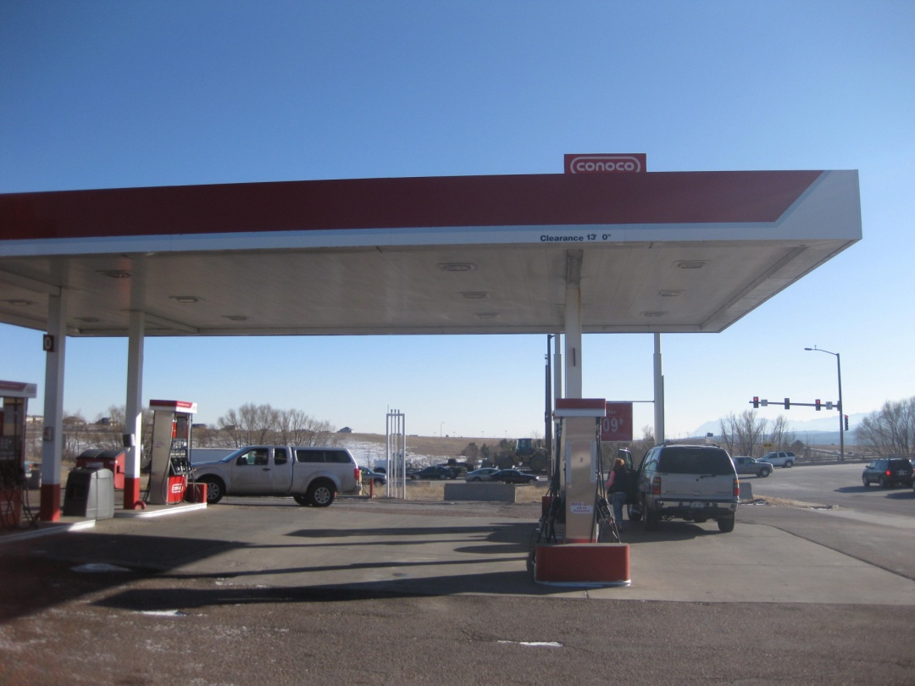
Photograph No. 4.
Amoco Gas Station (currently Conoco), 1949 Woodmoor Drive, Monument, Colorado – LUST, LUST TRUST, FINDS, UST. Looking south at canopy indicating currently a Conoco.

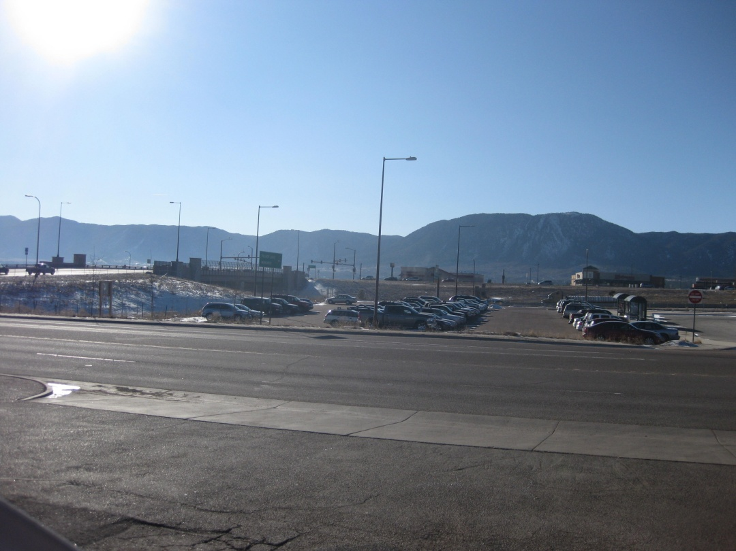
Photograph No. 5.
Amoco Gas Station (currently Conoco), 1949 Woodmoor Drive, Monument, Colorado – LUST, LUST TRUST, FINDS, UST. Looking west towards I-25. Parking lot between site and CDOT ROW visible across Woodmoor Drive.
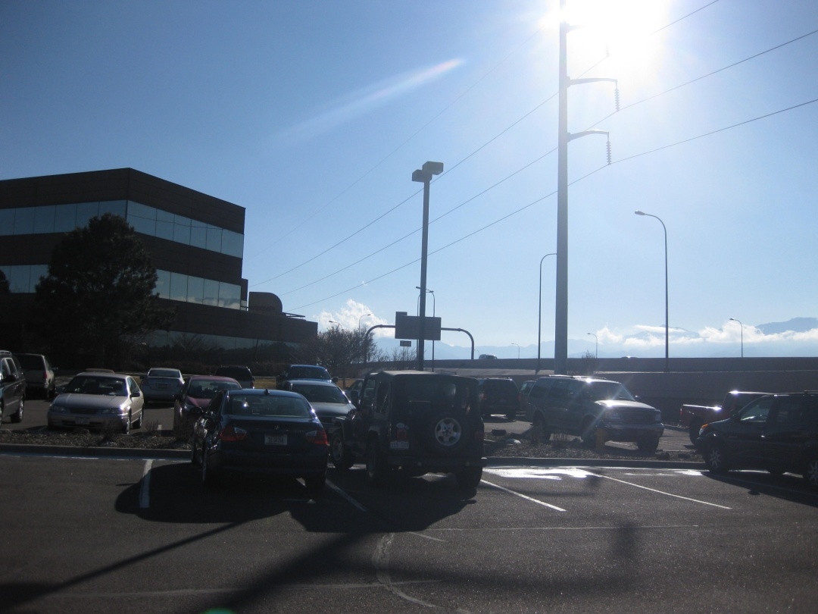
Photograph No. 6.
Woodman Office Complex, 7150 Campus Drive, Colorado Springs, Colorado – ERNS.
Omnipoint Corporation, 7150 Campus Drive, Suite 155, Colorado Springs, Colorado – RCRA-CESQG, FINDS. Looking south towards north side of building from parking lot.

