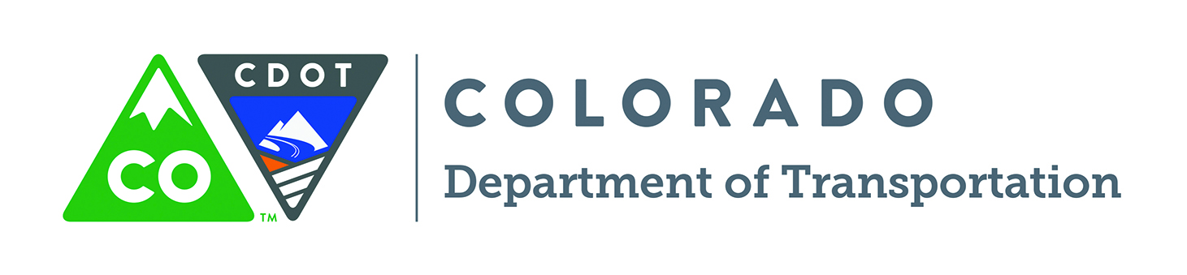

CDOT’s Bicycle and Pedestrian Program provides free educational materials for your use. Whenever possible, we encourage you to download publications directly from our website at http://www.coloradodot.info/programs/bikeped But if you need hard copies, please send this form to: Betsy Jacobsen, Bicycle and Pedestrian Section, 4201 E. Arkansas Avenue, Shumate Building, Denver, CO 80222.
FAX: 303-757-9727 Email: Betsy.jacobsen@ state.co.us

Quantity Publication Title

_____ Colorado Bicycling Manual – Official rules for road and trail use for bicyclists and walkers in Colorado. Chapters for all ages on commuting, traffic rules, skill building, equipment, accessories, safety, etc.

_____ Colorado Bicycling and Scenic Byways Map – State road map for bicyclists. Includes approximate shoulder width and traffic volumes, mountain pass elevations and designated Colorado Scenic and Historic Byways. Does not show local roads or trails. Our new interactive map provides additional information. Download it from our website at www.coloradodot.info/programs/bikeped

_____ Rules of the Road & Trail Wallet Cards* – Plastic card the size of a business card. Quick reference for rules related to bicycling, walking and driving.

_____ Colorado Safe Routes to School Brochure(Tri-fold) – Brochure explaining the Colorado Safe Routes to School Program.

_____ Colorado Safe Routes to School Book Mark (2”x8”) – CDOT book mark for K-8 grades. Provides safe walking tips.

_____ Colorado Safe Routes to School Paper Book Cover (Standard Text Book) – Book Covers for K-8 grades promoting walking to school.

*Only available in hard copy format.

The following are ONLY available as downloadable publications from http://www.coloradodot.info/programs/bikeped

2014 Colorado Bike Month Poster Artwork – This year’s poster and various artwork versions by Jennifer Davis, Davis Creative Inc., for your use in promoting Bike Month and Bike to Work Day.

Administration of Special Events on Colorado Roads: A Guide for Event Managers (25 pages) – Guide to the special event permit process and hosting bicycle and other events on state roadways.

Bike the Byways Colorado – Biking website for Colorado’s Scenic and Historic Byways. Register for free, and track your progress on completing all 25 routes. Plus, add your comments on the routes of which you are familiar. www.bikebyways.org

Colorado Guide for the Development of Local and Regional Bicycle and Pedestrian Plans (60 pages) – Guide to assist transportation planners and communities in developing a bicycle or pedestrian master plan and/or initiate discussions on how to accommodate these modes in existing planning documents such as a community’s comprehensive plan.

SRTS Lesson Plans – Bicycle Safety (42 pages) and Pedestrian Safety (33 pages) – Designed for elementary school educators, these publications are an all-inclusive training course for bicycle and pedestrian traffic safety education.

Share the Road Safety Video (8 minutes): Identifies the rules of the road and proper etiquette for all users: bicyclists, pedestrians and motorists.

Walk to School Colorado – Tool kit to assist in developing Walk and Bike to School programs.

(PLEASE PRINT)

Your Name:__________________________________________ Organization_____________________________________

Shipping Address:______________________________________________________________________________________

City, State, Zip:________________________________________________________________________________________

Phone: ( ) _________________________________ E-mail:_____________________________________________

