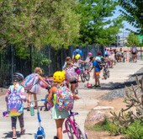
Futures in motion

BIKE TO SCHOOL
MAY 4, 2022

Ride On! Let’s Bike to [Name of School]
School activities include:
[activity name here]
[activity name here] [activity name here] [activity name here]

Why bike?
For fun with friends
For exercise
To help the planet To have fun!

For more information, contact: [Name]
[Email]
[Phone number]

Funded by Federal Highway Administration www.codot.gov/programs/bikeped/safe-routes

