

Traffic Incident Management Plan

Template

Prepared for:

Colorado Department of Transportation

425 C Corporate Circle

Golden, Colorado 80401

Prepared by:

Firm Logo

Firm Name

Firm Address

City, Colorado ZIP

June 2015

Version 1.2

# Disclaimer

This response manual is intended for internal use only and does not enlarge an agency’s civil or criminal liability in any way. It should not be construed as the creation of a recommended or higher standard of safety or care in an evidentiary sense, with respect to third party claims.

# Template purpose & Instructions

This TIMP Template has been developed as a cooperative effort between the Colorado Department of Transportation’s Transportation Systems Management & Operations division and representatives from jurisdictions across Colorado.

This TIMP Template should be used for all TIMP documents written or updated after June 2015. The template is to be used as a starting point for TIMP documents updated or developed for corridors within CDOT’s jurisdiction. TIMPs should be updated when there are significant changes for the project corridor including: changes in boundaries, new capabilities or technologies, major construction or reconstruction, etc.

Notes to authors are denoted in [highlighted brackets], editable text is highlighted. Notes in brackets should be updated with the applicable information or deleted, as appropriate. All sections that are not in brackets should be included in the final TIMP, in their entirety.

On the title sheet, insert the appropriate CDOT address and update the “Prepared by” section to reflect the appropriate author information, including firm logo. The “Template” text should be replaced with the name or description of the TIMP area and will propagate in the headers throughout the document once edited. Additionally, the “version” should be removed as this convention only applies to the template itself. The publish date of the TIMP and preliminary draft versions should be updated as needed.

The TIMP Template limits the flexibility of the author; the majority of TIMP specific items will be contained in the graphics and appendices. If segments of the TIMP Template need to be modified, contact the Real Time Traffic Management and Incident Management Branch Manager, at 303-512-5838 for protocol information.

[*******************************Remove this page from final TIMP documents **************************]

Contents

Disclaimer i

Template purpose & Instructions ii

List of Acronyms vi

Unified Terminology viii

Duties and Responsibilities xi

Executive Summary xiii

1.0 Working the Incident 1

1.1 Incident Classification 1

1.2 Size-up 2

1.2.1 Initial Radio Report 2

1.2.2 Follow-up Report 2

1.2.3 Detection and Verification 3

1.2.4 First Responder 3

1.3 Traffic Incident Management Area 3

1.3.1 Lane Designation Terminology 4

1.3.2 Response Vehicle Parking Guidelines 6

1.3.3 Flashing/Emergency Lights Guideline 7

1.3.4 Quick Clearance 8

1.3.5 Managing the Queue 8

1.3.6 Move It or Work It 8

1.3.7 Alternate Routes 11

1.3.8 Traffic Control 13

2.0 Communication 14

2.1 Communication on Scene 14

2.1.1 Incident Command System 14

2.1.2 Unified Command 14

2.2 Communication Center 15

2.2.1 Incident Detection and Verification 15

2.2.2 Interagency Communication 17

2.2.3 Operational Communications 21

2.2.4 Public Information 21

3.0 Post Incident 23

3.1 Hot Wash 23

3.2 After Action Review Objectives & Debriefing 23

3.2.1 Determining the Need for an After Action Review 23

3.2.2 Appointment of an Review Lead and Responsibilities 24

3.2.3 When to Conduct an After Action Review 24

3.2.4 After Action Review Objectives 24

3.2.5 How an After Action Review will be Conducted 25

3.2.6 After Action Report (AAR) 25

3.3 Program Management 26

3.3.1 Standing Program Management Team (SPMT) 26

3.3.2 Performance Measures 27

Works Cited 28

TABLE OF FIGURES

Figure 1.1 Phases of TIM [3] 3

Figure 1.2 Lane Designation Terminology 5

Figure 1.3 Incident Area Terminology 6

Figure 1.4 Typical Responder Vehicle Parking [7] 7

Figure 1.5 Vehicle Marking [9] 9

Figure 1.6 Move It or Work It Decision Workflow [10] 10

Figure 2.1 Incident Verification Communication 16

Figure 2.2 Responder to Communication Center Flow Chart 17

Figure 2.3 Resource Request Flow Chart through CSP Communication Center 18

Figure 2.4 Resource Request Flow Chart through Communication Center 2 19

Figure 2.5 Resource Request Flow Chart through Communication Center 3 20

Figure 3.1 Proposed Performance Measures 27

# LIST OF TABLES

Table 1.1 Incident Classification 1

Table 2.1 Conference Call Network Call-In Information 21

# APPENDICES

Appendix - Colorado Revised Statutes

Appendix - Radio Communication Plan

Appendix - Regional Detour and Hazardous Materials Routes

Appendix – Local Detour Routes

Appendix - Hot Wash and After Action Review Forms

# List of Acronyms

The use of acronyms should be avoided during incidents requiring the participation of multiple agencies or organizations. The use of plain language facilitates interoperability across agencies/organizations, jurisdictions, and disciplines. Plain language also ensures information dissemination is timely, clear, acknowledged, and understood by all intended recipients. [1] Acronyms are used frequently throughout the incident response and transportation industries, common acronyms or acronyms specific to traffic incident management are listed below, for clarity. [Insert additional TIMP specific acronyms below]

|  |  |
| --- | --- |
| AAR | After Action Report |
| CDOT | Colorado Department of Transportation |
| CRS | Colorado Revised Statute |
| CSP | Colorado State Patrol |
| CTMC | Colorado Transportation Management Center |
| EJMT | Eisenhower Johnson Memorial Tunnel (Traffic Management Center) |
| EMS | Emergency Medical Services |
| EOC | Emergency Operations Center |
| FHWA | Federal Highway Administration |
| HLT | Hanging Lake Tunnel (Traffic Management Center) |
| IC | Incident Commander |
| ICS | Incident Command System |
| ISM | Incident Site Management |
| ITS | Intelligent Transportation Systems |
| JIC | Joint Information Center |
| LZ | Landing Zone |
| MAC | Mutual Aid Channel |
| MHz | Megahertz |
| MM | Mile Marker |
| MP | Mile Post |
| MUTCD | Manual on Uniform Traffic Control Devices (2009 Edition) |
| NE-NET | Northeast NET [define whichever “NET” applies to the TIMP area] |
| NIMS | National Incident Management System |
| NUG | National Unified Goal |
| PIO | Public Information Officer |
| SH | State Highway |
| TIM | Traffic Incident Management |
| TIMP | Traffic Incident Management Plan |
| TMC | Traffic Management Center |
| UC | Unified Command |
| VMS | Variable Message Sign |
| WebEOC | Web Emergency Operations Center |

# Unified Terminology

The following terms are defined for use by the Colorado Department of Transportation (CDOT) personnel, incident commanders, persons on scene, dispatch operators and public information officers, for Traffic Incident Management on [Input Route #/Name here]. Use of these terms is recommended for all voice communications during traffic incidents (public information officers and variable message sign operators are expected to follow their own practices/procedures when communicating to the public).

**Accident Alert:** Severe weather conditions hinder Colorado State Patrol and local police jurisdictions’ response to the large volume of motor vehicle crashes. Accident Alert is initiated on a jurisdiction and geographical basis. Drivers without injury should exchange information and file a report as soon as possible.

**After Action Report (AAR):** A report prepared for Major incidents and by request. This document summarizes response activities of the incident and can define a plan of action for implementing improvements.

**After Action Review (Incident Debrief) Meeting:** A formal process of reviewing selected incidents.

**Blockage:** One or more lanes of the road are blocked by vehicles, debris and/or road damage but responsible authorities have not enacted a closure. A blockage is a temporary condition that will end by removal of the obstacle or will become a closure as defined herein.

**CDOT Conference Communication Net (CCN):** CCN is a communication tool to be used to facilitate scheduled conversations between multiple agencies to disseminate information and discuss solutions during an incident. This system will be used to link the Incident Commander or Unified Command with all responding agencies, as appropriate during complex incidents.

**First Responder:** The first responding unit to arrive at an incident scene. This term has traditionally been used to describe public safety emergency responders who have duties related to preservation of life and property. As transportation agencies become more actively involved in traffic incident response and take active roles in Incident Command (as partners in Unified Command), they are becoming accepted as first responders for traffic incidents. First responder is sometimes referred to as First Person on Scene.

**Incident:** An emergency road user occurrence, a natural disaster, or other unplanned event that affects or impedes the normal flow of traffic.

**Incident Commander (IC):** A representative of the agency in charge of the incident, which may vary depending on the type of incident. The Incident Commander is in charge of managing the incident, informing respective dispatch of the incident details, implementing closures and releases, directing additional emergency personnel, approving media releases, and conducting the After Action Review.

**Incident Command Post (ICP):** A vehicle or facility that signifies the location of the tactical-level, on-scene incident command and management organization.

**Incident Command System (ICS):** A systematic tool used for the command, control, and coordination of emergency response. ICS allows agencies to work together using common terminology and operating procedures controlling personnel, facilities, equipment, and communications at a single incident scene. It facilitates a consistent response to any highway incident by employing a common organizational structure that can be expanded and contracted in a logical manner based on the level of response required.

**Lane Closure:** Closing of a traffic lane by CDOT or an agency official with statutory authority to close the road (see Appendix A) while allowing vehicles to proceed past the point of closure in open lane or on the shoulder if directed to do so by a responsible authority.

**National Incident Management System (NIMS):** A system mandated by Homeland Security Presidential Directive 5 that provides a consistent nationwide approach for governments, the private-sector, and nongovernmental organizations to work effectively and efficiently together to prepare for, respond to, and recover from domestic incidents, regardless of cause, size, or complexity.

**National Unified Goal (NUG):** A unified national policy for traffic incident management developed by major national organizations representing traffic incident responders, under the leadership of the National Traffic Incident Management Coalition.

**Point of Closure:** The physical location within CDOT right-of-way at which the first warning device (such as a sign, light, or cone) is placed.

**Public Information Officer (PIO):** A designated communication professional responsible for communicating incident information with the media and public.

**Road Closure:** Closure of all lanes in one direction by CDOT or an agency official with the statutory authority to close the road (see Appendix A) to ensure no vehicles other than authorized responders may proceed past the point of closure.

**Secondary Incidents:** Incidents beginning with the time of detection of the primary incident where a collision occurs either within the incident scene or within the queue, including the opposite direction, resulting from the original incident.

**Total Closure:** Closure of all lanes in both directions by the CDOT incident commander or an agency official with the statutory authority to close the road (see Appendix A) to ensure no vehicles other than responders may proceed past the point of closure. Point(s) of closure may be at a single location or separated by a roadway segment.

**Traffic Management Center (TMC):** CDOT’s traffic information center. This center collects traffic data, observes traffic conditions, processes traffic information, and delivers system status messages. Messaging is provided to CDOT personnel, agency partners, media, and the travelling public via VMS, cotrip.org, social media, and direct distribution methods. CDOT has multiple TMCs including: CTMC, HLT and EJMT. The primary TMC for this project is [select either CTMC, HLT or EJMT].

**Unified Command (UC):** One of two methods of performing the Command function that employs multiple ranking personnel. UC is used when a highway incident affects multiple political or legal jurisdictions and/or involves several responding agencies with contrasting functional responsibilities and missions.

# Duties and Responsibilities

All agencies assume the role of Incident Commander or participate in/support Unified Command, as appropriate to the incident. The table below illustrates the stakeholders that may participate in traffic incident management activities and the duties and responsibilities that may be associated with each stakeholder.

| Stakeholder | Duties and Responsibilities [2] | |
| --- | --- | --- |
| Law Enforcement | * Secures incident scene * Performs first responder duties * Assists responders in accessing the incident scene * Establishes emergency access routes * Controls arrival and departure of incident responders * Polices perimeter of incident scene and impact area | * Conducts crash investigation * Performs traffic control * Responds to and assesses incidents involving a hazardous material release * Assumes role of Incident Commander, if appropriate * Conducts criminal investigation * Supports unified command, as necessary |
| Fire and Rescue | * Protects incident scene * Rescues/extricates patients * Extinguishes fires * Responds to and assesses incidents involving a hazardous materials release | * Contains or mitigates a hazardous materials release * Assumes role of Incident Commander, as necessary * Supports unified command, as necessary |
| Emergency Medical Services (EMS) | * Provides medical treatment to patients at the incident scene * Determines destination and transportation requirements for injured patients | * Transports patients for additional medical treatment * Supports unified command, as necessary |
| Emergency Management Agency | * Coordinates government response and resources * Provides technical expertise * Provides evacuation recommendations * Facilitates communication and coordination across jurisdictions | * Coordinates response from local, state and federal agencies * Directs EOC Operations * Supports unified command, as necessary |
| Transportation agencies, including:   * Highway maintenance * Service patrols * Traffic incident response teams * Transportation management center (TMC) * Highway Incident Commanders | * Protects incident scene * Implements traffic control strategies and provides supporting resources * Monitors traffic operations * Disseminates motorist information * Mitigates incidental, non-hazardous material spill confined to the roadway * Assesses and directs incident clearance activities * May perform first responder duties (service patrol) * Clears minor incident (service patrol) | * Performs incident detection and verification (service patrol/TMC) * Updates VMS boards, cotrip.org and 511 information (TMC) * Distributes mass notifications (email, text, social media, etc.)(TMC) * Develops and operates alternate routes * Assesses and performs emergency roadwork and infrastructure repair * Assumes role of Incident Commander, as necessary * Supports unified command, as necessary |
| Towing and Recovery | * Recovers vehicles and cargo * Removes disabled or wrecked vehicles and debris from incident scene | * Mitigates non-hazardous material (cargo) spills * Supports unified command, as necessary |
| Communication Centers | * Receives emergency and  non-emergency calls * Dispatches response agencies to incidents | * Monitors and assists response agencies in communicating * Requests resources, as necessary |

# Executive Summary

The Colorado Department of Transportation (CDOT) initiated the development and update of the [Input Route #/Name here] Traffic Incident Management Plan to support response agencies along the [Input Route #/Name here] corridor between [beginning and ending locations included in this TIMP]. The goal of providing coordinated response to incidents within the [Input Route #/Name here] right of way is consistent with the National Traffic Incident Management Coalition’s National Unified Goal (NUG). The NUG consists of three major objectives and eighteen strategies. The main objectives are:

* Responder safety
* Safe, quick clearance
* Prompt, reliable, interoperable communications.

[Provide a location description of the TIMP corridor. Refer to the following example: “The I-25 Traffic Incident Management Plan – SH 7 to Wyoming State Line (I-25 TIMP) is located north of Denver. Beginning on the south at SH 7 (mile marker 229), the 70 mile long corridor is a six lane divided highway with frontage road for the first 14 miles continuing as a four lane divided highway with frontage road north to Wyoming (mile marker 299). The route serves as the primary connection for communities along the Colorado front range while connecting the major east-west Interstates 70 and 80. This 70-mile stretch of interstate highway passes through Broomfield, Weld, and Larimer counties. Numerous cities and towns also exist adjacent to the corridor including Erie, Dacono, Frederick, Firestone, Berthoud, Johnstown, Loveland, Windsor, Timnath, Fort Collins, and Wellington.]

This TIMP is the result of the cooperative efforts of representatives from [list all agencies]. The [Input Route #/Name here] TIMP has been developed in harmony with the core set of concepts of the National Incident Management System (NIMS). The Plan uses the NIMS framework for cross-agency cooperation and understanding to outline procedures and tools anticipated to benefit plan users in executing their specific duties.

To facilitate a continuing dialog about best practices, a Standing Program Management Team is planned. The Standing Program Management Team is comprised of leadership representatives from all participating agencies; main goals include collaboration for data collection, development of MOUs, funding of TIM programs, executing mutually beneficial trainings, determining the direction of the TIMP and sharing resources.

CDOT is establishing performance measures to help track and evaluate progress toward objectives of this TIMP. Performance measurement can be helpful in determining the value of new programs and whether or not the benefits of new programs justify their costs. Performance measures tracked within the boundaries of this TIMP include [list specific performances measures established for this TIMP].

This document, including appendices and references, is the Traffic Incident Management Plan (TIMP) for [Input Route #/Name here] from [beginning to ending locations for the TIMP]. Copies of the plan and additional information are available by contacting CDOT Region [Input CDOT Region #] at the address below. In the continued effort to keep this manual up to date and accurate, any comments regarding corrections and necessary changes should be directed to:

Colorado Department of Transportation

Region [Input CDOT Region #], [Contact person’s title]

Attention: [Name]

[Street Address]

[City, State, Zip Code]

Phone: [Phone #]

Email: [Email Address]

The manual is accessible online with permission from CDOT. Contact the Colorado Traffic Management Center (CTMC) at 303-512-5830 for document access protocol.

This page intentionally left blank.

# Working the Incident

The topics and guidelines discussed in this document are written to align with the core principals of the National Incident Management System (NIMS) and Incident Command System (ICS). Traffic Incident Management (TIM) integrates the transportation professional into NIMS and ICS.

While maintaining or restoring traffic flow is the transportation profession’s goal, traffic incident response priorities include:

1. Life Safety
2. Incident stabilization
3. Preservation of property and environment
4. Maintaining or restoring traffic flow

## Incident Classification

Incident classes have been defined by the Manual on Uniform Traffic Control Devices (MUTCD) to support communication centers in strategic mobilization of resources (people and equipment). Incidents are classified based on expected incident duration. For the purposes of assessing traffic impacts, the duration of an incident is defined as the time elapsed between incident detection and verification and restoration of normal traffic flow. Once vehicles and debris are safely out of the travelled way and traffic queues have dissipated, the incident is effectively over. Incident classes are defined in Table 1.1.

The first responder assesses probable incident class based on operational experience. The Incident Commander (IC) determines incident class based on information provided by the first responder. Update incident classification as necessary during incident mitigation and recovery.

Table .1 Incident Classification

|  |  |  |
| --- | --- | --- |
| **Incident Class** | Expected  Duration | Typical Traffic Impact |
| **Minor** | 0 to 30 minutes | Short druation lane blockages; on-scene responders responsible for traffic control |
| **Intermediate** | 30 minutes to 2 hours | Lane blockages requiring traffic control; short duration closures may be needed |
| **Major** | More than  2 hours | Full or partial roadway closure |

## Size-up

Traffic incident management guidelines provide a framework to help reduce the impacts of an incident on the travelling public while maintaining the safety of both responders and the public. The foundation of effective traffic incident management is communication, which includes incident size-up and verification of the incident. Communication centers disseminate information outward, communicating with all plan participants, even those not directly involved in the incident. Response agencies can adjust other routine operations to reduce indirect impacts of the incident when fully informed of incidents nearby.

There are two parts of size-up: initial radio report and follow-up report. The initial radio report is intended to get immediate information to dispatch to verify the initial report and begin deploying resources. Once the first responder has walked around the incident scene, they are able to complete a more thorough report and follow-up with dispatch.

### Initial Radio Report

Initial radio report, sometimes referred to as a windshield report, is a brief description of the scene reported before exiting the vehicle. The report should include basic information such as:

* Location
* Number and types of vehicles involved
* Apparent cause of incident
* Classification of incident (Minor, Intermediate, or Major)
* Potential threats to safety
* Presence of hazardous materials
* Blockages and the need for lane or road closures
* Needed resources

### Follow-up Report

The second part of size-up is the follow-up report, also called the 360 evaluation. This report is much more in-depth; it fills in the incident details, identifies the scene strategy (Life Safety or vehicle hazards), identifies specific actions or needs, whether the vehicle(s) can be moved or if vehicles need to be worked in place, and tools required.

Specific details reported in the 360 evaluation might include:

* Lane(s) impacted
* Tools required
* Position and type of vehicle
* Number and/or condition of patients
* Location of Incident Command Post
* Resources required (equipment, towing, traffic control, detours, etc.)

Size-up is a continuous process. As the scene develops, updated reports should be communicated to dispatch. Update dispatch per agency’s protocol.

### Detection and Verification

Incident detection and verification is the first phase of TIM as shown in Figure 1.1. Once an incident occurs, it may be reported by the public, motorists involved in the incident, or responders passing by the scene. When an incident is reported, it is essential that dispatch obtains as much detailed information as possible about the location of the incident. Frequently, the travelling public is unsure of locational details in reporting incidents. Consequently, the role of first responder and video surveillance [video surveillance is only relevant where the infrastructure is in place and in use for this purpose—not required in all TIMPs are critical in responding to and clearing incidents quickly. The TMC operates cameras throughout the corridor and may be able to verify an incident location before the first person arrives on scene. [Not required in all TIMPs].

Figure .1 Phases of TIM [3]

### First Responder

The first responder at the scene shall be designated the Incident Commander until relieved. The first responder at the scene of a traffic incident relays the following traffic management information to their dispatch, if not previously provided in the size-up:

* Need for assistance (enforcement, emergency services, traffic control, recovery, etc.)
* Potential threats to safety
* Verification of incident information (number and type(s) of vehicles, direction, mile marker, location, etc.)
* Need for lane or road closure
* Apparent cause
* Expected length of traffic impacts (based on similar experience to classify the incident)
* Presence of hazardous materials
* Potential alternate routes, if needed

## Traffic Incident Management Area

The traffic incident management area is an area of a highway where temporary traffic controls are installed in response to a road user incident, natural disaster, hazardous material spill, or other unplanned incident. This type of temporary traffic control zone extends from the first warning device (such as a sign, light, or cone) to the last temporary traffic control device or to a point where vehicles return to the original lane alignment and are clear of the incident. [4]

Two critical locations for traffic control exist with each incident. One is at the traffic incident scene itself where clear direction is needed to move traffic safely past the incident and to protect responders working on the incident. The second is at the end of the queue of traffic that forms beginning at the incident and extends back for some distance, possibly many miles. While drivers approaching the end of a short queue may see the incident, drivers approaching the end of a long queue may be taken by surprise by a sudden slowing of traffic. It is estimated that approximately 20 percent of all incidents are secondary in nature, with most of these occurring near the end of the traffic queue. Monitoring the end of the traffic queue and moving advanced warning devices to warn approaching motorists as the queue grows is important for avoiding secondary collisions. [5]

Chapter 6I of the 2009 Manual on Uniform Traffic Control Devices (MUTCD) specifically addresses the control of traffic incident management areas. This chapter complements NIMS and should be referenced for traffic control during traffic incidents. Specifically, the MUTCD offers detailed guidance on the use of traffic control devices in traffic incident management areas. The MUTCD may be found online at [www.mutcd.fhwa.dot.gov](http://www.mutcd.fhwa.dot.gov).

### Lane Designation Terminology

State, regional, and local responders often use distinct terminology when communicating the location of crashes or response vehicles on roadways. Disparate terminology in communications could potentially lead to confusion on the scene, impact responder and patient safety, and adversely affect emergency response and traffic clearance times [6]. Figure 1.2 and Figure 1.3 detail the definitions that follow: [Figure 1.2 and Figure 1.3 can also be modified to include a corridor specific location.]

* Lane: Traffic incident responders use plain English where possible to identify incident location and lane designations. On roadways with 3 or fewer lanes, lanes are named left, center, and right when facing in the direction of traffic flow. [Use when TIMP roadways have fewer than 3 lanes and include the appropriate figure on the following page]
* Lane: When roadways have more than 3 lanes in any one direction, the lanes shall be identified and labeled with numbers, starting with the far left lane. When using lane numbers, the far left lane shall be called “Lane 1”. Each lane to the right is numbered sequentially 2 through n. [Use when TIMP roadways have more than 3 lanes and include the appropriate figure on the following page.]
* Shoulders: Shoulders should be identified using “right/left” and the term “shoulder”; and direction of travel (e.g. “northbound left shoulder”).
* Restricted Lanes: Separated, high occupancy vehicle (HOV) or high occupancy toll (HOT), car pool, or bus only lanes that are physically separated shall be designated as HOV1 northbound (NB), HOV2, HOT1, HOT2, etc. as appropriate. [list only if one of the above types of restricted lanes is used in the TIMP area]

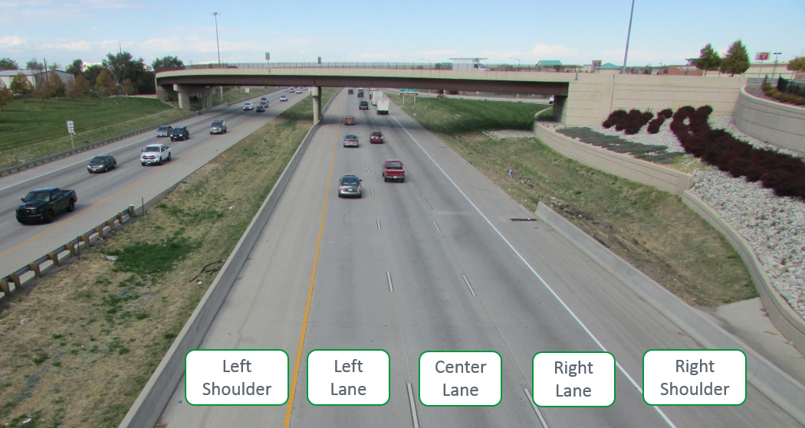

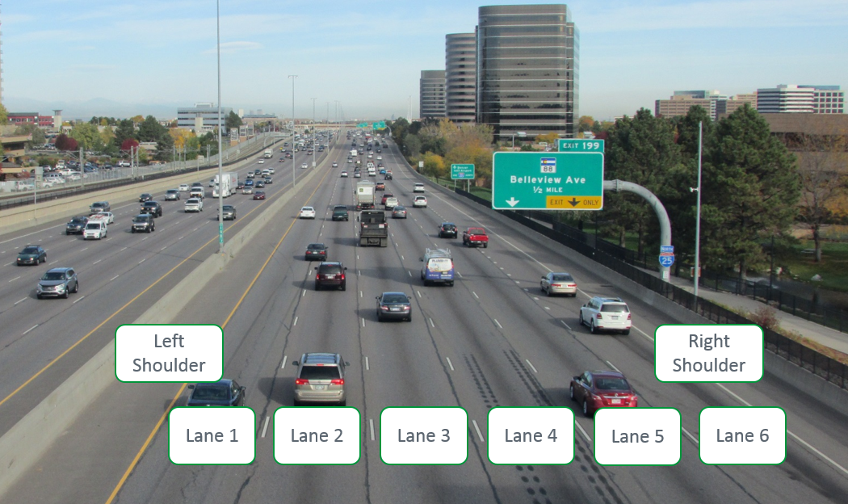

Figure .2 Lane Designation Terminology

* Direction of Travel: Responders should also indicate the relative direction of travel (e.g. northbound or southbound) along with other incident location detail and any specific position assignments.
* Ramp: If the incident is located before the merge point it shall be considered a separate roadway and identified as such, i.e. left hand exit ramp.
* Upstream/Downstream: The term “upstream” is defined as before the incident area. The term “downstream” is defined as past or beyond the incident area when facing in the direction of traffic flow.
* Gore Area: The physical space that separates the interstate or highway from the on or off ramp.
* Queue: The traffic backup upstream of the incident.

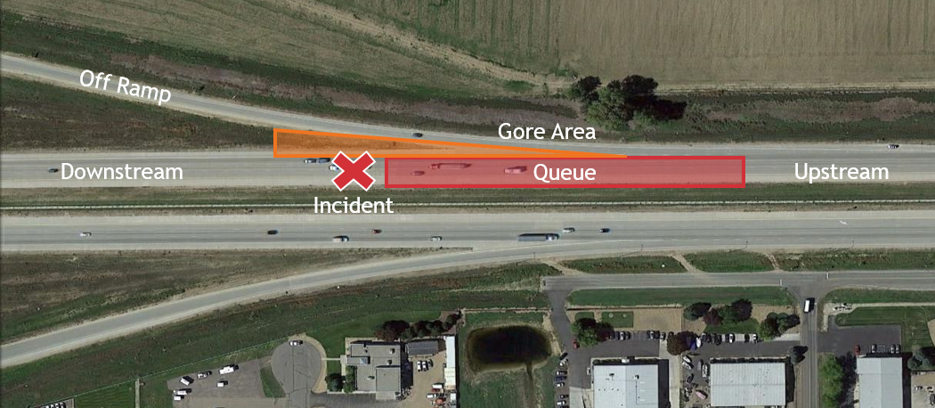

Figure .3 Incident Area Terminology

### Response Vehicle Parking Guidelines

* All response vehicles should be parked on the same side of the roadway on which the incident occurred to avoid a split-scene scenario.
* Except for vehicles positioned to protect the incident scene, response vehicles should be parked on the shoulder.
* Fire-fighting vehicles should be parked directly behind or in front of the vehicles involved in the incident.
* Tow trucks and support vehicles should be parked where they can be accessed and moved while not interfering with lane-opening activities.
* Median parking is discouraged.
* A general model of response vehicle parking is presented in Figure 1.4. Conditions may require adjustments of the positions of response vehicles to accommodate a particular incident scene. In all scenarios, response vehicle parking positions should protect the incident scene and responding personnel.
* Where practical, “safe positioning” techniques should be followed including:
  + Placing fend-off vehicles at a 30 degree angle to the travelled way.
  + Positioning the front bumper of a fend-off vehicle at least two feet from the edge of an active traffic lane.
* Locations for helicopter landing zones will be identified and coordinated by the Incident Commander/Unified Command and air ambulance service.

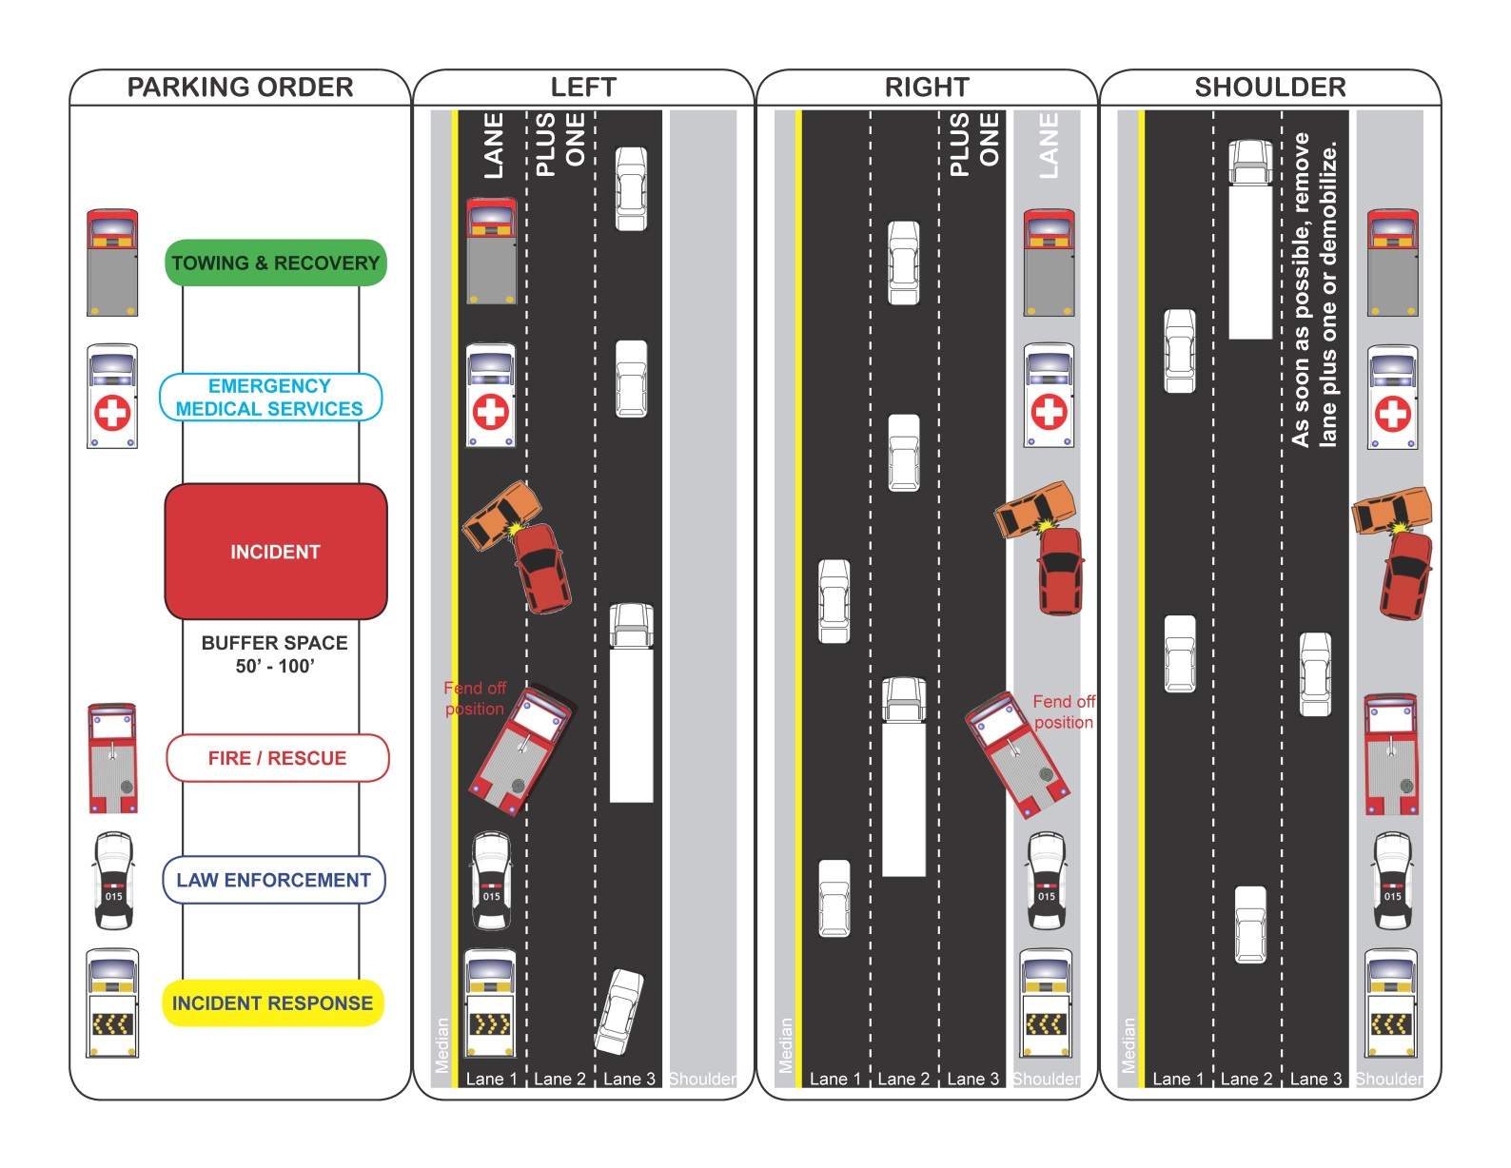

Figure .4 Typical Responder Vehicle Parking [7]

### Flashing/Emergency Lights Guideline

Flashing and emergency lights are generally used to warn the public of the presence of emergency vehicles. However, the presence of multiple vehicles with activated emergency lights can also cause a distraction to motorists resulting in reduced speeds. The following are recommendations about when flashing or emergency lights should be utilized.

Flashing/emergency lights should be active when:

* Traveling through stopped traffic to the incident scene.
* Traveling on the shoulder.
* Working through traffic to remove blocking, disabled vehicles.
* Response vehicles are parked on the shoulder and adjacent traffic is traveling at speeds near or above the posted limit.
* Response vehicles are parked on the shoulder at night.

Flashing/emergency lights should NOT be active when:

* Multiple response vehicles are lined up. In this scenario, only the front and rear response vehicles should have activated overhead flashers.
* Both incident and response vehicles are safely outside of the traveled way. The use of yellow flashers once the response vehicle has parked helps alleviate “rubbernecking” by passing motorists.

### Quick Clearance

Quick clearance is the practice of rapidly and safely removing temporary obstructions from the roadway [8]. Vehicles are moved as soon as practical off the travelled portion, median, ramp or frontage road to the nearest suitable cross street or other suitable location. The Colorado Revised Statutes support this effort in subsection 42-4-1602, Accident involving damage – duty (see Appendix A). [If there are specific procedures or designated storage areas identified within the limits of the TIMP, identify in this section.]

### Managing the Queue

Responders arriving at a traffic incident should estimate the magnitude of the traffic incident, the expected time duration of the traffic incident, the expected vehicle queue length based on previous experience, and should set up the appropriate temporary traffic controls for these estimates; typically further upstream from the current end of the queue. [4] Section 1.3.8, Traffic Control gives additional guidance on temporary traffic control devices. Care should also be given to provide planned adequate ingress and egress of emergency vehicles, through the queue.

### Move It or Work It

In support of the quick clearance initiative, property obstructing traffic can also be physically moved off of the roadway, by a law enforcement officer or person appointed by a law enforcement officer, to open up the roadway or reduce impacts to roadway. The Colorado Revised Statutes support this effort in subsection 42-4-1803. Abandonment of motor vehicles - public property (see Appendix A).

If the vehicle can be moved, the scene should be marked to preserve evidence for accident reconstruction. Figure 1.5 shows the basic vehicle marking example. At a minimum, all four wheels should be marked with a “T,” direction can be given by connecting the front to the “T” to the stem to create a figure “4.”

When property has been moved out of the traveled way and is not impacting traffic, final removal can be scheduled for a more convenient, off peak time. Benefits of waiting for a more convenient time for removal include reducing first responder exposure and having response assets available for other incidents during peak periods. Delaying the tow or removal of property should be approved by CDOT, CSP and the local agency.

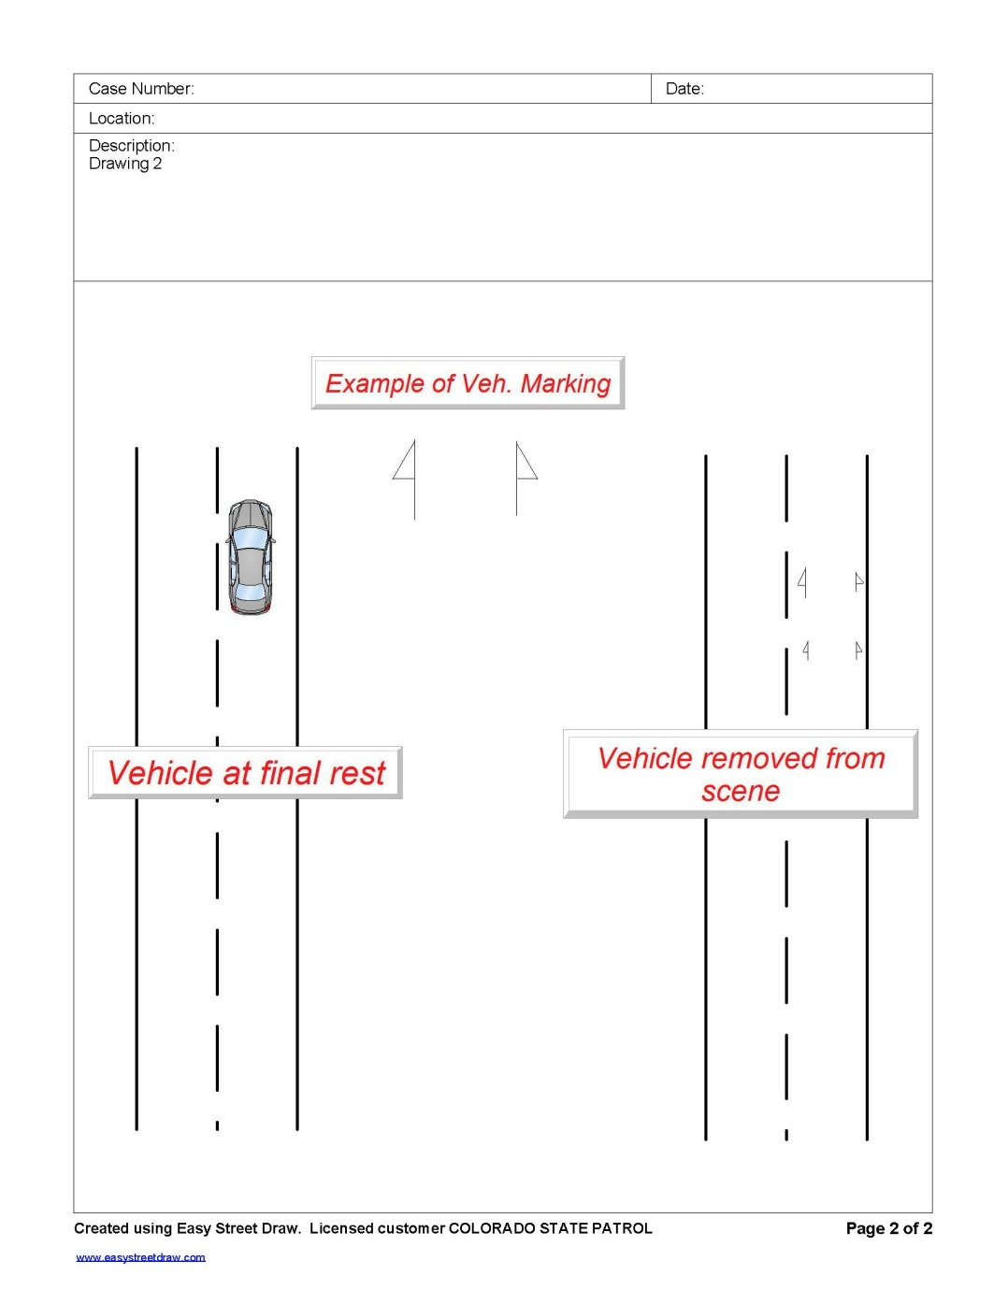

Figure .5 Vehicle Marking [9]

If the initial scene cannot be moved, due to Hazmat or Life Safety reasons, it must be worked in place. The scene should be re-evaluated as the incident mitigation progresses to identify opportunities to move portions of the incident out of the travel way. Figure 1.6 outlines scenarios for evaluating move it or work it.

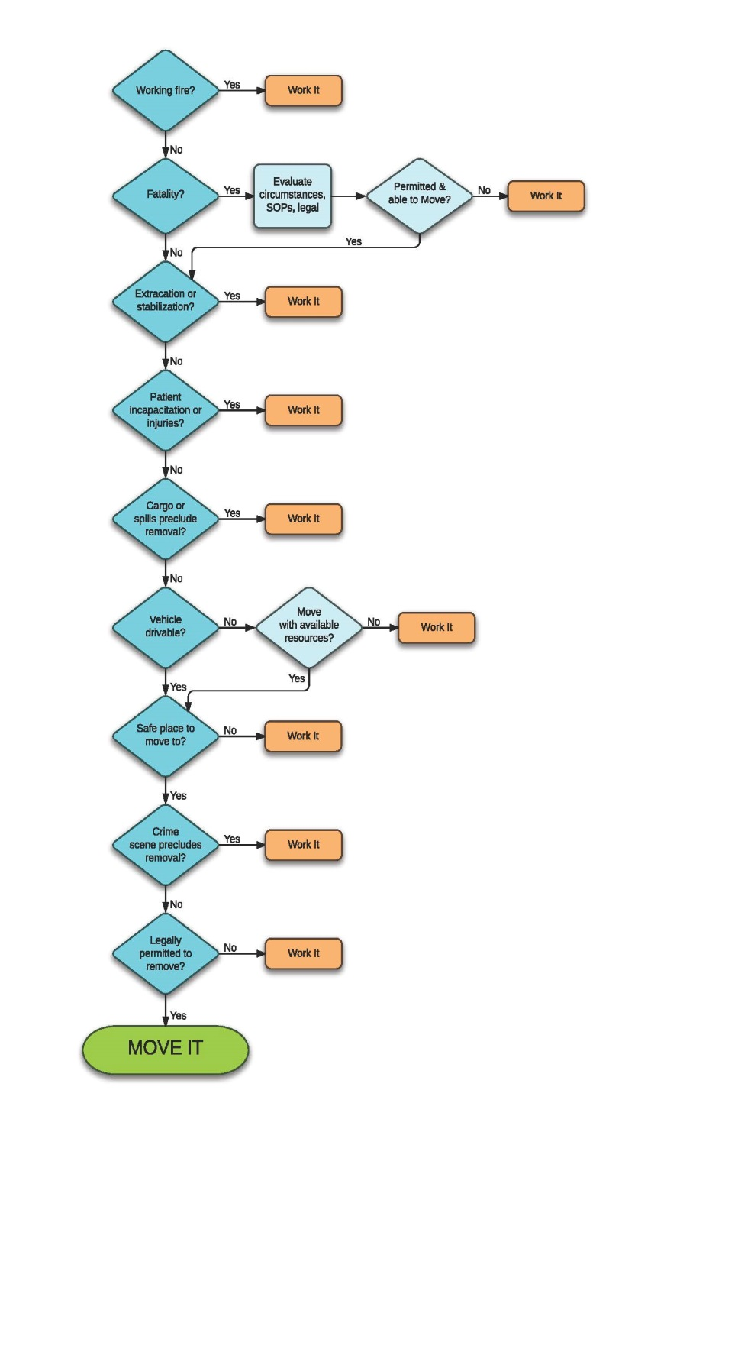

Figure .6 Move It or Work It Decision Workflow [10]

### Alternate Routes

[Alternate routes should be investigated for the project corridor. For routes with frontage roads, the frontage road typically becomes the primary detour route. Decision making regarding the information evaluated to determine alternate routes should be recorded (ie: local postings, school zones, weight rated bridges, restricted lane requirements, etc).]

Frontage roads can also serve as a direct route for responders to access an incident. The use of the frontage road for incident response or other circumstances may offset its efficacy as a detour option. [Include this section if frontage roads are an option within the boundary of the TIMP.]

Primary, alternate and regional detour routes have also been identified with the following considerations:

* Proximity to [TIMP route]
* Direct connections to crossroads
* Pavement condition
* Roadway alignment
* Adjacent land use
* Permanent traffic control infrastructure
* Suitability for interstate truck traffic
* School zones
* Railroad crossings

[Regional detour routes should be identified, as appropriate. For some locations, the regional routes may serve also as primary detour routes. Local detours, on local routes, may require a MOU or IGA as part of the TIMP development process.]

Regional detours utilize [route, from location to location]. Hazmat [is/is not (select appropriate)] accepted on this route. The Department of Public Safety has designated Hazardous Materials Routes in Colorado, which include state highways that cross [route]. [Hazmat routes should only be listed if designated by the Department of Public Safety.] These state highways have been identified in the regional detour plan provided in Appendix A - Colorado Revised Statutes

Appendix B - Radio Communication Plan

Appendix C [list appropriate appendix]. Where available, median crossovers may be used during major incidents requiring road closures in one direction. [Only include median crossovers if the project route includes this design element.]

#### When to Establish a Local Detour

The establishment of local detours should be considered during Intermediate and Major incidents requiring a closure of one or more lanes. The Incident Commander or Unified Command should make this decision based on the estimated incident duration, traffic demands, and the availability of resources. Before the local detour is implemented, CDOT Maintenance and/or other responding traffic control entities should be consulted to ensure that appropriate signing and barricading can be provided.

#### How to Implement a Local Detour

Detour routes have been identified and are included in Appendix D. When the primary detour route is restricted or is undesirable, an alternate detour route may be initiated. Before a local detour plan is initiated, Incident Commander/Unified Command should verify that neither construction activities nor maintenance issues are present along the route. Local public works departments should be contacted to confirm the suitability of detour routes, including snow removal schedules during the winter. Given the required setup time, signed detour routes are unlikely to provide great benefit for Intermediate incidents, especially if the route cannot be fully implemented within an hour of incident verification.

When detour signing is implemented:

* Install MUTCD compliant signs.
* Signs should be deployed from the downstream end of the alternate route.
* Fasten signs on poles or erect on portable sign structures. Standard mounting height is 7 feet, if that is not achievable, the signs should be visible above the tops of cars.
* Erect signs on the right side of the roadway at a minimum of two feet from the edge of traveled way.
* Once the incident has been cleared, remove signs immediately.

#### Trucks Carrying Hazardous Materials & Oversized/Overweight Vehicles

[Route(s)] serves as a designated hazardous materials route; the presence of vehicles carrying hazardous materials should be taken into account when a traffic incident occurs. Once the decision to implement a road closure has been made, overhead Variable Message Sign (VMS) instructions for the drivers of trucks carrying hazardous material or oversized/overweight (OS/OW) vehicles should be posted at locations prior to the exits for the designated hazardous materials routes and oversized/overweight vehicles. [If overhead VMS are not assets on the TIMP route, portable message signs should be used.] Except for local deliveries, trucks carrying hazardous materials or oversized/overweight vehicles can be directed to use the designated routes to bypass any local detours implemented as part of [route] traffic incident management. Appendix C includes the routes intended to serve as hazardous material routes as well as regional detour routes [CDOT’s permit website is a great resource to use as a starting point for investigating and evaluating Hazmat, OS/OW & regional detour routes. <http://www.coloradodot.info/business/permits/truckpermits/restrictions.html>]

#### Traffic Signals on Local Detour Routes

Appropriately timed traffic signals along a detour route can offer the dual benefit of improving traffic flow while also relieving uniformed officers from having to direct traffic at an intersection. When a detour is implemented along a route with traffic signals, the jurisdiction maintaining those signals should be contacted to determine whether changing of signal timing is practical given the anticipated incident duration. Timing changes should provide additional green time to detour route movements without significantly increasing the delay to non-detour traffic. Along detour routes with a series of signals, the local jurisdiction should consider developing traffic incident signal timing plans that are prepared and ready for activation. [This section will not apply to TIMPs in areas that do not have signals. If the TIMP area does have signals, listing all signals along the TIMP is not required. In working with local jurisdictions, if the agencies are unable or not interested in developing alternate signal timing plans, removing this section may be appropriate.]

### Traffic Control

The primary functions of temporary traffic control at a traffic incident management area are to inform road users of the incident and to provide guidance information on the path to follow through the incident area. Alerting road users and establishing a well defined path to guide road users through the incident area will serve to protect the incident responders and those involved in working at the incident scene, will aid in moving road users expeditiously past or around the traffic incident, will reduce the likelihood of secondary traffic crashes, and will preclude unnecessary use of the surrounding local road system [4].

Given the extent of duties required of both CDOT Maintenance and county, city and town traffic control units, private traffic control companies may be utilized to provide a reduction in incident response time for installing traffic control devices. Reduced response time for installing traffic control devices may increase the frequency and duration for which signed detours can be fully implemented during incidents of any magnitude, potentially reducing secondary accident occurrences. [The paragraph may be removed if private traffic control companies are not utilized or anticipated within the boundary of the TIMP]

# Communication

Effective communication is critical to the success of incident response efforts. In order to facilitate communication between responding agencies and their respective communication centers, use plain language. This approach is consistent with NIMS and includes eliminating the use of “codes” commonly used for intra-agency communication.

## Communication on Scene

### Incident Command System

The Incident Command System (ICS) is a command and control protocol for use by responding agencies at the incident scene. The ICS is just one part of the broader incident management process outlined in NIMS and will be used for all incidents. Where an incident does not overlap jurisdictional or functional agency boundaries, one ranking person has management and control authority over the incident. This Incident Commander (IC) sets the response objectives and ensures that all responders are working to accomplish those objectives. The Incident Commander is also responsible for establishing an Incident Command Post (ICP) where responders arriving on scene can check in and command can be reorganized, as needed. The first responder to an incident will assume the role of Incident Commander until relieved or Unified Command (UC) is established.

### Unified Command

Unified Command will be established when an incident affects multiple legal or political jurisdictions and/or involves several responding agencies with contrasting functional responsibilities and missions. The Unified Command structure allows multiple agencies to contribute to the process of determining strategies and objectives without a loss of individual authority or accountability. Unified Command can be as simple as ranking personnel from separate jurisdictions having a conversation.

The Unified Command will consist of the on-scene ranking officials from all agencies that have statutory authority at an incident scene including law enforcement, fire departments, emergency management, and CDOT. Once Unified Command has been established, a single Incident Command Post will be designated. Additionally, the lead agency whose functional responsibility is the prioritized mission will be assigned. Unified Command will then work to develop a written or verbal plan that provides unified tactical operations and resource assignments.

## Communication Center

Communication centers and dispatch personnel play an important role in the incident response effort. Standardized communication procedures between the communication center and responders in the field facilitate distribution of the appropriate information about an incident to other responding agencies.

### Incident Detection and Verification

Incident detection and verification are the first notification steps once an incident has occurred. Detection occurs when a communication center first receives notification of an incident either from a call to a public service answering point or from a responder passing by. If detection of the incident originates with the first responder, then the type and exact geographic location of the incident should be verified immediately to facilitate the correct deployment of resources.

When detection originates with a non-responder, the communication center dispatches appropriate resources to verify the incident. [Where Closed Circuit Television cameras exist in the vicinity of the detected incident, the communication center should contact the Traffic Management Center (TMC) (CTMC, HLT, or EJMT) that monitors them to attempt to verify the incident type and location.] Once verified, the communication center may adjust the resource deployment per direction from the Incident Commander and their agency’s standard procedures. In addition to direct resource deployment, the first responder’s communication center is also responsible for notifying other centers in the area of the incident status using [Metro Net, Northeast Net, Southeast Net, Southwest Net,Northwest Net] console-to-console network and WebEOC, shown generally in Figure 2.1. Specific resources are requested directly from their respective communication centers. A quick reference communication card for dispatchers has been included in Appendix B. The reference card summarizes incident classifications, provides NET guidance and sample NET messaging, lists typical mutual aid channels, lists dispatch centers within the boundary of the TIMP and provides additional guidance for radio communication specific to the TIMP and traffic incidents. [A communication card template and instructions for completing it are included in Appendix B.]

Figure . Incident Verification Communication

Upon arriving on scene and verifying the incident location and general type to dispatch, the first responder will assume the role of Incident Commander. The Incident Commander will report the establishment of command along with the location of the Incident Command Post back to dispatch. Dispatch will notify all resources en route to the incident that the Incident Commander has been established and of the Incident Command Post location for check in upon arrival.

The first responder (now Incident Commander) will then briefly size up the incident. The following checklist should be used by both the Incident Commander and their respective communication center to confirm that critical information is not overlooked during the size-up:

Initial Radio Report Checklist

* Location
* Number and types of vehicles involved
* Apparent cause of incident
* Classification of incident (Minor, Intermediate, or Major)
* Potential threats to safety
* Presence of hazardous materials
* Blockages and the need for lane or road closures
* Needed resources

After reporting findings of the initial size-up to dispatch, the Incident Commander proceeds with a 360 evaluation described in Section 1.2.2. and functional duties until additional responders arrive on scene. At that time, command may be shifted to a higher ranking official or Unified Command may be established with a designated lead agency.

### Interagency Communication

Timely communication between response agencies about incident status is essential to efficient clearance. As emphasized in Figure 2.2, TIMP stakeholders including the Incident Commander or Unified Command request assistance through their own dispatch.

Figure . Responder to Communication Center Flow Chart

Figure 2.3, Figure 2.4, Figure 2.5 show which TIMP stakeholders are dispatched by each communication center. To respond to a specific resource request, centers can refer to the Connect Colorado website located at <https://connect.state.co.us> for current availability.

[Shapes with orange text in the figure above and the figures on the following pages should be modified to fit each TIMP. Once the appropriate text has been entered, the text color should be changed to white. Word 2013 SmartArt graphics were used to create these graphics so additional blocks can easily be added or subtracted as needed. All communication centers dispatching for resources that may typically be called upon in the TIMP area should be included. Under each communication center, list only the agency names and phone numbers of resources that the center may dispatch to the TIMP area. Specifc law enforcement agencies, fire districts, EMS, CDOT Maintenance Sections, and any other agencies should all be named. Specialized resources such as Hazmat teams may be listed under the main resource, as appropriate.]

Figure . Resource Request Flow Chart through CSP Communication Center

Figure . Resource Request Flow Chart through Communication Center 2

Figure . Resource Request Flow Chart through Communication Center 3

### Operational Communications

Where interoperable radio communications are needed, Unified Command will request channel assignment for the incident through dispatch. New channels and templates are frequently added and so the Radio Communication Plan included in Appendix B should be consulted to see which channels may be available. Standard Mutual Aid Channels (MACs) used in this TIM area include [insert MACs here].

Radio communication may be supplemented by cellular phone communication in some instances. Identifying and resolving coverage gaps along the TIMP corridor as quickly as feasible is highly recommended for improved operations. This improvement has the added benefit of potentially reducing the time between when an incident occurs and when it is detected at a communication center.

#### Conference Call Network

The Conference Call Network (CCN) is a statewide tool that can be used to aid communication during complex, multi-jurisdictional responses. When initiated by the CDOT Unified Command representative, CCN can be used to discuss details of the incident, to coordinate among all involved agencies, and to determine the appropriate actions needed to resolve the impacts of the incident. The call-in number and start time of the CCN session will be announced over [Metro Net, Northeast Net, Southeast Net, Southwest Net, Northwest Net]. The call in information is not broadcast over the radio; distribution is restricted to a predefined list. The call-in information for this plan is listed below: [update and confirm all numbers, specific to the plan]

Table .1 Conference Call Network Call-In Information

|  |  |
| --- | --- |
| Participant Passcode: | [Insert] |
| Dial-In Numbers: |  |
| Local: | 1-720-279-0026 |
| Toll Free: | 1-877-820-7831 |

### Public Information

#### Traffic Operations Center

[CTMC,HLT or EJMT] updates notifications on permanent Variable Message Sign (VMS) installations, the [www.cotrip.org](http://www.cotrip.org) traveler information website, the 511 traveler information telephone service, and sends GovDelivery emails to disseminate traffic information to the public. The TMC also notifies adjacent state’s TMCs.

#### WebEOC

WebEOC is an internet based Emergency Operations Center operated by the State of Colorado Division of Homeland Security and Emergency Management for the sharing of incident information. While accessible by anyone with log-in credentials, WebEOC is typically monitored by Public Information Officers (PIOs) and Emergency Managers throughout the state. WebEOC postings should only be updated with the prior approval of the Incident Commander/Unified Command.

#### Media Coordination

CDOT’s Public Information Officer (PIO) is responsible for media coordination and social networking updates. When media staging areas are necessary for Major incidents, the CDOT PIO will provide information regarding staging to media personnel. Staging should be located outside of the hazard area and as close to the scene as practical. The CDOT PIO should provide on-scene dissemination of incident information at the media staging area. The CDOT PIO will only release information with prior approval from the Incident Commander/Unified Command.

# Post Incident

Debriefing of all incidents is desirable. In consideration of time commitments, a hot wash may approach of debriefing will be used for Minor and Intermediate incidents to assess incident successes and opportunities for improvement. Formal After Action Reviews will be held for all Major incidents or as requested for Intermediate incidents.

## Hot Wash

The hot wash is a facilitated discussion held immediately following an incident, it is intended to capture feedback about any issues, concerns, or opportunities for improvements responders may have about incident. The Incident Commander should take notes during the hot wash and include these observations in their analysis. The hot wash should be conducted immediately following the incident, once responder’s vehicles have been cleared from the scene and last no more than 30 minutes. The hot wash does not replace the After Action Review procedure. Hot wash forms are provided in Appendix E.

## After Action Review Objectives & Debriefing

The primary aim of the After Action Review debriefing is to examine incident actions, compare them to the TIMP, identify strengths and weaknesses, and improve future responses. A secondary aim of the incident debrief is to share information with partner agencies on performance. CDOT has an extensive public information capability to address all aspects of transportation in the State of Colorado, and traffic incident management is a subset of their responsibilities. CDOT Public Information Officer (PIO) involvement in debriefings will therefore, be determined on a case by case basis, with a primary emphasis on Major and Extended incidents.

### Determining the Need for an After Action Review

An After Action Review will typically be conducted after Major incidents. They may also be conducted for any other incident for which CDOT or another responding agency requests the multi-agency debriefing. The Incident Commander should contact the CDOT Coordinator for this TIMP to schedule the review.

Any agency that was involved in an incident may request a debrief meeting at which point they will be designated as the ‘initiator.’ CDOT will take this initiation request under advisement and coordinate the activity, or decline the request and provide the basis for the decision. In some cases, CDOT may accept the request with the condition that the initiator lead the meeting. CDOT plans to accept and manage debrief requests as they are deemed necessary for continued improvement of the plan.

### Appointment of an Review Lead and Responsibilities

The Lead of the After Action Review debrief meeting will normally be the CDOT Coordinator for this TIMP or his/her designee.

The Lead will provide administration and in conjunction with the initiator of the review meeting, will agree on who will be invited to participate. This procedure facilitates attendance by the appropriate persons who can represent their organization, or sections thereof, best. The procedure should also ensure the process stays on topic and is manageable. No responding agency should be excluded from participation.

It is possible that people with valuable first-hand information may be overlooked or unavailable for the review. CDOT will accept written information from these individuals to supplement the After Action Report records.

### When to Conduct an After Action Review

Once CDOT establishes the need for an After Action Review, the debriefing meeting or phone conference will be scheduled as soon as possible after an incident, normally within a week. The CDOT Coordinator for this TIMP or his/her designee will be responsible for scheduling and conducting the After Action Review within that timeframe.

### After Action Review Objectives

The objectives of the multi-agency review include:

* Reporting on the response from the participant’s perspective.
* Considering the safety and effectiveness of actions taken during the response, with focus upon traffic incident management.
* Summarizing the strengths and weaknesses of the response.
* Identifying any lessons learned in order to improve future response.
* Identifying any positive points or ideas for the future that might improve the practice of traffic incident management
* Identifying any changes needed in the Traffic Incident Management Plan.

Following the After Action Review, the Lead will:

* Prepare and distribute meeting minutes, and in the case of a Major incident, an After Action Report.
* Provide a factual record of the event/incident, including a brief description of the incident, chronology/time line of incident, agencies involved, etc.
* Work with the CDOT PIO to produce a statement for issue to the media on the findings of the debriefing process.
* Arrange a follow up meeting with partner agency representatives to discuss and document the changes where lessons learned resulted in changes to the CDOT plan, policies or practices.

### How an After Action Review will be Conducted

The Lead will keep the focus on the After Action Review objectives, listed above, and encourage open discussion to identify any critical issues that need to be addressed in an expedient manner. An open and frank discussion should be encouraged.

Recording of the incident debrief may be made to assist with production of minutes or an After Action Report should one be required. Alternatively, CDOT may take written notes, particularly of the discussion and information sharing. The Lead, or his/her designee, will produce and distribute meeting minutes to all parties, including those jurisdictions/agencies that were unable to participate in the meeting or conference call.

The Lead will facilitate the discussion, answer questions, and seek to understand the events, issues, problems, successes, and seek to identify solutions and recommendations for improvement.

Specific recommendations that require revision of the TIMP may result from this process. CDOT will assume responsibility for making necessary changes.

The Lead may include action items in the minutes distributed to all parties. In that case, the Lead is responsible for confirming that each assignment is completed.

### After Action Report (AAR)

An After Action Report, prepared for Major incidents, recognizes strengths, identifies problematic issues, proposes measures to counteract the problematic elements, and documents “lessons learned.” The After Action Report is a source of response activities of the incident and can define a plan of action for implementing improvements. It is advised that the AAR Lead or his/her designee be responsible for data collection during the incident. The report should include:

* Executive Summary
* Incident Overview (includes: introduction, background, type/location of incident and chronological summary)
* Discussion of response
* Analysis of Capabilities (strengths and areas of improvements)
* Interaction of Systems, Agencies, and Programs
* Issues, Challenges, and Concerns
* Training Needs
* Summary of Recommended Improvements
* Supporting Documentation (includes: maps, charts, improvement plan, lessons learned, participant feedback form and incident events summary form)

A template of the After Action Report is included in Appendix E.

## Program Management

### Standing Program Management Team (SPMT)

To facilitate a continuing dialogue about best practices, establishment of a Standing Program Management Team (SPMT) is planned. Leadership representatives from all participating agencies are encouraged to participate in the SPMT. The SPMT will provide a format for collaboration in data collection; development of MOUs; funding of TIM programs; executing mutually beneficial training; determining the future direction of the TIMP; sharing resources, etc.

The SPMT will kick off with a planning meeting. At a minimum, the kick off meeting will establish a plan for the SPMT, including meeting frequency and actions to be undertaken by the SPMT and its members. The SPMT is responsible for maintaining the corridor contact list [an example is provided in the TIMP Template Packet].

#### Goals of the SPMT

A primary goal of the SPMT will be to identify changes to this plan or other policy guidelines that have the potential to decrease incident-related impacts without sacrificing the safety of responders, patients, or the public. Along with procedural changes, the SPMT can identify improvements to the physical infrastructure or new programs that may help reduce incident impacts to traffic. As specific examples, the SPMT can explore whether courtesy patrol, on-call towing, on-call traffic control contracts, or incident traffic signal coordination plans might improve clearance times to a significant degree.

#### Training

Training regarding the TIMP and its use is recommended for CDOT personnel, responders, dispatchers, public information officers, and others. The SPMT is expected to increase awareness and execution of the TIMP within the stakeholder organizations by developing training opportunities for plan participants. Table top and field exercises are valuable metrics of plan implementation. Exercises offer the dual benefit of assessing the plan itself and an agency’s understanding of their respective duties during plan execution. SPMT sponsored exercises should attempt to involve as many stakeholders as possible and touch on each agency’s respective responsibilities during an incident. Training tools and tools for exercising may also be developed in conjunction with representatives of the SPMT.

#### Enhance Communication

The SPMT will enhance team communications and public/motorist communications by building working relationships between agencies; facilitating multi-agency training; expanding contact to additional user groups; and updating practices through combined experience. Additionally, regular interaction of the SPMT agencies will foster identification of opportunities to collaborate in pursuit of mutual goals like installation of strategic communication towers, development of training tools, expansion of CDOT VMS and camera systems, etc.

### Performance Measures

CDOT is establishing performance measures to help track and evaluate progress toward objectives of this TIMP. Performance measurement can be helpful in determining the value of new programs and whether or not the benefits of those programs justify their costs. Performance measures are anticipated to include: Roadway Clearance Time, Incident Clearance Time, and Secondary Crashes. Roadway Clearance Time is measured between Incident Detection and Verification and first confirmation that all lanes are available for traffic flow. Incident clearance time is measured between Incident Detection and Verification and the time at which the last responder has left the scene. Secondary Crashes are those that occur either a) within the primary incident scene or b) within the queue, including the opposite direction. Secondary Crashes are counted whenever they occur during the Incident Clearance Time interval. Traffic flow recording devices installed along the TIMP corridor will also be used to collect data regarding the length of time between detection of an incident and the restoration of normal traffic flow along the highway. This Total Incident Time will conclude at the point in time when average highway speeds return to expected levels. Proposed performance measures are presented graphically in Figure 3.1.

Figure . Proposed Performance Measures

# Works Cited

|  |  |
| --- | --- |
| [1] | FEMA, *IS-700.A National Incident Management System, An Introduction, Student Manual,* Washington, D.C. : Homeland Security, 2009. |
| [2] | J. Ang-Olson and S. Latoski, "Simplified Guide to the Incident Command System for Transportation Professionals," FHWA, Washington DC, 2006. |
| [3] | E. Rensel and D. e. a. Lebo, "Traffic Incident Management Cost Management and Cost Recovery," FHWA, Washington DC, 2012. |
| [4] | FHWA, Manual on Uniform Control Devices, Washington DC: FHWA, 2009. |
| [5] | FHWA, "Responder and Motorist Safety," [Online]. Available: http://ops.fhwa.dot.gov/eto_tim_pse/about/rms.htm. [Accessed 18 August 2014]. |
| [6] | N. T. I. M. C. (NTIMC), "Traffic Incident Response Lane Designation Terminology," [Online]. Available: http://ntimc.transportation.org/Documents/12.13.10_laneDesignation-2pg-printer.pdf. [Accessed 18 August 2014]. |
| [7] | I. D. o. Transportation, "IN-TIME: INdiana-Traffic Incident Management," June 2010. [Online]. Available: http://www.in.gov/isp/files/2010_IN-TIME_Visor_Card_version_0.3.pdf. [Accessed 26 August 2014]. |
| [8] | W. M. Dunn and S. P. Latoski, "NCHRP Synthesis 318, Safe and Quick Clearance of Traffic Incidents, A Synthesis of Highway Practice," Transportation Research Board, Washington DC, 2003. |
| [9] | Easy_Street_Draw, *Licensed to Colorado State Patrol,* 2014. |
| [10] | Responder Safety, "Move It or Work It Training Module," [Online]. Available: https://learning.respondersafety.com/Programs/7e77f54c-91bc-4822-bec5-b885b82a17d1/Pdf/e3e25bcb-046c-4da8-9c15-0eecb9547c2b/MoveItOrWorkItFlowChart.pdf. [Accessed 26 August 2014]. |

Appendix A - Colorado Revised Statutes

[Update/download the Colorado Revised Statues when updating or creating a new TIMP. Add additional Colorado Revised Statutes, as necessary.]

TITLE 42. VEHICLES AND TRAFFIC

REGULATION OF VEHICLES AND TRAFFIC

ARTICLE 4.REGULATION OF VEHICLES AND TRAFFIC

PART 1. TRAFFIC REGULATION – GENERALLY

C.R.S. 42-4-106 (2014)

42-4-106. Who may restrict right to use highways - repeal

(1) Local authorities with respect to highways under their jurisdiction may by ordinance or resolution prohibit the operation of vehicles upon any such highway or impose restrictions as to the weight of vehicles to be operated upon any such highway, for a total period of not to exceed ninety days in any one calendar year, whenever any said highway by reason of deterioration, rain, snow, or other climatic conditions will be seriously damaged or destroyed unless the use of vehicles thereon is prohibited or the permissible weights thereof reduced.

(2) The local authority enacting any such ordinance or resolution shall erect or cause to be erected and maintained signs designating the permissible weights.

(3) Local authorities, with respect to highways under their jurisdiction, may also, by ordinance or resolution, prohibit the operation of trucks or commercial vehicles on designated highways or may impose limitations as to the weight thereof, which prohibitions and limitations shall be designated by appropriate signs placed on such highways.

(4) The department of transportation shall likewise have authority as granted in this section to local authorities to determine by resolution and to impose restrictions as to the weight of vehicles operated upon any highway under the jurisdiction of said department, and such restrictions shall be effective when signs giving notice thereof are erected upon the highways or portion of any highway affected by such resolution.

(4.5) (a) The department of transportation has authority to close any portion of a state highway to public travel.

(b) (I) A person who operates a motor vehicle or vehicle combination over thirty-five feet in length on state highway 82 between mile markers 47 and 72 in violation of a closure under paragraph (a) of this subsection (4.5) is subject to an enhanced penalty as set forth in section 42-4-1701 (4) (a) (I) (F).

(II) A person who operates a motor vehicle or vehicle combination over thirty-five feet in length on state highway 82 between mile markers 47 and 72 in violation of a closure under paragraph (a) of this subsection (4.5), where the result of the violation is an incident that causes the closure of a travel lane in one or both directions, is subject to an enhanced penalty as set forth in section 42-4-1701 (4) (a) (I) (F).

(c) (I) By October 1, 2014, the department of transportation shall erect signs on state highway 82 giving notice of enhanced penalties set forth in section 42-4-1701 (4) (a) (I) (F).

(II) This paragraph (c) is repealed, effective July 1, 2016.

(5) (a) (I) The department of transportation shall also have authority to close any portion of a state highway to public travel or to prohibit the use thereof unless motor vehicles using the same are equipped with tire chains, four-wheel drive with adequate tires for the existing conditions, or snow tires with a "mud and snow" or all weather rating from the manufacturer having a tread of sufficient abrasive or skid-resistant design or composition and depth to provide adequate traction under existing driving conditions during storms or when other dangerous driving conditions exist or during construction or maintenance operations whenever the department considers such closing or restriction of use necessary for the protection and safety of the public. Such prohibition or restriction of use shall be effective when signs, including temporary or electronic signs, giving notice thereof are erected upon such portion of said highway, and it shall be unlawful to proceed in violation of such notice. The Colorado state patrol shall cooperate with the department of transportation in the enforcement of any such closing or restriction of use. "Tire chains", as used in this subsection (5), means metal chains which consist of two circular metal loops, one on each side of the tire, connected by not less than nine evenly spaced chains across the tire tread and any other traction devices differing from such metal chains in construction, material, or design but capable of providing traction equal to or exceeding that of such metal chains under similar conditions. The operator of a commercial vehicle with four or more drive wheels other than a bus shall affix tire chains to at least four of the drive wheel tires of such vehicle when such vehicle is required to be equipped with tire chains under this subsection (5). The operator of a bus shall affix tire chains to at least two of the drive wheel tires of such vehicle when such vehicle is required to be equipped with tire chains under this subsection (5).

(II) Any person who operates a motor vehicle in violation of restrictions imposed by the department of transportation or the state patrol under subparagraph (I) of this paragraph (a), where the result of the violation is an incident that causes the closure of a travel lane in one or both directions, shall be subject to an enhanced penalty as set forth in section 42-4-1701 (4) (a) (I) (F).

(III) A person who violates subparagraph (I) of this paragraph (a) while operating a commercial vehicle shall be subject to an enhanced penalty as set forth in section 42-4-1701 (4) (a) (I) (F).

(IV) A person who violates subparagraph (I) of this paragraph (a) while operating a commercial vehicle and the violation causes a closure in a travel lane shall be subject to an enhanced penalty as set forth in section 42-4-1701 (4) (a) (I) (F).

(V) If a fine is enhanced under subparagraphs (III) and (IV) of this paragraph (a), the portion of the fine that exceeds the fine imposed under subparagraph (I) for an enhancement under subparagraph (III), or subparagraph (II) for an enhancement under subparagraph (IV), that is allocated to the state by sections 42-1-217 and 43-4-205, C.R.S., shall be transferred to the state treasurer, who shall deposit it in the highway construction workers' safety account within the highway users tax fund created by section 42-4-1701 (4) (c) (II) (B), to be continuously appropriated to the department of transportation for work zone safety equipment, signs, and law enforcement.

(VI) Subparagraphs (III) and (IV) of this paragraph (a) shall not apply to a tow operator who is towing a motor vehicle or traveling to a site from which a motor vehicle shall be towed.

(VII) The Colorado department of transportation shall identify an appropriate place for commercial vehicles to apply chains, if necessary, to comply with subparagraph (I) of this paragraph (a) and provide adequate notice to commercial vehicle operators of such places.

(b) The transportation commission may promulgate rules to implement the provisions of this subsection (5).

(6) (a) The department of transportation and local authorities, within their respective jurisdictions, may, for the purpose of road construction and maintenance, temporarily close to through traffic or to all vehicular traffic any highway or portion thereof for a period not to exceed a specified number of workdays for project completion and shall, in conjunction with any such road closure, establish appropriate detours or provide for an alternative routing of the traffic affected when, in the opinion of said department or concerned local authorities, as evidenced by resolution or ordinance, such temporary closing of the highway or portion thereof and such rerouting of traffic is necessary for traffic safety and for the protection of work crews and road equipment. Such temporary closing of the highway or portion thereof and the routing of traffic along other roads shall not become effective until official traffic control devices are erected giving notice of the restrictions, and, when such devices are in place, no driver shall disobey the instructions or directions thereof.

(b) Local authorities, within their respective jurisdictions, may provide for the temporary closing to vehicular traffic of any portion of a highway during a specified period of the day for the purpose of celebrations, parades, and special local events or civic functions when in the opinion of said authorities such temporary closing is necessary for the safety and protection of persons who are to use that portion of the highway during the temporary closing.

(c) The department of transportation, local municipal authorities, and local county authorities shall enter into agreements with one another for the establishment, signing, and marking of appropriate detours and alternative routes which jointly affect state and local road systems and which are necessary to carry out the provisions of paragraphs (a) and (b) of this subsection (6). Any temporary closing of a street which is a state highway and any rerouting of state highway traffic shall have the approval of the department of transportation before such closing and rerouting becomes effective.

(7) (a) The transportation commission may also by resolution and within the reasonable exercise of the police power of the state adopt rules and regulations concerning the operation of any motor vehicle in any tunnel which is a part of the state highway system.

(b) In promulgating such rules and regulations, the transportation commission shall consider the regulations of the public utilities commission and the United States department of transportation relating to the transportation of dangerous articles and may prohibit or regulate the operation of any motor vehicle which transports any article, deemed to be dangerous, in any tunnel which is a part of the state highway system.

(8) (a) Except as provided in paragraph (b) of this subsection (8), a person who violates any provision of this section commits a class B traffic infraction.

(b) A person who violates paragraph (a) of subsection (5) of this section while operating a commercial vehicle commits a class B traffic infraction and shall be punished as provided in section 42-4-1701 (4) (a) (I) (F); except that this paragraph (b) shall not apply to a tow operator who is towing a motor vehicle or traveling to a site from which a motor vehicle shall be towed.

HISTORY: Source: L. 94: Entire title amended with relocations, p. 2229, § 1, effective January 1, 1995.L. 96: (5) amended, p. 277, § 1, effective April 11.L. 2002: (5)(a)(II) amended, p. 96, § 1, effective March 26.L. 2007: (5)(a)(III), (5)(a)(IV), (5)(a)(V), (5)(a)(VI), and (5)(a)(VII) added and (8) amended, pp. 1332, 1333, § § 1, 2, effective August 3.L. 2014: (4.5) added, (HB 14-1021), ch. 188, p. 702, § 1, effective August 6.

TITLE 42. VEHICLES AND TRAFFIC

REGULATION OF VEHICLES AND TRAFFIC

ARTICLE 4.REGULATION OF VEHICLES AND TRAFFIC

PART 1. TRAFFIC REGULATION - GENERALLY

C.R.S. 42-4-111 (2014)

42-4-111. Powers of local authorities

(1) This article shall not be deemed to prevent local authorities, with respect to streets and highways under their jurisdiction and within the reasonable exercise of the police power, except those streets and highways that are parts of the state highway system that are subject to section 43-2-135, C.R.S., from:

(a) Regulating or prohibiting the stopping, standing, or parking of vehicles, consistent with the provisions of this article;

(b) Establishing parking meter zones where it is determined upon the basis of an engineering and traffic investigation that the installation and operation of parking meters is necessary to aid in the regulation and control of the parking of vehicles during the hours and on the days specified on parking meter signs;

(c) Regulating traffic by means of police officers or official traffic control devices, consistent with the provisions of this article;

(d) Regulating or prohibiting processions or assemblages on the highways, consistent with the provisions of this article;

(e) Designating particular highways or roadways for use by traffic moving in one direction, consistent with the provisions of this article;

(f) Designating any highway as a through highway or designating any intersection as a stop or yield intersection, consistent with the provisions of this article;

(g) Designating truck routes and restricting the use of highways, consistent with the provisions of this article;

(h) Regulating the operation of bicycles or electrical assisted bicycles and requiring the registration and licensing of same, including the requirement of a registration fee, consistent with the provisions of this article;

(i) Altering or establishing speed limits, consistent with the provisions of this article;

(j) Establishing speed limits for vehicles in public parks, consistent with the provisions of this article;

(k) Determining and designating streets, parts of streets, or specific lanes thereon upon which vehicular traffic shall proceed in one direction during one period and the opposite direction during another period of the day, consistent with the provisions of this article;

(l) Regulating or prohibiting the turning of vehicles, consistent with the provisions of this article;

(m) Designating no-passing zones, consistent with the provisions of this article;

(n) Prohibiting or regulating the use of controlled-access roadways by nonmotorized traffic or other kinds of traffic, consistent with the provisions of this article;

(o) Establishing minimum speed limits, consistent with the provisions of this article;

(p) Designating hazardous railroad crossings, consistent with the provisions of this article;

(q) Designating and regulating traffic on play streets, consistent with the provisions of this article;

(r) Prohibiting or restricting pedestrian crossing, consistent with the provisions of this article;

(s) Regulating the movement of traffic at school crossings by official traffic control devices or by duly authorized school crossing guards, consistent with the provisions of this article;

(t) Regulating persons propelling push carts;

(u) Regulating persons upon skates, coasters, sleds, or similar devices, consistent with the provisions of this article;

(v) Adopting such temporary or experimental regulations as may be necessary to cover emergencies or special conditions;

(w) Adopting such other traffic regulations as are provided for by this article;

(x) Closing a street or portion thereof temporarily and establishing appropriate detours or an alternative routing for the traffic affected, consistent with the provisions of this article;

(y) Regulating the local movement of traffic or the use of local streets where such is not provided for in this article;

(z) Regulating the operation of low-power scooters, consistent with the provisions of this article; except that local authorities shall be prohibited from establishing any requirements for the registration and licensing of low-power scooters;

(aa) Regulating the operation of low-speed electric vehicles, including, without limitation, establishing a safety inspection program, on streets and highways under their jurisdiction by resolution or ordinance of the governing body, if such regulation is consistent with the provisions of this title;

(bb) Authorizing and regulating the operation of golf cars on roadways by resolution or ordinance of the governing body, if the authorization or regulation is consistent with this title and does not authorize:

(I) An unlicensed driver of a golf car to carry a passenger who is under twenty-one years of age;

(II) Operation of a golf car by a person under sixteen years of age; or

(III) Operation of a golf car on a state highway;

(cc) Authorizing, prohibiting, or regulating the use of an EPAMD on a roadway, sidewalk, bike path, or pedestrian path consistent with section 42-4-117 (1) and (3);

(dd) Authorizing the use of the electrical motor on an electrical assisted bicycle on a bike or pedestrian path;

(ee) Enacting the idling standards in conformity with section 42-14-103.

(2) No ordinance or regulation enacted under paragraph (a), (b), (e), (f), (g), (i), (j), (k), (l), (m), (n), (o), (p), (q), (r), (v), (x), (y), (aa), or (cc) of subsection (1) of this section shall be effective until official signs or other traffic control devices conforming to standards as required by section 42-4-602 and giving notice of such local traffic regulations are placed upon or at the entrances to the highway or part thereof affected as may be most appropriate.

(3) (a) A board of county commissioners may by resolution authorize the use of designated portions of unimproved county roads within the unincorporated portion of the county for motor vehicles participating in timed endurance events and for such purposes shall make such regulations relating to the use of such roads and the operation of vehicles as are consistent with public safety in the conduct of such event and with the cooperation of county law enforcement officials.

(b) Such resolution by a board of county commissioners and regulations based thereon shall designate the specific route which may be used in such event, the time limitations imposed upon such use, any necessary restrictions in the use of such route by persons not participating in such event, special regulations concerning the operation of vehicles while participating in such event in which case any provisions of this article to the contrary shall not apply to such event, and such requirements concerning the sponsorship of any such event as may be reasonably necessary to assure adequate responsibility therefor.

HISTORY: Source: L. 94: Entire title amended with relocations, p. 2235, § 1, effective January 1, 1995.L. 97: (1)(aa) added and (2) amended, p. 394, § § 8, 9, effective August 6.L. 2009: IP(1) and (1)(aa) amended and (1)(bb) added, (SB 09-075), ch. 418, p. 2323, § 7, effective August 5; IP(1), (1)(h), (1)(z), and (2) amended and (1)(cc) and (1)(dd) added, (HB 09-1026), ch. 281, p. 1271, § 36, effective October 1.L. 2011: (1)(ee) added, (HB 11-1275), ch. 215, p. 942, § 1, effective July 1.L. 2012: (1)(bb)(II) amended, (SB 12-013), ch. 148, p. 533, § 2, effective May 3.

TITLE 42. VEHICLES AND TRAFFIC

REGULATION OF VEHICLES AND TRAFFIC

ARTICLE 4.REGULATION OF VEHICLES AND TRAFFIC

PART 16. ACCIDENTS AND ACCIDENT REPORTS

C.R.S. 42-4-1602 (2014)

42-4-1602. Accident involving damage - duty

(1) The driver of any vehicle directly involved in an accident resulting only in damage to a vehicle which is driven or attended by any person shall immediately stop such vehicle at the scene of such accident or as close thereto as possible but shall immediately return to and in every event shall remain at the scene of such accident, except in the circumstances provided in subsection (2) of this section, until the driver has fulfilled the requirements of section 42-4-1603. Every such stop shall be made without obstructing traffic more than is necessary. Any person who violates any provision of this subsection (1) commits a class 2 misdemeanor traffic offense.

(2) When an accident occurs on the traveled portion, median, or ramp of a divided highway and each vehicle involved can be safely driven, each driver shall move such driver's vehicle as soon as practicable off the traveled portion, median, or ramp to a frontage road, the nearest suitable cross street, or other suitable location to fulfill the requirements of section 42-4-1603.

HISTORY: Source: L. 94: Entire title amended with relocations, p. 2400, § 1, effective January 1, 1995.

TITLE 42. VEHICLES AND TRAFFIC

REGULATION OF VEHICLES AND TRAFFIC

ARTICLE 4.REGULATION OF VEHICLES AND TRAFFIC

PART 18. VEHICLES ABANDONED ON PUBLIC PROPERTY

C.R.S. 42-4-1803 (2014)

42-4-1803. Abandonment of motor vehicles - public property

(1) (a) No person shall abandon any motor vehicle upon public property. Any sheriff, undersheriff, deputy sheriff, police officer, marshal, Colorado state patrol officer, or agent of the Colorado bureau of investigation who finds a motor vehicle that such officer has reasonable grounds to believe has been abandoned shall require such motor vehicle to be removed or cause the same to be removed and placed in storage in any impound lot designated or maintained by the law enforcement agency employing such officer.

(b) If an operator is used by the responsible law enforcement agency to tow or impound the motor vehicle pursuant to paragraph (a) of this subsection (1), the operator shall be provided with written authorization to possess the motor vehicle on a document that includes, without limitation, the year, make, model, vehicle identification number, and storage location.

(2) Whenever any sheriff, undersheriff, deputy sheriff, police officer, marshal, Colorado state patrol officer, agent of the Colorado bureau of investigation, or agency employee finds a motor vehicle, vehicle, cargo, or debris, attended or unattended, standing upon any portion of a highway right-of-way in such a manner as to constitute an obstruction to traffic or proper highway maintenance, such officer or agency employee is authorized to cause the motor vehicle, vehicle, cargo, or debris to be moved to eliminate any such obstruction; and neither the officer, the agency employee, nor anyone acting under the direction of such officer or employee shall be liable for any damage to such motor vehicle, vehicle, cargo, or debris occasioned by such removal. The removal process is intended to clear the obstruction, but such activity should create as little damage as possible to the vehicle, or cargo, or both. No agency employee shall cause any motor vehicle to be moved unless such employee has obtained approval from a local law enforcement agency of a municipality, county, or city and county, the Colorado bureau of investigation, or the Colorado state patrol.

(3) The operator shall be responsible for removing the motor vehicle and the motor vehicle debris from the site pursuant to this section, but shall not be required to remove or clean up any hazardous or commercial cargo the motor vehicle carried. The commercial carrier shall be responsible for removal or clean-up of the hazardous or commercial cargo.

HISTORY: Source: L. 2002: Entire part amended with relocations, p. 470, § 1, effective July 1.L. 2009: (1) amended and (3) added, (HB 09-1279), ch. 170, p. 763, § 2, effective August 5.

Appendix B - Radio Communication Plan

The following are the mutual aid channels (MACs) that apply to the TIMP area. Responders will contact their dispatch center for talkgroup assignment. Channels listed are consistent with the following Tactical Interoperable Communications (TIC) Plans:

* [TIC Plans are available at communication centers statewide. In this section, list the plans applicable to the TIMP along with their date and/or version number. Assure that any MAC talkgroups listed below are consistent with the TIC Plans. ]

**[Add channel name here]**

[Describe the above talkgroup’s primary use per the TIC Plan(s).]

**[Add channel name here]**

[Describe the above talkgroup’s primary use per the TIC Plan(s).]

[Add additional channels as needed.]

instructions for COMMUNICATION REFERENCE CARD

The Communication Reference Card on the following page is intended for distribution at dispatch centers. Authors should address all highlighted text in the document depending on the circumstances of the TIMP. Guidance on completing individual card fields is provided below:

NET – The console to console network applicable in the TIMP area (Metro Net, Northeast Net, Southeast Net, Southwest Net,Northwest Net) should be entered here.

TMC – Traffic Management Center, this may be replaced with the appropriate center, such as that at CTMC, HLT or EJMT, as appropriate in the TIMP area.

Dispatch Center Identification – List all TIMP dispatch centers

DTRS MAC Channels – Consistent with the Tactical Interoperable Communications (TIC) Plan for the region, list all Digital Trunked Radio System (DTRS) Mutual Aid Channels and their primary use. This should match the Radio Communication Plan on the previous page.

Unified Command – Information similar to the highlighted text may be included if users in the TIMP area may be using communication systems other than DTRS.

Detour Routes – Include the highlighted text if the TIMP highway has an adjacent frontage road that would typically be used for detours.

[****************************Remove this page from final TIMP documents****************************]

**Incident Classifications**

|  |  |  |  |
| --- | --- | --- | --- |
| Incident Class | Duration | Typical Traffic Impact | NET  Announcement |
| Minor | 0 to 30  minutes | Short duration lane blockages; on-scene responders responsible for traffic control | No |
| Intermediate | 30 minutes  to 2 hours | Lane blockages requiring traffic control; short duration closures may be needed | Yes |
| Major | More than 2 hours | Full or partial roadway closure | Yes |

**Dispatch Center Identification**

* Dispatch Center 1
* Dispatch Center 2
* Dispatch Center 3
* Dispatch Center 4
* Dispatch Center 5
* Dispatch Center 6
* Dispatch Center 7
* Dispatch Center 8

**DTRS MAC Channels**

* MAC [#]-Incident Command
* MAC [#]-Fire
* MAC [#]-Law Enforcement
* MAC [#]-EMS

**NET**

* Name for group: Template
* Please acknowledge (Communication Centers), as needed
* Announce who has dispatch
* Announce detour route (Incident Command –will advise)
  + TMC will announce on Gov Delivery

**Sample NET messages:**

**Initial Incident:** Attention on Template *(roll call): (Classification-i.e. Intermediate or Major)* Incident at *(location),* please acknowledge.

**Unified Command:** Attention Template: *(Dispatch Center)* has dispatch, Unified Command on MAC*(#).* Incident Command Post located at *(location)*.

**Incident Commander:** Attention Template: Incident at *(location),* *(Dispatch Center)* has dispatch, *(designated responding agency*) has Command. Incident Command Post located at *(location)*.

**Command Change:** Attention Template: Incident at *(location),* *(Dispatch Center)* has dispatch, Command has moved to *(designated responding agency*).

**Incident Status Update:** Attention Template: Incident at *(location),* scene update: *(status of closure, IC status, etc.). ­­­*

**Roadway Closed:** Attention Template: Incident at *(location), (NB, SB, etc.)* isclosed-traffic is not allowed to proceed*.*

**Detour Route:** Attention Template: Incident at *(location), (NB, SB, etc.)* traffic using detour route *(#)*, see Appendix D in I-25 TIMP.

**Roadway Open:** Attention Template: Incident at *(location), (NB, SB, etc.)* is now open-traffic in all lanes is restored.

**Incident Clear:** Attention Template: Incident at *(location),* is now clear-all responders are off-scene.

**Detour Routes**

* Incident Command will advise of selected detour route.
* Routes are illustrated in Appendix D of the Template TIMP document.
* Typically, the Frontage Road is the primary detour route.
* Announce on **NET**

**Unified Command**

* Announce who has dispatch
* Do not patch Template incidents effective _____________.
* FRCC system users: switch to   
  DTRS MAC

**Radio Guidelines**

* Use plain English, clear speech
* No codes
* ID location

Appendix C - Regional Detour and Hazardous Materials Routes

instructions for REGIONAL detour route EXHIBITS

Regional detour plans for the TIMP will be created using MicroStation computer aided drafting software. This software is commonly available to CDOT employees and engineering consultants. Drafting standards set in the “CDOT Workspace” supplement to MicroStation will be used to create detour maps with consistent line-types and symbols. In addition to the workspace, maps of all Colorado counties that include roadways, waterways, bridges, municipal boundaries, and highway mileposts are available.

The CDOT Workspace configuration files and county maps can be downloaded at the following web address:

[http://www.coloradodot.info/business/designsupport/cadd/microstation-inroads-configuration](http://www.coloradodot.info/business/designsupport/cadd/microstation-inroads-configuration%20)

Examples of detour routes are shown in the following pages. The TIMP author should apply the following guidelines when creating exhibits:

* Each exhibit should be scaled to fit on a single 8.5”x11” sheet. Available with this template are MicroStation files of the following example exhibits that include a border matching this document.
* County maps described above may be used for exhibit base mapping.
* The TIMP highway will be colored blue (RGB: 33,80,163), hazardous materials routes will be colored orange (RGB: 239,117,33), and any other regional detour routes where hazardous materials are not permitted will be colored green (RGB: 62,175,73).
* All text will be at least 0.07 inches in height and will be Trebuchet MS font to match the TIMP document.
* State and county boundaries should be shown and labelled when either the highway or detour route crosses. The author may include municipal boundaries as needed.
* At the author’s discretion, various roadway features on or in the vicinity of a detour route may be included. Features that make a shorter route undesirable may be included to clarify why an alternate was chosen. MicroStation cells available in the CDOT Workspace library will be used to mark elements such as signalized intersections, roundabouts, school zones, and railroad crossings. When an appropriate symbol is not included in the library, leader lines with a text description will be used.
* All exhibits will include a legend and north arrow.
* Detours should be numbered for easy reference, generally increasing with highway mile number. A short description of the applicable highway closure limits will be included beneath the detour route designation.

[****************Remove this page and the following examples from final TIMP documents****************]

Appendix D – Local Detour Routes

instructions for LOCAL detour route EXHIBITS

Local detour plans for the TIMP will be created using MicroStation computer aided drafting software. This software is commonly available to CDOT employees and engineering consultants. Drafting standards set in the “CDOT Workspace” supplement to MicroStation will be used to create detour maps with consistent line-types and symbols. In addition to the workspace, maps of all Colorado counties that include roadways, waterways, bridges, municipal boundaries, and highway mileposts are available.

The CDOT Workspace configuration files and county maps can be downloaded at the following web address:

[http://www.coloradodot.info/business/designsupport/cadd/microstation-inroads-configuration](http://www.coloradodot.info/business/designsupport/cadd/microstation-inroads-configuration%20)

Examples of detour routes are shown in the following pages. The TIMP author should apply the following guidelines when creating exhibits:

* Each exhibit should be scaled to fit on a single 8.5”x11” sheet. Available with this template are MicroStation files of the following example exhibits that include a border matching this document.
* County maps described above and/or an aerial photograph may be used for exhibit base mapping.
* The detour route will be colored orange (RGB: 239,117,33) and the TIMP highway will be colored blue (RGB: 33,80,163). For clarity, only one detour route will be shown on each sheet.
* All text will be at least 0.07 inches in height and will be Trebuchet MS font to match the TIMP document.
* State, county, and municipal boundaries should be shown and labelled when either the highway or detour route crosses. Each exhibit should include a list of agencies, such as public works, that should be notified prior to the detour being implemented.
* At the author’s discretion, various roadway features on or in the vicinity of a detour route may be included. Features that make a shorter route undesirable may be included to clarify why an alternate was chosen. MicroStation cells available in the CDOT Workspace library will be used to mark elements such as signalized intersections, roundabouts, school zones, and railroad crossings. When an appropriate symbol is not included in the library, leader lines with a text description will be used.
* All exhibits will include a legend and north arrow.
* Detours should be numbered for easy reference, generally increasing with highway mile number. A short description of the applicable highway closure limits will be included beneath the detour route designation.

[****************Remove this page and the following examples from final TIMP documents****************]

appendix e hot wash and after action report forms

Forms for the Hot Wash and After Action Report template are included. The Hot Wash does not need to have formal documentation, but a summary from on-scene personnel should be provided to the Incident Commander.

A template for the After Action Report is provided; within the After Action Report template is a form for participant feedback. The Participant Feedback Form should be distributed to on-scene personnel when an After Action Review will be conducted; the form can be sent electronically, or submitted as a hard copy. Summaries of the Participant Feedback Form will be incorporated into the After Action Report.

hot wash form

Fill out Hot Wash Form and return to the Incident Commander.

Incident Name: Incident Date:

Participant Name: Title:

Agency: Email:

Role: Phone:

List the top 3 Strengths:



List the top 3 Areas for Improvement:



Additional Remarks or Comments:

[Note for After Action Report/Improvement Plan (AAR/IP) Template:

* Text found in this document that is highlighted and bracketed is included to provide instruction or to indicate a location to input text.
* All text that is not highlighted is to be included in the final version of the AAR/IP.]

**[Full Incident Name]**

**[Incident Dates]**

**After Action Report/**

**Improvement Plan**

**[Publication Date]**

[On the cover page, insert additional graphics such as logos, pictures, and background colors as desired. The word “Draft” should be included before the phrase “After Action Report/Improvement Plan” on the cover page and in the header/footer of all versions except the final AAR/IP.]

administrative Handling Instructions

The title of this document is [complete and formal title of document].

The information gathered in this AAR/IP is classified as [For Official Use Only (FOUO)] and should be handled as sensitive information not to be disclosed. This document should be safeguarded, handled, transmitted, and stored in accordance with appropriate security directives. Reproduction of this document, in whole or in part, without prior approval from [agency] is prohibited.

At a minimum, the attached materials will be disseminated only on a need-to-know basis and when unattended, will be stored in a locked container or area offering sufficient protection against theft, compromise, inadvertent access, and unauthorized disclosure.

Points of Contact: [List all points of contact.]

[Incident Commander:]

Name   
Title  
Agency  
Street Address  
City, State ZIP  
xxx-xxx-xxxx (office)  
xxx-xxx-xxxx (cell)  
e-mail

[other:]

Name   
Title  
Agency  
Street Address  
City, State ZIP  
xxx-xxx-xxxx (office)  
xxx-xxx-xxxx (cell)  
e-mail

Contents

Administrative Handling Instructions [p]

Contents [p]

Executive Summary [p]

Section 1: Incident Overview [p]

Section 2: Analysis of Capabilities [p]

Section 3: Conclusion [p]

Appendix 1: Improvement Plan [p]

Appendix 2: Lessons Learned [p]

Appendix 3: Participant Feedback Summary [p]

Appendix 4: Incident Events Summary Table [p]

[If an AAR contains graphics, figures, or tables, they should be numbered and listed in the Contents section (e.g. Figure 1, Table 1, etc.)]

Executive Summary

[When writing the Executive Summary, keep in mind that this section may be the only part of the AAR/IP that some people will read. Introduce this section by stating the full name of the incident and providing a brief overview of the incident. All areas will be discussed in more detail in the subsequent chapters of the AAR/IP. In addition, the Executive Summary may be used to summarize any high-level observations that cut across multiple capabilities.]

The purpose of this report is to analyze incident results, identify strengths to be maintained and built upon, identify potential areas for further improvement, and support development of corrective actions.

[In general, the major strengths and primary areas for improvement should be limited to three each to ensure the Executive Summary is high-level and concise.]

Major Strengths

The major strengths identified during this incident are as follows:

* [Describe each major strength.]
* [Additional major strength]
* [Additional major strength]

Primary Areas for Improvement

Throughout the incident, several opportunities for improvement were identified. The primary areas for improvement, including recommendations, are as follows:

* [State each primary area for improvement and its associated key recommendation(s).]
* [Additional key recommendation]
* [Additional key recommendation]

Section 1: Incident Overview

[Information in the Incident Overview should be “structured data”—written as a list rather than in paragraph form—in order to facilitate preparation of other parts of the AAR/IP, maintain consistency within AAR/IPs, and facilitate the analysis of AAR/IPs for program reporting.]

Incident Details

Incident Name

[Insert formal name of incident, which should match the name in the header.]

Type of Incident

[Insert the type of incident.]

Incident Start Date/Time

[Insert the month, day, year and time that the incident began.]

Incident End Date/Time

[Insert the month, day, year and time that the incident ended.]

Duration

[Insert the total length of the incident, in day or hours, as appropriate.]

Location

[Insert all applicable information regarding the specific location of the incident; including any city, State, Federal region, international country, or military installation.]

Participating Organizations

[Insert a list of the individual participating organizations or agencies, including Federal, State, Tribal, non-governmental organizations, local and international agencies, and contract support companies as applicable.]

Number of Participants

[Insert a list of the total number of each of the following incident participants, as applicable.]

Scenario Summary

[This section should summarize the scenario or situation, key events, and the time in which these events occurred.]

Section 2: Analysis of Capabilities

This section of the report reviews the performance of the incident capabilities, activities, and tasks. In this section, observations are organized by capability and associated activities. The capabilities of [full incident name] are listed below, Each capability is followed by related observations, which include references, analysis, and recommendations.

[The format for Chapter 2, as described above, represents the preferred order for analysis of incident observations. However, observations that are cross-cutting and do not apply to one, specific activity within the capability should be listed first, directly under the capability summary.]

Capability 1: [Capability Name]

Capability Summary: [Include a detailed overview of the capability. The exact length of this summary will depend on the scope of the incident.]

Observation 1.1: [Begin this section with a heading indicating whether the observation is a “Strength” or an “Area for Improvement.” A strength is an observed action, behavior, procedure, and/or practice that is worthy of recognition and special notice. Areas for improvement are those areas in which the evaluator observed that a necessary task was not performed or that a task was performed with notable problems. Following this heading, insert a short, complete sentence that describes the general observation.]

References:[List relevant plans, policies, procedures, laws, and/or regulations, or sections of these plans, policies, procedures, laws, and/or regulations. If no references apply to the observation, it is acceptable to simply list “N/A” or “Not Applicable.”]

1. [Name of the task and the applicable plans, policies, procedures, laws, and/or regulations and 1-2 sentences describing their relation to the task]
2. [Name of the task and the applicable plans, policies, procedures, laws, and/or regulations and 1-2 sentences describing their relation to the task]
3. [Name of the task and the applicable plans, policies, procedures, laws, and/or regulations and 1-2 sentences describing their relation to the task]

Analysis: [The analysis section should be the most detailed section of Section 2. Include a description of the behavior or actions at the core of the observation, as well as a brief description of what happened and the consequence(s) (positive or negative) of the action or behavior. If an action was performed successfully, include any relevant innovative approaches utilized by the incident participants. If an action was not performed adequately, the root-causes contributing to the shortcoming must be identified.]

Recommendations: [Insert recommendations to address identified areas for improvement, based on the judgment and experience of the evaluation team. If the observation was identified as a strength, without corresponding recommendations, insert “None.]

1. [Complete description of recommendation]
2. [Complete description of recommendation]
3. [Complete description of recommendation]

[Continue to add additional observations, references, analyses, and recommendations for each capability as necessary. Maintain numbering convention to allow for easy reference.]

Section 3: Conclusion

[This section is a conclusion for the entire document. It provides an overall summary to the report. It should include the demonstrated capabilities, lessons learned, major recommendations, and a summary of what steps should be taken to ensure that the concluding results will help to further refine the TIMP document, policies, procedures, and training for this type of incident.

Appendix 1: Improvement Plan

This improvement plan has been developed specifically for [identify the State, county, jurisdiction, etc., as applicable] as a result of [full incident name] conducted on [date of incident]. These recommendations draw on both the After Action Report and the After Action Conference. [The IP should include the key recommendations and corrective actions identified in *Chapter 2: Analysis of Capabilities*.]

*Improvement Plan Matrix*

| **Capability** | **Observation Title** | **Recommendation** | **Corrective**  **Action**  **Description** | **Primary**  **Responsible Agency** | **Agency**  **POC** | **Start**  **Date** | **Completion Date** |
| --- | --- | --- | --- | --- | --- | --- | --- |
| [Capability 1: Capability Name] | 1. Observation 1 |  |  |  |  |  |  |
|  |  |  |  |  |
|  |  |  |  |  |  |
|  |  |  |  |  |
| 2. Observation 2 |  |  |  |  |  |  |
|  |  |  |  |  |

Appendix 2: Lessons Learned

While the After Action Report/Improvement Plan includes recommendations which support development of specific post-incident corrective actions, incidents may also reveal lessons learned which can be shared with the broader homeland security audience. The Department of Homeland Security (DHS) maintains the *Lessons Learned Information Sharing* (LLIS.gov) system as a means of sharing post-incident lessons learned with the emergency response community. This appendix provides jurisdictions and organizations with an opportunity to nominate lessons learned from incidents for sharing on *LLIS.gov*.

Incident Lessons Learned

[Insert a summary of lessons learned here. If there are not any nominations for inclusion in the DHS LLIS.gov system, a simple statement to that effect should be included here.]

Appendix 3: Participant Feedback Summary

[Provided in this section is a sample Participant Feedback Form, which should be distributed to incident participants at a post-incident hot wash for Major incidents. Appendix 3 of the AAR/IP should provide a summary of the feedback received through this form.]

Participant Feedback Form

Incident Name: Incident Date:

Participant Name: Title:

Agency: Email:

Role: Phone:

Part I: Recommendations and Corrective Actions

1. Based on the incident today and the tasks identified, list the top 3 strengths and/or areas that need improvement.

1. Identify the corrective actions that should be taken to address the issues identified above. For each corrective action, indicate if it is a high, medium, or low priority.

1. Describe the corrective actions that relate to your area of responsibility. Who should be assigned responsibility for each corrective action?

1. List the applicable equipment, training, policies, plans, and procedures that should be reviewed, revised, or developed. Indicate the priority level for each.

Part II – Participant Feedback

Please provide any recommendations on how this incident or future incidents could be improved or enhanced.

Appendix 4: Incident Events Summary Table

[This section should summarize what actually happened during the incident in a timeline table format. ]

*Incident Events Summary*

|  |  |  |
| --- | --- | --- |
| **Date** | **Time** | **Event/Action** |
|  |  |  |
|  |  |  |
|  |  |  |
|  |  |  |