Frequently Asked Questions for Local Agencies Interested in State only Funding (Defederalization) For Permanent Water Quality (PWQ) Mitigation Fund Projects

Why is CDOT Piloting State-Only Funded Projects?
Question: Why is CDOT conducting a pilot project on a locally-administered project funded solely with state money?
Answer: CDOT continues to be encouraged by our federal and local partners to find more efficient ways to streamline and deliver the local program while still ensuring safe and effective movement of people, goods and information. Other Department of Transportations have successfully implemented fund swaps, or exchanges, of federal-for-state funds in different, but similar program areas and CDOT believes that this idea has merit and should receive further investigation. Pilot projects will be used to identify obstacles/challenges and develop the process for future state fund only projects.

Question: What does CDOT hope to learn from the pilot project?
Answer: CDOT hopes to determine where CDOT needs to make improvements to CDOT processes. Additionally CDOT hopes to determine what and how much efficiency can be gained in developing and administering a project which complies with state laws and regulations, as well as federally-mandated laws. It is anticipated that the overall time to develop a project would shorten, resulting in use of fewer resources and fewer inactive projects. Since CDOT is using Pilot projects to determine where efficiencies can be found, Local Agency’s participating in the pilot projects may not see all of the possible efficiencies that a future state only program may offer. Local Agency’s participating in these pilot projects will be asked to provide lessons learned.

Are There Specific Restrictions/Requirements Associated With Using State or PWQ Pool Funds?
Question: Are there restrictions on use of state Highway User Tax Funds (HUTF)?
Answer: Yes, however, Kathy Young from the Attorney General’s office has made a determination that these Permanent Water Qualify (PWQ) Mitigation projects are eligible for HUTF funds. As stated in CRS 43-4-206 State Allocation (1)(b)(V) highway users tax funds shall be expended for the following purposes…”(V) The construction, reconstruction, repairs, improvement, planning, supervision, and maintenance of the state highway system and other public highways, including any county and municipal roads and highways, together with the acquisition of right-of-ways and access rights for the same.” This was tested on a project where a park-N-Ride parking lot was developed using HUTF funds and was challenged in court (No. 03SC616. Dep’t of Transportation v. Stapleton. Colorado Supreme Court -- September 13, 2004.) The court supported the use of HUTF funds for building this parking lot because it served the transporation system. Other uses, such as for a bike path that is not linked to a public highway, could be in that “grey” area for having a public highway connection and may not qualify for using HUTF funds.

Question: Are there restrictions on the use of PWQ Mitigation Pool Funds?
Answer: Yes. CDOT’s MS4 permit restricts what the PWQ Mitigation Pool can be used to accomplish. PWQ Mitigation Pool Funds must be used for the Design and Construction of PWQ Facilities elements only.

Funding can only be used for the following activities, after IGA completion:
• Design of PWQ Control Measures meeting CDOT MS4 Permit requirements
• Acquisition of required right of way (ROW) consistent with CDOT ROW policy
• Construction of PWQ Control Measures meeting CDOT MS4 Permit requirements

Activities that are not eligible for funding include:
• Activities completed prior to IGA completion
• Maintenance of existing or new Control Measures
• Flood detention that does not meet Design Standards
• Enhancements, such as benches, recreational paths, and additional landscaping beyond site stabilization.

Question: Does Using State Funds Count Against a Local Agency’s Colorado Tax-Payers Bill of Rights (TABOR) Cap?
Answer: The Local Agency should be aware that the state-only funds received may count against their TABOR revenue cap if they have not exempted themselves (aka de-Bruced) for this particular type of revenue. It is up to the Local Agency to work with their own accountants and attorneys to determine if the state money that is received must be booked as TABOR revenue.

When and How Does NEPA Apply to a Local Agency Permanent Water Quality Project?
Question: When does the National Environmental Policy Act (NEPA) apply to a Local Agency project?
Answer: Under federal law, NEPA applies to any proposed action or transportation project that has a federal nexus, including but not limited to instances where:
- Federal funds or assistance will be used at some phase of project development
- Federal funding or assistance eligibility must be maintained
- Federal permits or approvals are required (Clean Water Act – Section 404 Individual Permit, Endangered Species Act – Biological Opinion for Section 7, or Federal Lands are involved, etc.)
- There will be new or revised access to the interstate system, requiring FHWA approval

Question: Then if we defederalize a project, can we say NEPA does not apply?
Answer: Because many federal regulations, as well as state regulations, still apply even if NEPA does not, CDOT has a policy stated in the CDOT NEPA Manual and the Environmental Stewardship Guide that commits to following the intent of NEPA for all transportation projects, regardless of whether or not the projects have a federal nexus. CDOT’s Policy Directive 1904.0 establishes the CDOT NEPA Manual as the method that shall be used for maintaining compliance with NEPA standards on CDOT projects. This environmental process could look differently when it is defederalized versus what is done for formal NEPA projects. The suggested approach is at the discretion of the local CDOT Region Planning and Environmental Manager but, in most cases, follows the Categorical Exclusion checklist process.

Question: Why would CDOT take on a requirement such as NEPA when they don’t have to?
Answer: Although non-federal projects will not require federal agency approval, the NEPA process is an excellent framework for ensuring required environmental factors are addressed even without a federal nexus. The following figure displays this well: NEPA is the umbrella; the regulations underneath the umbrella may still apply even without the umbrella.
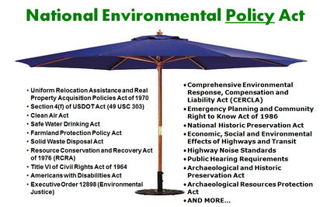
Some examples of regulations that still apply include:
- Clean Water Act,
- Clean Air Act,
- Endangered Species Act,
- Migratory Bird Treaty Act,
- Section 6(f) of the Land and Water Conservation Act,
- Senate Bill 40 that protects riparian areas, and
- Local ordinances such as those that need to be considered for noise generation if construction occurs at night.
In addition, some state regulations, or other parts of federal regulations, take the place of federal nexus-driven regulations when these regulations no longer apply.
- An example of a state regulation that comes into play includes the State Register Act that protects historic/archaeological resources when Section 106 of the National Register of Historic Places no longer applies.
- An example of a federal regulation that changes with loss of federal nexus includes the Endangered Species Act where a more streamlined Section 7 applies to those projects having a federal nexus, whereas the more complicated, expensive, and lengthy process of Section 10 applies when there is no federal nexus – this is the difference of multiple years for Section 10 instead of weeks for Section 7, and for Section 10, the mitigation is required up front.
With all of these regulations still required even for those projects that do not need to incorporate NEPA, CDOT has elected to use a NEPA-like checklist to make sure projects are still in compliance with these regulations.

Question: What are the planning processes that must be followed whether or not a project is federalized?
Answer: From Chapter 3 in CDOT’s NEPA Manual, the following Table 1 explains what the planning requirements are for NEPA projects funded with federal funds or for NEPA-like projects not funded with federal funds.

Table 1: Planning Requirements for Federal and Non-Federal Funded Projects
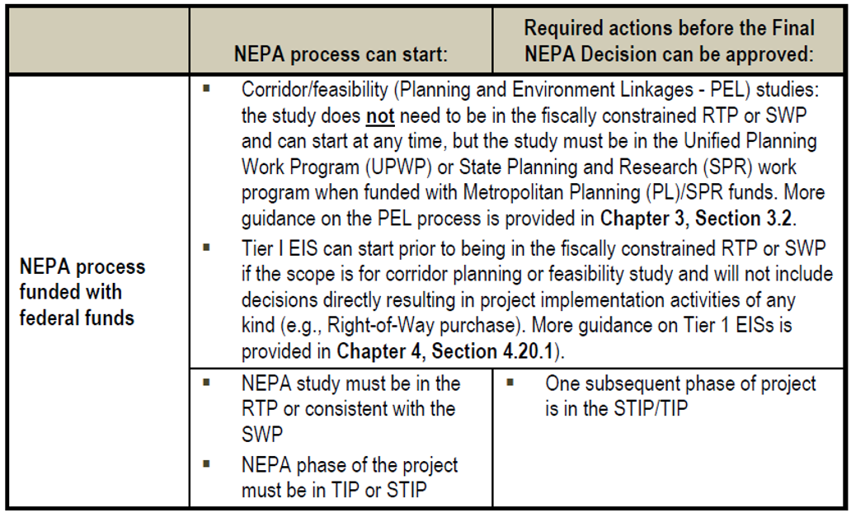
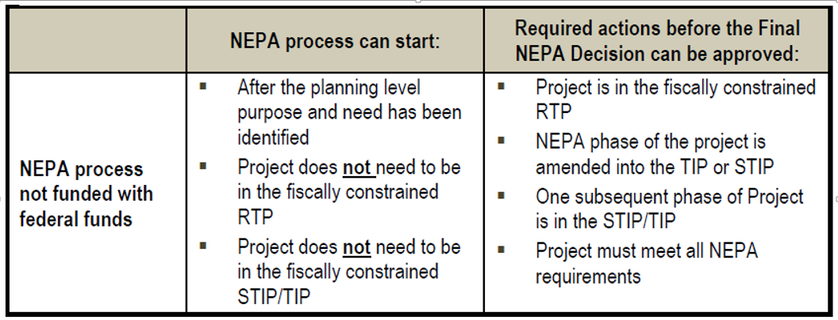

Question: For PWQ Mitigation Pool funded projects, how will environmental resource investigations/clearances be treated differently when using state vs federal funds?
Answer: The following is a list of some commonly asked about resources that could affect a project. Table 2 has a list that is presented side by side, federal nexus vs non-federal nexus. See the first question in this NEPA section “When does the National Environmental Policy Act (NEPA) apply to a Local Agency project?” for more information on what drives a federal nexus.

Table 2: Resource Clearance Application of Federal Nexus Specifically for PWQ Projects
Regular Federal Process | Defederalized Process | Regulatory/Policy Driver
1) Hazardous Materials – Do “Geosearch” Database Search, do a site visit, maybe order a Phase 1 (if purchasing ROW) or even Phase 2 ASTM Standard survey (if haz mat is suspected to be encountered during construction) that would include sampling, maybe estimate clean-up costs if you find something during these surveys. “You touch it, you clean it” applies for mitigation. | 1) Hazardous Materials – Same as for federal process. | The drivers for both processes are the CDOT process outlined in the NEPA Manual as well as state requirements for hazardous materials clean-up (CERCLA/RCRA). Superfund or Comprehensive Environmental Response, Compensation, and Liability Act of 1980 (CERCLA) is a United States federal law designed to clean up sites contaminated with hazardous substances and pollutants. The Resource Conservation and Recovery Act (RCRA) gives EPA the authority to control hazardous waste from the "cradle-to-grave." This includes the generation, transportation, treatment, storage, and disposal of hazardous waste.
2) Wetlands – Conduct a site visit, determine possibility of wetlands in and around project site, survey/delineate wetlands having a potential for impact (include FACWet), prepare wetland delineation report, prepare wetland finding if necessary, prepare mitigation plan if necessary. These would include both jurisdictional and non-jurisdictional wetlands. | 2) Wetlands – Same as for federal process except that the interpretation of protected wetlands is limited to what is considered jurisdictional under the Clean Water Act Section 404 and would not include non-jurisdictional wetlands. | This is required by Section 404 of the Clean Water Act for both processes. In addition, for the federal nexus process, FHWA interprets a wetland as any wetland under EO 11990, not just jurisdictional wetlands.
3) T&E Species – Falls under Section 7 of the Endangered Species Act (ESA). Conduct a database search and a site visit, determine if there is a possibility of impact to T&E species, have a T&E specialist do further surveys if necessary, prepare a Bio Assessment if necessary, enter consultation with USFWS if necessary and get a Bio Opinion. This could take weeks or months to complete. | 3) T&E Species – When not on Federal Land, Section 10 of the ESA applies, rather than Section 7. This requires development of a Habitat Conservation Plan for impacted listed wildlife (and for plants if there is a jeopardy opinion). CDOT still needs to comply with state law though and plants may be added sometime soon. Warning: HCPs are considerably more complicated, expensive, could take years to complete, and will require up-front mitigation. | This is governed by the Federal Endangered Species Act Section 7 for those with federal nexus and Section 10 for those without federal nexus, and the State Endangered Species Act.
4) Vegetation and Wildlife – Conduct data search on sensitive plants/animals, noxious weeds, or wildlife considerations in the area including existing or needed wildlife crossings or other facilities, conduct a site survey of project area, identify resources and mitigations required. Prepare SB 40 certification for riparian impacts. | 4) Vegetation and Wildlife - Same as for federal process. | This is driven by regulations such as State Senate Bill 40 that protects riparian areas, the Federal Migratory Bird Treaty Act, the Bald and Golden Eagle Protection Act, and the Colorado Noxious Weed Act (involves city and county governments to implement programs aimed at noxious weeds).
5) Noise – Determine if the project construction may increase noise levels in areas protected by a local noise ordinance for this action. Night work is typically the focus of these noise ordinances. No permanent mitigation is required since PWQ mitigation facilities do not trigger threshold noise levels during operation for sensitive receptors. | 5) Noise –Follows local noise ordinances. | Local noise ordinances only since permanent water quality features will not generate the kind of noise that would require mitigation to meet FHWA guidance and CDOT policy.
6) Air Quality – Is the project in a maintenance or non-attainment area for PM10? If so, will the project have an impact on the air pollutant of concern during construction? May need to implement dust suppression mitigation during construction. | 6) Air Quality – Same as for federal process. | Clean Air Act for maintenance/non-attainment areas in the state for dust particles (PM10) including the greater Denver area.
7) Paleontological Resources – Conduct database search regarding what is known in the area, conduct a site survey, prepare a report of the findings, consult regarding significance of resource, and request a determination of effect of the action.  Determine if mitigation is necessary and define what that is; conduct mitigation when necessary. | 7) Paleontological Resources-  State Register of Historic Properties Act requires the determination regarding significance of resource, and request a determination of effect of the action.  This means the database and survey work required for federal projects is also required for defederalized projects. | State Register of Historic Properties Act (Sect. 24-80.1-102)
8) Historic Properties - (with federal nexus)  Section 106 (36 CFR 800)  - Conduct OAHP Compass file search of project area  - Identify historic properties via field survey and/or archival sources  - Develop Area of Potential Effects (APE)  - Evaluate effects to historic properties  - Consult with SHPO and consulting parties  - Notify Advisory Council on Historic Preservation (ACHP) if there are adverse effects  - Develop Memorandum of Agreement (MOA) and complete mitigation if necessary. | 8) Historic Properties -  State Register of Historic Properties Act (CRS 24-80.1/8 CCR 1504-5)  - Conduct OAHP Compass file search of project area  - Identify properties eligible to State Register via field survey and/or archival sources  - Develop Area of Proposed Action  - Evaluate effects to State Register properties  - Consult with SHPO and consulting parties  - Complete mitigation if necessary (such as a programmatic statewide historic highway inventory or simply the site forms already done for the identification of resources).  - No notification of ACHP  - No MOA required | National Register of Historic Places, Section 106 (36 CFR 800) for projects with federal nexus.  State Register of Historic Properties Act (CRS 24-80.1/8 CCR 1504-5) for those that do not have a federal nexus.
9) Water Resources – Conduct database search for proximity to state waters, sensitive or impaired waters including special districts, and identify TMDL requirements for an area. Identify qualifying and overlapping MS4 permit requirements. Identify project needs and mitigations including Stormwater Construction Permit needs. | 9) Water Resources - Same as for federal process. | Clean Water Act, Section 401 and 402 (including stormwater construction, dewatering, CDOT and Local Agency Municipal Separate Storm Sewer System (MS4) and other applicable permits given through the state regulation system #61). Water Quality Control Commission Regulations, including but not limited to Cherry Creek Reservoir Control Regulation 72, 303(d)/Total Maximum Daily Loads (TMDL) set on various stream segments that limit further degradation of state waters.
10) Environmental Justice – Determine if EJ population are within the project’s area of influence, determine if the project will have disproportionate negative impacts on these populations, prepare mitigation to offset those impacts. | 10) Environmental Justice – Same as for federal process. | Title VI of the Civil Rights Act of 1964 - Section 601 prohibits discrimination based on race, color, or national origin by any government agency receiving federal assistance. Also, the Equal Protection Clause of the Fourteenth Amendment, defends minority rights.
11) Section 4(f) (Dept. of Transportation Act) – Requires the consideration of park and recreational lands, wildlife and waterfowl refuges, and historic sites in transportation project development. This requirement is only for projects with a federal nexus. | 11) Section 4(f) (Dept. of Transportation Act) – Not applicable because of no federal nexus. | Dept. of Transportation Act - Section 4(f) – Only applies when there is a federal nexus using transportation funds.
12) Section 6(f) (Land and Water Conservation Act) – Applies when a resource purchased with Land and Water Conservation Act funds could be affected by a project. The conversion of lands or facilities acquired using these funds require coordinated with the Department of Interior. Usually replacement in kind is required. | 12) Section 6(f) (Land and Water Conservation Act) – Same as for federal process. | Federal Land and Water Conservation Act - Section 6(f).
13) Visual Resources – When a project is along a Scenic By-Way or All American Highway (see the map developed by CDOT), the impacts to the visual resources are even more pronounced and need to be considered. There are several areas in the state that have these resources in MS4 areas, such as Jefferson County, Ft. Collins, and Durango. | 13) Visual Resources – Same as for federal process. | Eleven of Colorado’s 26 byways are designated by the U.S. Secretary of Transportation as America’s Byways. The Colorado Scenic and Historic Byways Commission and state agencies work in partnership with the U.S. Forest Service, Bureau of Land Management, local byways organizations and public and private resources to serve as a resource in the development of both infrastructure and byway management plans, including interpretation, promotion, and protection of distinctive byway characteristics.
14) PWQ Facility Maintenance Interagency Governmental Agreement (IGA) – Each new facility needs to have an IGA developed when entities other than CDOT are required to maintain the facility. | 14) PWQ Facility Maintenance Interagency Governmental Agreement (IGA) – Same as for federal process. | These IGAs for maintenance are required by CDOT’s MS4 Permit.

What Design/Pre-Construction and Project Setup Requirements Apply to a Local Agency’sPermanent Water Quality Mitigation Pool Funded Project Using State Only Funding?
Question: What SAP inputs are still required?
Answer: SAP inputs will be the same as any other project, except that if the funding information will show state dollars instead of federal. It will look similar to a FASTER Safety project.

Question: What is the Environmental clearance process?
Answer: Please see the NEPA heading Q&As.

Question: What is the Utility clearance process?
Answer: The Utility clearance process will follow the usual process.

Question: What is the Right of Way clearance process? Does the Uniform Act apply?
Answer: The intent of the Uniform Act applies for state-only funded ROW acquisition.
As background, Public Law 91-646, the "Uniform Relocation Assistance and Real Property Acquisition Policies Act of 1970," (Uniform Act) only applies if there are federal funds involved in some phase of the project. However, the Colorado Constitution and Colorado Revised Statutes impose very similar requirements on ROW acquisition. The Colorado Revised Statutes' (CRS) property takings parameters are taken from the Uniform Act and the Code of Federal Regulations (CFR) implementing the Uniform Act; in many passages, they are copied verbatim into the CRS.
Additionally, following the Code of Federal Regulations that implements the Uniform Act is required in most eminent domain power use situations in Colorado (CRS 38-1-121 [2012]), although it is not expected that eminent domain will be required for these PWQ mitigation features.
Every governmental entity has a duty to treat all property owners fairly, and to be responsible with taxpayer funds. CDOT is responsible for the use of FHWA funds for acquisitions and relocations, and CDOT sets the policy on how the funds are used. When a local government has a project that is off-system, using their own funds, CDOT does not get involved, but State and Federal law on takings still apply and must be followed. The Uniform Act, the Code of Federal Regulations and the pertinent State laws aren't to be disregarded based on where a public improvement project is located or what type of money is spent on it. Following the CDOT ROW Manual will keep local entities who are doing their own acquisition and relocation (without benefit of a CDOT-qualified ROW consulting agent) within the Federal and State laws that they are required to follow. It is a good practice to follow the CDOT ROW Manual, but not "required." The CDOT ROW Manual describes some process/cost efficiencies that are available such as filling out a one-page/one-day waiver valuations that can be used instead of a property appraisal for properties worth less than $25,000.

Question: Do the Uniform Guidance requirements apply? Do we need project end dates?
Answer: In general, the Uniform Guidance does not apply, but end dates will be required as part of the SAP input and because of MS4 permit requirements regarding project expenditures that are tied to a timeline. CDOT’s MS4 permit requires that CDOT spend 80% of the Pool on a three year rolling average.

Question: Will the project be required to be listed in the Transportation Improvement Program (TIP)/Statewide Transportation Improvement Program (STIP)?
Answer: The Pool will be in the STIP/TIP and it is CDOT policy to STIP all projects. See the table in the question under NEPA “What are the planning processes that must be followed whether or not a project is federalized?” for more info on TIP/STIP requirements.

Question: Will the Davis-Bacon Act be applicable to a defederalized project?
Answer: No, the Davis-Bacon Act applies to contractors and subcontractors performing on federally funded or assisted contracts in excess of $2,000 for the construction, alteration or repair of public buildings or public works.

What Project Delivery/Construction Requirements Apply to Permanent Water Quality Projects?
Question: If the Local Agency is hiring a consultant, does the Brooks Act still apply?
Answer: The Brooks Act is a federal requirement. Since there are no federal funds in the project, the Act does not apply. However, Kathy Young from the Attorney General’s office says that the “Mini Brooks Act” (C.R.S 24-30-1403) does apply, which basically means you can’t select a professional services contractor on price.

Question: What requirements must be followed for consultant selection?
Answer: Local agencies may use their own procurement policies provided selection meets the requirements of C.R.S. 24-30-1403 which limits selection to qualified firms. Depending on availability, the CDOT Project Manager or Local Agency Coordinator will continue to participate in consultant selection.

Question: Can a Local Agency request fees be a part of the process to select a consultant?
Answer: Fees cannot be used to select the consultant. Once a consultant is selected, the local agency enters into negotiations with the consultant to obtain a fair and reasonable price for the anticipated work.

Question: Does a consultant selection need to be qualifications-based?
Answer: Yes, but the Local Agency can use their own selection process provided it is qualifications-based per C.R.S 24-30-1403.

Question: Can a Local Agency have warranties included in their contract documents?
Answer: Yes.

Question: Will the Local Agency PWQ Project be required to comply with “Buy America” requirements (23 CRF 635.410)?
Answer: No. As confirmed with Kathy Young from the Attorney General’s office, “Buy America” does not apply for state-funded projects, and state statute is for state agencies, not Local Agencies.

Question: What material testing requirements are there during construction?
Answer: Material testing requirements will be developed in collaboration with the Local /agency based on the work involved. Please see question “What CDOT Forms and Documentation are Required?” heading to see what forms are required.

Question: Will a Local Agency “employee in responsible charge” of the project be required?
Answer: Yes, even though this is not a state requirement, CDOT will continue to adhere to this requirement.

Question: Will there be On-the-Job (OJT) Training program/goals for this project?
Answer: These OJT goals are usually not required for state-only funded projects, but it is best to ask the Region civil Rights Manager on a case by case basis since certain circumstances can change this requirement. OJT goals might be required and are set at the design phase when the engineer forwards the estimates and other information to the Region Civil Rights Manager. The goals are set according to type of work, quantity of work, length of project, location of the work, the availability of work, etc.

Question: Will Title VI Assurances be required?
Answer: Yes, all recipients of federal funds, for any purpose, are required to comply with this Act. Title VI, 42 U.S.C. § 2000d et seq., was enacted as part of the landmark Civil Rights Act of 1964. It prohibits discrimination on the basis of race, color, and national origin in programs and activities receiving federal financial assistance.

“CDOT is committed to achieving full compliance with Title VI of the 1964 Civil Rights Act and all related non-discrimination laws. Through its policies, assurances and Procedures, CDOT makes every effort to ensure that no person is excluded from participation in, denied the benefits of, or otherwise subject to discrimination in any CDOT program or activity on the basis of race, color, national origin, sex, disability or age.”

Question: Will the “Keep Jobs in Colorado Act” apply to this project?
Answer: As confirmed by Kathy Young from the Attorney General’s office, the Keep Jobs in Colorado Act (CRS 8-17-101) requires that Colorado labor be employed to perform at least 80% of the work on a public works projects, as defined in CRS 8-19-102(2). Agencies can waive the requirements under certain circumstances.

The web link provided here (https://www.colorado.gov/pacific/cdle/node/24341) has more information on the “Keep Jobs in Colorado Act”.

Some of the relevant definitions of the act are listed in the box below.
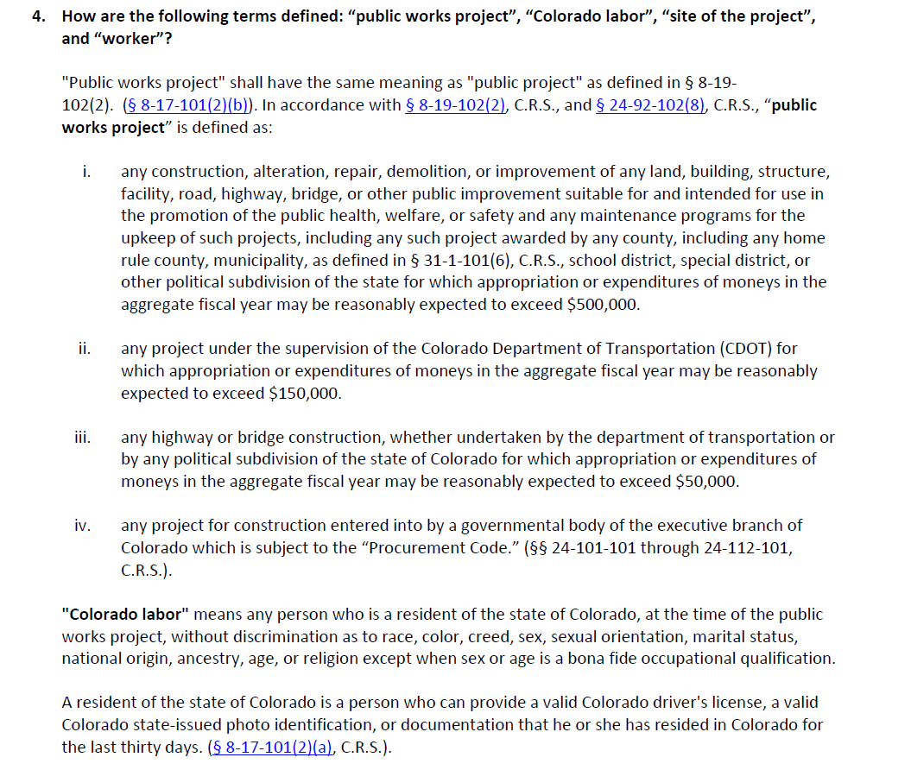

What CDOT Forms and Documentation are Required for a Local Agency Permanent Water Quality Mitigation Pool Funded Project Using State Only Funds?
Question: What CDOT forms is the Local Agency required to complete during the Design Phase of a project?
Answer: The following CDOT forms are required to complete the design phase of a project:
- Form 463 (Design Data),
- Form 859 (Project Control Data Construction),
- Form 128 (Categorical Exclusion Determination – Environmental),
- Form 1180 (Standards Certification and Project PS&E Approval), and
- Form 1243 (Local Agency Contract Administration Checklist).

Question: What clearances are required for the Local Agency Project to be advertised?
Answer: You are required to get the following clearances: Right of Way, Utilities, and Environmental (CDOT Form 128).

Question: Are CDOT Forms 250 and 379 still required?
Answer: The CDOT Form 250 (Materials Document Record), or an acceptable substitute, is required. Most de-federalized projects should not require an Independent Assurance Testing. CDOT Form 379 (Project Independent Assurance Sampling Schedule) is also required.

Question: What documents are required to close a project?
Answer: Other than CDOT’s labor and civil rights forms, the requirements for project closure are the same.

Question: Does the Local Agency need to fill out any other forms
Answer: Typically forms listed as required under this FAQ topic are typically the only forms required, but there may be other forms that apply when specific conditions exist. The CDOT Project Manager will work with the Local Agency to identify any additional forms that may be required.

Question: Will there be a Disadvantaged Business Enterprise (DBE) goal (CDOT Form 863 – UDBE Contract Goal Recommendation) for the project?
Answer: No. None of the CDOT Forms associated with the DBE program will be required for this project including, but not limited to, CDOT Forms:
- 1330 (DBE Bid Conditions Assurance for Non-Project Specific (NPS) Consultant),
- 1331 (Certificate of Proposed DBE Participation for Project Specific),
- 1414 (Anticipated DBE Participation Plan),
- 1415 (Commitment Confirmation),
- 1416 (Good Faith Effort Report),
- 1419 (DBE Participation Report), and
- 1420 (DBE Participation Plan Modification).

Question: At project close, will the Local Agency prepare a consultant evaluation (CDOT Form 313)?
Answer: No. Filling out CDOT Form 313 (Consultant Performance Evaluation Agreements) is a CDOT practice for CDOT consultants and contractors and does not extend to Local Agency contracted companies.

What is the Intergovernmental Agreement (IGA) Process for a Local Agency Permanent-Water-Quality-Mitigation-Pool Funded Project Using State-Only Funds?
Question: Will the documents currently supplied by the Local Agency (Funding Application, Cost Estimate, Statement of Work and Schedule) continue to be required prior to initiation of the region scoping/IGA meetings?
Answer: Yes, the process to initiate an IGA will remain the same. The Local Agency will be required to submit the documents in advance of the meeting. The CDOT Form 463 and Form 1243 will be completed at the initial IGA meeting. CDOT Form 418 (Federal-aid Program Data) will no longer be required to be submitted by CDOT to FHWA, nor will FHWA Form 1273 (Required Contract Provisions Federal-Aid Construction Contracts) be included in the IGA.

What Other Requirements do I Need to Know About for a Project?
Question: Are Findings In the Public Interest (FIPI’s) required? If so when?
Answer: No, but the Local Agency may have to provide a justification for any variances from the standard procedures.

Question: Where might other requirements be listed and what could those include?
Answer: In the IGA, there will be numerous standard requirements listed, which include but are not limited to:
- The Local Agency is adequately staffed and suitably equipped to undertake and satisfactorily complete some or all of the Work, including special accounting and reporting of fund expenditures. An IGA will outline the roles of the Local Agency and the State and what is expected of them specifically for this task.
- The Local Agency shall permit the State, or any other duly authorized agent of the state, to monitor all activities conducted by the Local Agency pursuant to the terms of the contract.
- The Local Agency’s performance shall be subject to Evaluation and Review in accordance with the terms and conditions of this Contract, State law, including CRS §24-103.5-101, and State Fiscal Rules, Policies, and Guidance. Evaluation and Review of Local Agency’s performance shall be part of the normal Contract administration process and the Local Agency’s performance will be systematically recorded in the statewide Contract Management System.
- The Local Agency shall perform its duties hereunder as an independent contractor and not as an employee. Neither the Local Agency nor any agent or employee of the Local Agency shall be deemed to be an agent or employee of the State.
- The Local Agency shall strictly comply with all applicable federal and State laws, rules, and regulations in effect or hereafter established, including, without limitation, laws applicable to discrimination and unfair employment practices.

Question: Where can I research State laws?
Answer: State codes are available on line at each state’s web site: https://www.colorado.gov/ or http://www.lexisnexis.com/hottopics/colorado/

