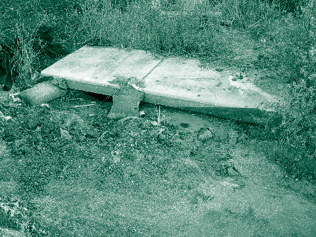
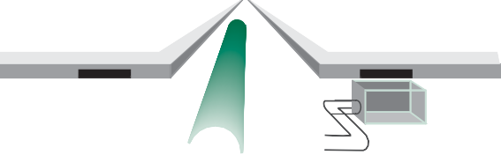

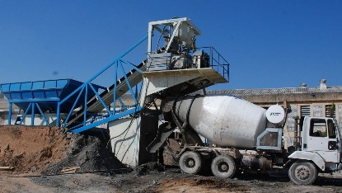

Industrial Stormwater Resources
- Guidance on discharges without a Permit https://www.colorado.gov/pacific/cdphe/clean-water-construction-compliance-assistance-and-guidance
- Utility Accommodation Code
https://www.sos.state.co.us/CCR/GenerateRulePdf.do?ruleVersionId=3222
- Industrial Facilities Control Measures
https://udfcd.org/wp-content/uploads/2014/07/Chapter-5-Source-Control-BMPs.pdf

CDOT Resources
- CDOT Environmental Clearance Information
https://www.codot.gov/programs/environmental/resources/guidance-standards/environmental-clearances-info-summary-august-2017/view
- CDOT Stormwater Programs
https://www.codot.gov/programs/environmental/water-quality/stormwater-programs
- CDOT Erosion Control and Stormwater Quality Field Guide
https://www.codot.gov/programs/environmental/landscape-architecture/erosion-storm-quality
- CDOT Water Quality program and MS4 permit
https://www.codot.gov/programs/environmental/water-quality
- CDOT Water Quality Field Guide
https://www.silverthorne.org/home/showdocument?id=8530

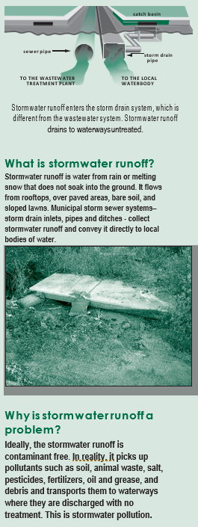

catch basin

sewer pipe storm drain
pipe

CDOT has a MS4 permit (COS-000005) from the Colorado Department of Public Health and the Environment (CDPHE) to discharge stormwater from their storm drain system. The permit states that only stormwater (and a few other allowable discharges like landscape irrigation overflow) can be discharged from CDOT’s storm drain system. Pollutants, such as dirt, fertilizers, pesticides, oil and grease, antifreeze, and other automotive fluids are strictly prohibited from being disposed of in CDOT’s storm drain system. As part of the permit, CDOT has several different programs to prevent pollutants from entering the storm drain system. The programs are:
- Construction sites
- Permanent Water Quality
- Illicit discharges

Industrial facilities

Public education and outreach
- Pollution prevention and good housekeeping

Wet Weather Monitoring

Water Quality Program
Industrial Facilities Program

TO THE WASTEWATER TREATMENT PLANT
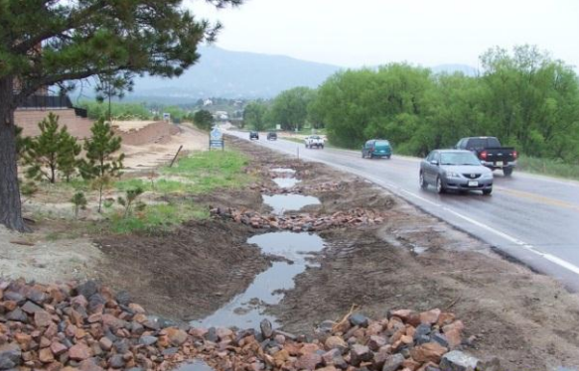
TO THE LOCAL WATERBODY
Stormwater runoff is water from rain or melting snow that does not soak into the ground. It flows from rooftops, over paved areas, bare soil, and sloped lawns. Municipal Separate Storm Sewer Systems (MS4s) – storm drain inlets, pipes and ditches - collect stormwater runoff and convey it directly to local bodies of water.

For more information on CDOT Utility and Special Use Permits:
https://www.codot.gov/business/permits/utilitiesspecialuse

For more information on CDOT Access Permits:
https://www.codot.gov/business/permits/accesspermits

For more information on CDOT’s Water Quality Program Contact:
2829 W Howard Place
Denver, CO 80204
302-512-4053

CDOT’s stormwater program website: www.codot.gov/programs/environmental/water-quality

CDOT Illicit Discharge Hotline: 303-512-4H2O (4426)
Stormwater runoff enters the storm drain system, which is different from the wastewater system. Stormwater runoff drains to waterways untreated.

What is stormwater runoff? Stormwater runoff is water from rain or melting snow that does not soak into the ground. It flows from rooftops, over paved areas, bare soil, and sloped lawns. Municipal storm sewer systems– storm drain inlets, pipes and ditches - collect stormwater runoff and convey it directly to local bodies of water.
Ideally, the stormwater runoff is contaminant free. In reality, it picks up pollutants such as: soil, animal waste, salt, pesticides, fertilizers, oil and grease, and debris and transports them to waterways where they are discharged with no treatment. This is stormwater pollution.

“Storm sewer systems are not set up to treat or process
anything and exist solely to transport rain water to
surrounding rivers, streams, and other bodies of
water.”
Stormwate

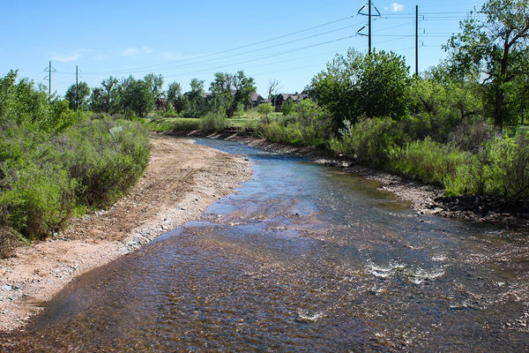

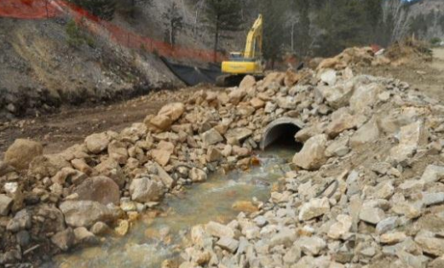

Stormwater Control Measures for Industrial Facility Permittees

Industrial facilities are required to use stormwater control measures (SCMs) during construction of the facility and when operating the facility. Stormwater control measures are schedules of activities, prohibitions of practices, maintenance procedures, and other management practices to prevent or reduce pollution entering CDOT’s storm drain system. SCMs also include treatment, operating procedures, and practices to control site runoff, spillage or leaks, waste disposal, or drainage from material storage. SCMs include structural and nonstructural controls.
- Examples of Stormwater Control Measures

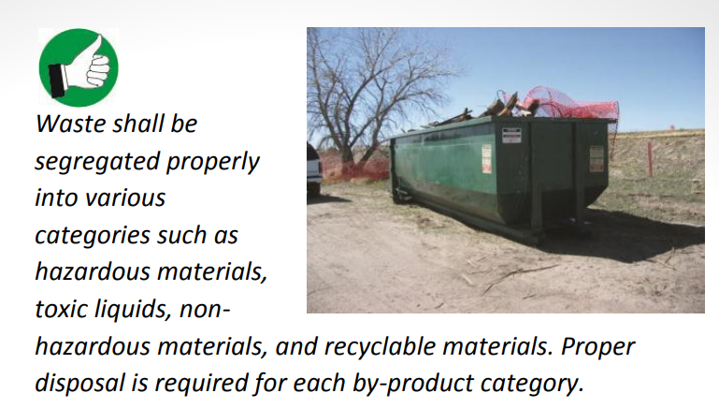
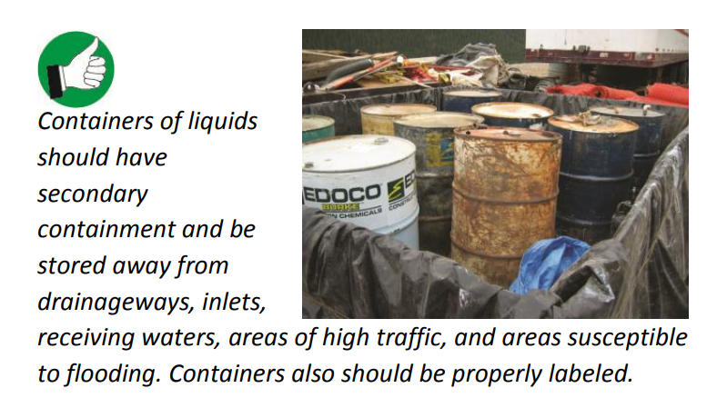
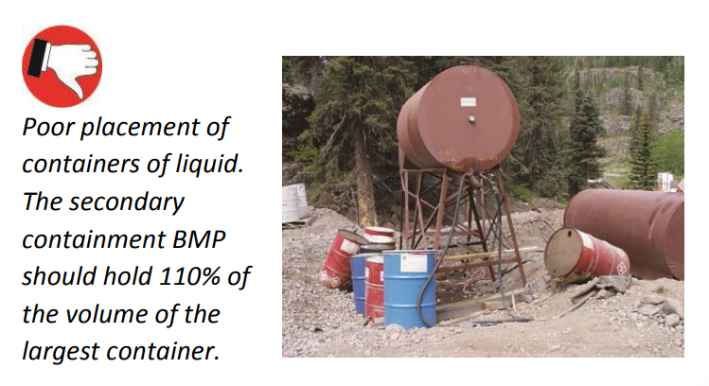

Industrial facilities program
CDOT issues Utility Permits to those utility companies, special use permittees, industry, or others wishing to install, adjust, relocate, remove, or maintain utilities in CDOT’s right-of-way. CDOT issues Access Permits for building access from private property (driveways) to state highways (driveways). These two permits are issued, and inspections are conducted through CDOT’s five regional offices located throughout Colorado. CDOT’s Water Quality Program tracks and maintains a record of any permittee that ties into CDOT’s storm drain system.

CDOT’s Industrial Facilities Program is focused on educating those industrial facilities that discharge stormwater into CDOT’s storm drain system. Under this program, CDOT also educates industrial facilities on the proper management of potential pollutants that could enter the CDOT storm drain system.

Industrial facilities include a site that includes any of the following activities for any of the following categories of industries:
- Activities
  - Manufacturing, processing, raw materials storage
  - Industrial plant yards (e.g., concrete batch plants)
  - Access roads/rail lines used to carry raw materials, manufactured products, waste materials, or byproducts
  - Material handling
  - Refuse site
  - Application or disposal of process waste waters
  - Storage and maintenance of materials handling equipment
    - Residual treatment, storage, or disposal
    - Shipping and receiving areas
    - Manufacturing buildings
    - Storage areas used (including tank farms) for raw materials and immediate and final products
    - Areas where industrial activity has taken place in the past and significant materials remain and are exposed to stormwater.
If any of the listed activities applies to a site, CDOT is required to report the industrial facility to CDPHE on the potential discharges and water quality concerns.

CDOT defines a utility or utility facility as any privately, publicly, or cooperatively owned line, facility, or system producing, transmitting, or distributing the following
- Communications
- Cable television
- Power
- Electricity
- Light
- Heat gas
- Oil
- Crude products
- Water steam
- Waste
- Stormwater not connected with highway drainage
- Other similar commodities as defined in page 10 of the utility code

Allowable discharges into CDOT’s storm drain system include the following:
- Landscape irrigation
- Lawn Watering
- Diverted stream flows
- Irrigation return flow
- Rising ground waters
- Uncontaminated ground water infiltration to separate storm sewers
- Uncontaminated pumped ground water
- Springs
- Flow from riparian habitats and wetlands
- Water line flushing in accordance with the division’s Low Risk Policy Discharge guidance: Potable Water
- Discharges from potable water sources
- Foundation Drains
- Air conditioning condensation
- Water from crawl space pumps
- Footing drains
- Individual residential car washing
- Dechlorinated swimming pools discharges
- Water incidental to street sweeping
- Dye testing in accordance with manufacturing recommendations
- Stormwater runoff
- Emergency firefighting activities
- Authorized discharges by CDPS or NPDES permit
- Agricultural runoff that does not require a CDPS or NPDES permit.

