Colorado Department of Transportation
Division of Transportation Development

Guidelines for Reviewing the National Highway System and Principal Arterial Routes

October 10, 2012

Introduction
Many local agencies reported that they did not have adequate time to properly respond to CDOT’s Division of Transportation Development (DTD) September 11th memorandum to the Statewide Transportation Advisory Committee (STAC) titled Inclusion of Principal Arterials on National Highway System. CDOT would like to perform a more thorough review of the NHS routes with the assistance of the STAC. In consultation with FHWA, CDOT is requesting that the STAC perform this review within six months. Detailed in this document, DTD has developed a review process, evaluation criteria, and a schedule to guide agencies in performing the review.

Background
Section 1104 of MAP-21 eliminates the statutory mileage cap on the NHS and requires its expansion. The expansion included adding principal arterials to the NHS. On September 6, 2012 CDOT was notified by the Colorado Division Office of FHWA to perform a review of existing principal arterial highways to determine whether there was a need to reclassify any of the routes by September 20, 2012. On September 11, 2012 a memorandum was sent to the STAC requesting assistance in the review of routes. Responses were collected by DTD and were forwarded to the Division Office on September 20, 2012. Due to the accelerated time-line for review and response, many STAC members reported that they did not have enough time to perform the review, or consult with their local agencies.
On September 28, 2012, CDOT was notified by the Division Office that the maps for the NHS were available at http://www.fhwa.dot.gov/planning/national_highway_system/nhs_maps/. FHWA requested that CDOT review the maps for modifications. Modifications can range from technical corrections to questions about the NHS designation of selected highways. Upon receipt of a State’s modifications, FHWA will make a determination on whether the issue constitutes a non-substantive technical map correction or an NHS designation issue requiring further coordination.

Review Process and Agency Roles
DTD will develop and provide instruction on the evaluation criteria to the STAC, and forward to the contacts identified in section IV Agency Leads, information about the NHS, principal arterial routes, and any other data required to perform the review. The STAC (MPOs, TPRs), and CDOT Region Offices will then work collaboratively with each other and with their local agencies to evaluate NHS routes and roadways using the criteria detailed in section V Evaluation Criteria. Changes will be sent by MPOs and TPRs to DTD for processing and final review in the formats detailed in section VII File Formats. DTD will forward changes and modifications to FHWA for their review.

Roles
- DTD
  - Develop and instruct on application of evaluation criteria (including presentation to MPO Transportation Advisory Committee’s (TAC) and TPR meetings).
  - Deliver data sets – NHS, principal arterials, and other roadway to agency leads.
  - Collect and process data from MPOs, TPRs, and Region Offices.
  - Deliver final data set to FHWA – reference section VI Schedule.
- CDOT Region Offices
  - Provide 1 Region Lead to work with MPOs, TPRs, local agencies, and DTD.
  - Responsibility for making sure a review of state highway and local roads is completed by working collaboratively with MPOs, TPRs, and local agencies to perform the review.
  - Reconcile issues with the MPO and TPR review results of state highways – reference section VI Schedule.
  - Provide data about changes and modifications to DTD – reference section VI Schedule.
- MPOs and TPRs
  - Provide 1 Agency Lead to work with CDOT and local agencies.
  - Provide two data sets to DTD. 1 for state highways, 1 for local roads – reference section VI Schedule.
  - Organize with DTD attendance at TAC or TPR meetings.
  - Work collaboratively with DTD Region Office Agency Leads and local agencies to perform the review.
  - Provide data about changes and modifications to DTD – reference section VI Schedule.

A schematic illustration of this process is provided in figure 1.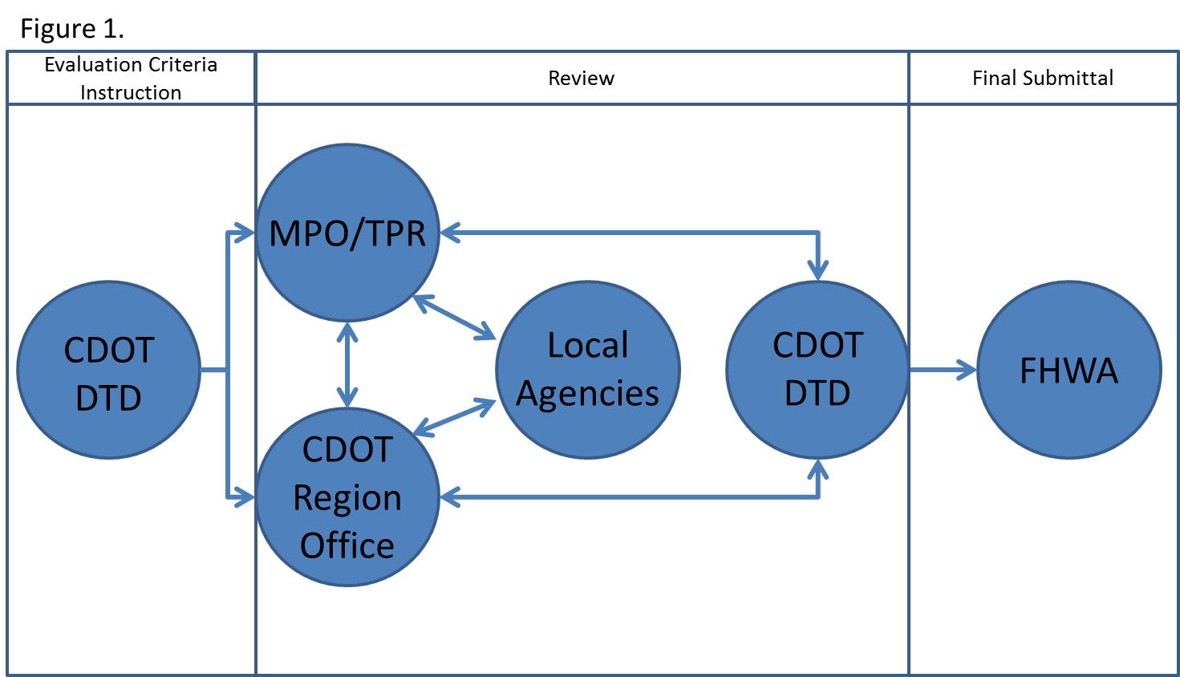

Agency Leads
- CDOT
  - DTD – William Johnson, GIS Data Management Section Manager williama.johnson@state.co.us
  - Region 1 – Chuck Attardo, Regional Planning and Environmental Manager
  - Region 2 – Lisa Streisfeld, Regional Planning and Environmental Manager
  - Region 3 – Michael Vanderhoof, Regional Planning and Environmental Manager
  - Region 4 – Myron Hora, Regional Planning and Environmental Manager
  - Region 5 – Tony Cady, Regional Planning and Environmental Manager
  - Region 6 – Lizzie Kemp, Regional Planning and Environmental Manager
- MPOs
  - DRCOG – Steve Rudy, Director, Transportation Planning and Operations
  - GVMPO – Todd Hollenbeck, Manager, Mesa County Regional Transportation Planning Office
  - NFRMPO – Suzette Mallette, Interim Executive Director
  - PACOG – Pepper Whittlef, Traffic Engineer
  - PPACG – Craig Casper, Transportation Director
- TPRs
  - Central Front Range – Jim Austin, Custer County Commissioner
  - Eastern – Trent Bushner, Yuma County Commissioner, District 1
  - Gunnison Valley – Vince Rogalski, STAC Chair
  - Intermountain – Peter Runyon, Eagle County Commissioner
  - Northwest – Diane Mitsch Bush, Routt County Commissioner
  - San Luis Valley – George Wilkinson, Alamosa County Commissioner
  - Southeast - Dan Tate, Executive Director, Southeast Colorado Enterprise Development, Inc.
  - Southwest - Greg Schulte, STAC Representative
  - South Central – Priscilla Fraser, STAC Representative
  - Upper Front Range – Barbara Kirkmeyer, Weld County Commissioner

Evaluation Criteria
CDOT is proposing two sets of evaluation criteria for determining if a road can be classified as a principal arterial, and whether a road can be designated as an NHS route, detailed below:
- In-line with the original request by FHWA to evaluate the functional classification of roadway, CDOT will use Section II of the FHWA Functional Classification Guidelines (http://www.fhwa.dot.gov/planning/processes/statewide/related/functional_classification/fc02.cfm). Specifically:
- Rural Principal Arterial System
The rural principal arterial system consists of a network of routes with the following service characteristics:
1. Corridor movement with trip length and density suitable for substantial statewide or interstate travel.
2. Movements between all, or virtually all, urban areas with populations over 50,000 and a large majority of those with populations over 25,000. (Note: 2010 census data will be the baseline population data set.)
3. Integrated movement without stub connections except where unusual geographic or traffic flow conditions dictate otherwise (e.g., international boundary connections or connections to coastal cities).

In the more densely populated states, this class of highway includes most (but not all) heavily traveled routes that might warrant multilane improvements in the majority of states; the principal arterial system includes most (if not all) existing rural freeways.

The principal arterial system is stratified into the following three classifications: (1) Interstate highways, (2) other freeways and expressways, and (3) other principal arterials.

- Urban Principal Arterial System
The urban principal arterial system serves the major centers of activity of urbanized areas, the highest traffic volume corridors, and the longest trip desires. This system carries a high proportion of the total urban area travel even though it constitutes a relatively small percentage of the total roadway network. The system should be integrated both internally and between major rural connections.

The urban principal arterial system carries most of the trips entering and leaving the urban area, as well as most of the through movements bypassing the central city. In addition, significant intra-area travel, such as between central business districts and outlying residential areas, between major innercity communities, and between major suburban centers, is served by this class of facility. Frequently, the urban principal arterial system carries important intra-urban as well as intercity bus routes. Finally, in urbanized areas, this system provides continuity for all rural arterials that intercept the urban boundary.

Because of the nature of the travel served by the principal arterial system, almost all fully and partially controlled access facilities are usually part of this functional class. However, this system is not restricted to controlled-access routes. To preserve the identification of controlled-access facilities, the principal arterial system should be stratified as follows: (1) interstate, (2) other freeways, and (3) other principal arterials (with partial or no control of access).

The spacing of urban principal arterials is closely related to the trip-end density characteristics of particular portions of the urban areas. Although no firm spacing rule applies in all or even in most circumstances, the spacing between principal arterials (in larger urban areas) may vary from less than 1.6 km [1 mi] in the highly developed central business areas to 8 km [5 mi] or more in the sparsely developed urban fringes.

- The second set of evaluate criteria is from Section 139 (a) and (b), of title 23, U.S.C. Specifically;
  - The proposed route should be of sufficient length to serve long-distance Interstate travel, such as connecting routes between principal metropolitan cities or industrial centers important to national defense and economic development.
  - The proposed route should not duplicate other Interstate routes. It should serve Interstate traffic movement not provided by another Interstate route.
  - The proposed route should directly serve major highway traffic generators. The term "major highway traffic generator" means either an urbanized area with a population over 100,000 or a similar major concentrated land use activity that produces and attracts long-distance Interstate and statewide travel of persons and goods. Typical examples of similar major concentrated land use activities would include a principal industrial complex, government center, military installation, or transportation terminal.
  - The proposed route should connect to the Interstate System at each end, with the exception of Interstate routes that connect with continental routes at an international border, or terminate in a "major highway traffic generator" that is not served by another Interstate route. In the latter case, the terminus of the Interstate route should connect to routes of the National Highway System that will adequately handle the traffic. The proposed route also must be functionally classified as a principal arterial and be a part of the National Highway System.
  - The proposed route must meet all the current geometric and safety standards criteria as set forth in 23 CFR part 625 for highways on the Interstate System, or a formal agreement to construct the route to such standards within 12 years must be executed between the State(s) and the Federal Highway Administration. Any proposed exceptions to the standards shall be approved at the time of designation.
  - A route being proposed for designation under 23 U.S.C. 139(b) must have an approved final environmental document (including, if required, a 49 U.S.C. 303(c) [Section 4(f)] approval) covering the route and project action must be ready to proceed with design at the time of designation. Routes constructed to Interstate standards are not necessarily logical additions to the Interstate System unless they clearly meet all of the above criteria.

Schedule
- October 2012 – CDOT DTD will perform outreach and guidance with MPOs, TPRs and CDOT Region Offices.
- October – November 2012 – CDOT Region Offices perform review of NHS routes
- October 2012 – January 15, 2013 – MPOs and TPRs perform review of NHS routes
- December 3, 2012 – MPOs and TPRs submit state highway review results to DTD and CDOT Region Office Leads.
- January 15, 2013 – MPO and TPR submit local road review results to CDOT DTD
- January 15 – March 15, 2013 – Final review and reconciliation by CDOT DTD
- March 29, 2013 – CDOT DTD submits NHS route modifications to FHWA

File Format
Please deliver data and information about changes and modifications to the NHS and principal arterials in the following formats:

- GIS
  - Shape file that includes the following attributes: Route (roadway name), Segment Length, From, To
- Non-GIS
  - Please use the attached spreadsheet

