April 15, 2022

― PROJECT UPDATE ―
Highway surface treatment on CO 64 and US 40 is back to work
Crews are back to work in Rio Blanco and Moffat Counties

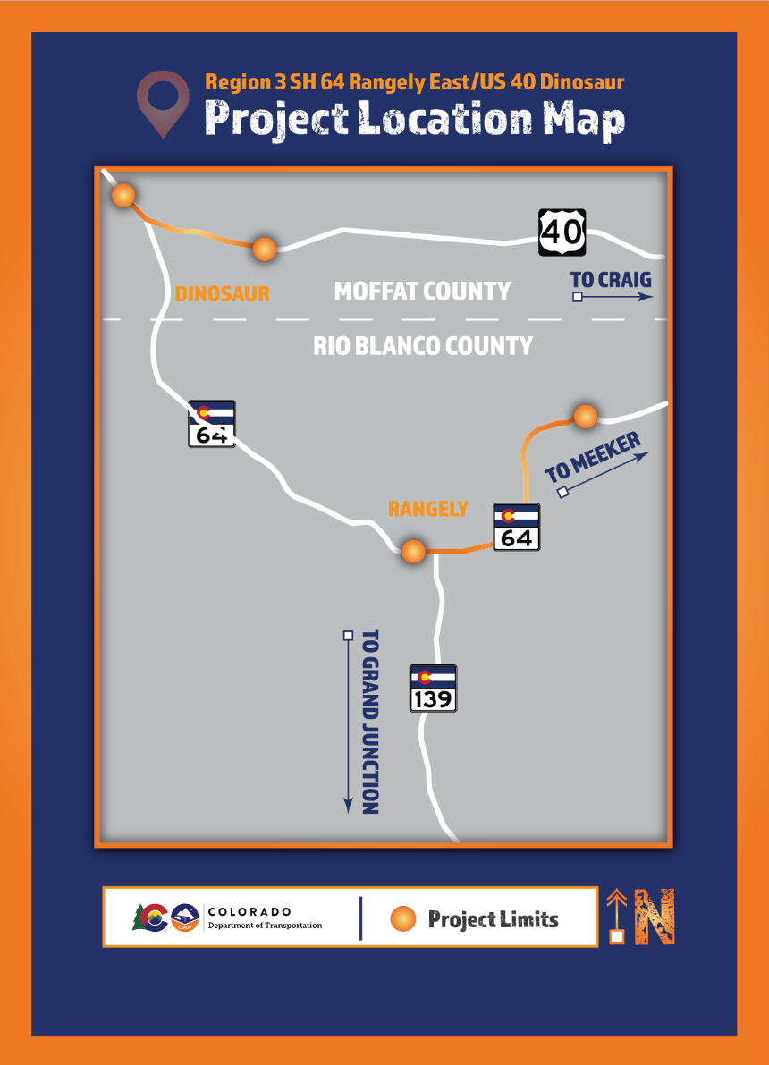
MOFFAT AND RIO BLANCO COUNTIES — The Colorado Department of Transportation is starting back to work after the planned winter shutdown for the Highway surface treatment and upgrade project on CO 64 and US 40. During the 2021 construction season, crews worked on overlay on both roadways, pavement markings, and bringing guardrails up to new standards.
Beginning the week of Monday, April 25, 2022, motorists can expect increased oversize/overweight truck traffic on these routes:
- US-40 between Craig and Dinosaur
- Deserado Mine Road
- CO-64 between Rangely and Meeker
There will also be asphalt milling in and around the Town of Dinosaur. Watch for trucks, heavy equipment, and construction workers entering the roadway along Brontosaurus Boulevard.

Motorists should be especially cautious on CO 64 between mileposts 28 and 30, where trucks will be making wide turns onto the highway. Please drive at or below the posted speed limit. Pay close attention to "Trucks Turning Today" flashing message boards, which are updated daily.

Travel Impacts
Daytime work hours range from 7 a.m. to 7 p.m. Monday through Friday. Motorists should expect some travel impacts throughout the construction of this project and be aware of lane closures, alternating single lanes, flaggers and width restrictions of 10 feet on CO 64 and 12 feet on US 40 will be in place 24 hours a day. The speed limit will be reduced to 45 mph through the work zone. The project is expected to last until the end of June, 2022.

Project Contact Information
For additional information about this project, contact the project team.
- Project website: https://www.codot.gov/projects/co64-us40-resurfacing-rioblanco-moffat
- Project/study/other information hotline: 970-601-1118
- Project/study/other email: surfacetreatmentr3@gmail.com

# # #

