CO 83 Roundabout at CountyLine/Palmer Divide Rd. -Preliminary Design

About the Project
Preliminary design has been completed. The project is on hold until additional funding is identified and future improvements are determined for this intersection.
The southeastern region of the Colorado Department of Transportation (CDOT) (Region 2) has identified a need to evaluate traffic operations and design of a roundabout at the intersection of CO 83 and County Line/Palmer Divide Avenue located at the boundary of Douglas County and El Paso County. See the Project Map below for the specific location. A project team consisting of representatives from CDOT Regions 1 (serves Douglas County) and 2, Douglas and El Paso Counties, FHWA, and a consultant design team was formed to advance the design of a roundabout at this intersection and better understand the functional characteristics, associated impacts and costs for future implementation. Characteristics of a properly designed roundabout include elements that provide optimal safety and operations specifically for high speed conditions approaching the roundabout. Design elements may include geometric approaches to slow traffic, advanced signing, pavement markings and raised channelization. With proper design, drivers adjust their speed to navigate the roundabout safely.
For more information, see the FHWA brochure on Roundabouts and Rural Highways.
- A temporary traffic signal was installed to address increased traffic demand at the CO 83 and Palmer Divide Avenue intersection during construction of the I-25 South Gap Monument to CastleRock project, with the intention of replacing the signal with a roundabout. A traffic signal is not currently warranted at CO 83 and Palmer Divide Avenue and is not anticipated to meet warrants in the coming years. Traffic signal warrants establish minimum criteria for evaluating the need for a traffic signal at a specific intersection. Implementing a signal at unwarranted locations is shown to have negative impacts on traffic flow, including increased crashes, delay, and traffic violations. With that in mind, CDOT Region 2 evaluated and selected a roundabout to address traffic operational and safety concerns, including conflicts created by high-speed conditions, now and into the future. Roundabouts are a safer type of intersection as they reduce fatal and injury crashes by 78% (FHWA). They are also efficient in terms of keeping people moving. Even while calming traffic, they can reduce delay and queuing when compared to other intersection alternatives. For more information about roundabouts, there are video and case study links provided on this project website page.
- The project team has completed the necessary data collection and traffic operational analysis that confirmed a roundabout will operate acceptably at CO 83 and Palmer Divide Avenue based on current and future projected traffic volumes through 2045. Based on the lane recommendations from the traffic analysis, the project team developed a preliminary design of the roundabout to better understand the impacts and construction cost. See the Project Schedule below for more information on upcoming activities and timelines. CDOT and the local agencies are currently reviewing options to obtain project funding for final design and future implementation. The project does not currently have full construction funding.

Project Map
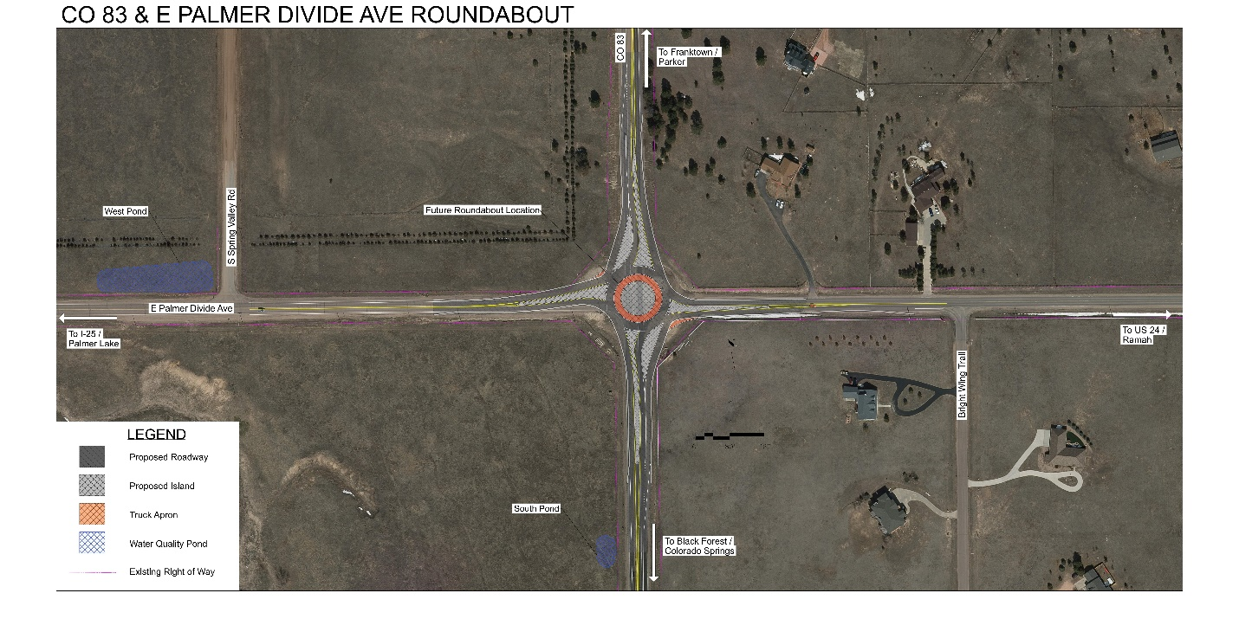
(Click image to enlarge)

Project Schedule
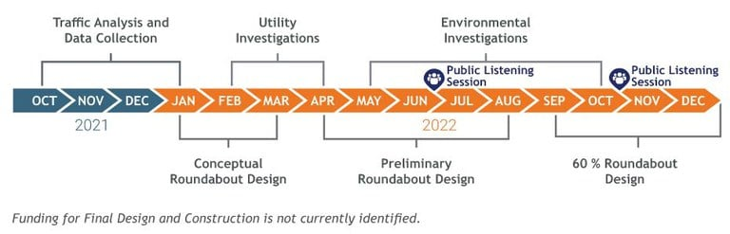
(Click image to enlarge)

Want to be included in future updates?

If you want to be notified of future updates, please email us your contact information.
CDOT is committed to producing the best roundabout design possible to allow this intersection to operate safely and effectively into the future.

