Website Outline for Edwards Spur Road
codot.gov/projects/edwards-spur-road

Front Page:

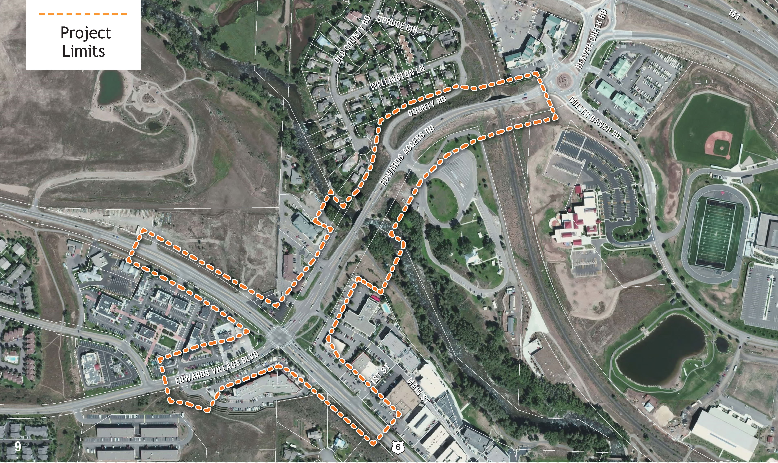
https://www.dropbox.com/s/zoljvqxypxgduwr/Project%20Limits.jpg?dl=0

Contact Us

Project Hotline:
970-446-1001

Press 1 for English.
Press 2 for Spanish.
You may leave a message for a project representative at the end of the recording. Please leave your name, number, and a brief message.
Public Relations Team:
Sam Stavish
sam@cig-pr.com

Interstate 70 (I-70) serves as the primary transportation corridor through Eagle County and much of Colorado. US Highway 6 (US 6) near Edwards, CO is a major collector that runs parallel to I-70 from Dotsero to Dowd Canyon. The I-70 Edwards Spur road located at the Edwards Interchange along I-70 is approximately 0.6 miles long and runs north and south connecting I-70 to US 6 in the unincorporated town of Edwards, CO. The Colorado Department of Transportation in cooperation with Eagle County has determined that the Edwards Spur Road requires improvements.
Phase 1 of the project, constructed in 2011 under the name I-70 Edwards Interchange Phase 1, consisted of improvements on the northern half of the Spur Road including four new roundabouts and improved connections with the I-70 on- and off-ramps. Phase 2 of the project will include design of improvements for the southern half of the Edwards Spur Road starting north of the roadway bridge over the UPRR (where Phase 1 terminated) and ending with the connection to US 6 to the south, a distance of approximately 0.4 miles. The project will include road and bridge widening, intersection improvements and pedestrian mobility improvements.

Project Updates
OPEN HOUSE MEETING
Thursday, Jan. 17, 2019
Open house between 5 and 7 p.m. Short presentation at 5:30 p.m.

Battle Mountain High School Auditorium
0151 Miller Ranch Rd.
Edwards, CO 81632

Representatives with Eagle County and the Colorado Department of Transportation will be on hand to discuss upcoming construction and answer any questions. Stop by anytime during this open house to learn more about this project and how to receive construction updates. Short presentation at 5:30 p.m.

Contractor: Kraemer North America LLC
To see more project background information, please visit the Eagle County Website: https://www.eaglecounty.us/Engineering/Projects/Edwards_Interchange_Project/

