Car plunges into Clear Creek in JeffCo
By Kieran Nicholson
The Denver Post
Posted: 06/21/2010 09:28:27 AM MDT
Updated: 06/22/2010 02:01:32 AM MDT

http://www.denverpost.com/search/ci_15343098

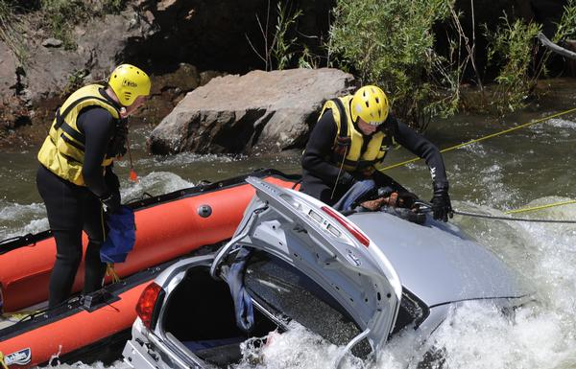
A car ran off of U.S. 6 in Jefferson County last night, going into Clear Creek, just west of tunnel No. 1. The car remained overnight and was removed this morning. (THE DENVER POST | JOHN PRIETO)
A car ran off of U.S. Highway 6 in Jefferson County last night, crashing into Clear Creek.
The accident happened at about 10:30 p.m. just west of Tunnel No. 1 in Clear Creek Canyon, said Karlyn Tilley, a Golden Fire Department spokeswoman.
It took rescue personnel about two hours to free the driver from the wreckage.
He was not seriously injured but was taken by ambulance to a local hospital as a precautionary measure, Tilley said.
The car remained in the creek overnight, but workers pulled it from the water this morning.
The accident is being investigated by the Colorado State Patrol.
Kieran Nicholson: 303-954-1822 or knicholson@denverpost.com.

