UNIVERSAL COMMENT:
Can you add PDF links to the images so that for each image file you click on, the PDF version pops up in a separate browser window?
ABOUT THE PROJECT
Fix typo and link in Overview paragraph
The project is designed to integrate with the other active multimodal projects on the corridor to ensure community members can safely and reliably travel throughout the corridor using their mode(s) of choice.
Remove this Benefits for Commuters text from the top of the page (you added this content in the accordion section)
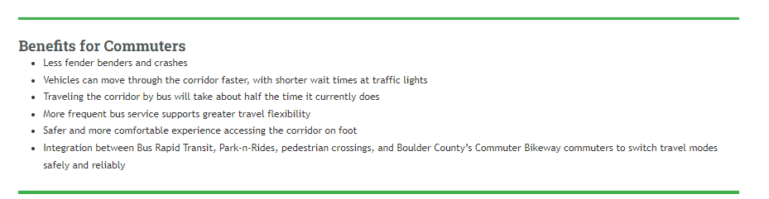
Link the text in red to the Proposed Bus Rapid Transit Stops document currently in the Document Library
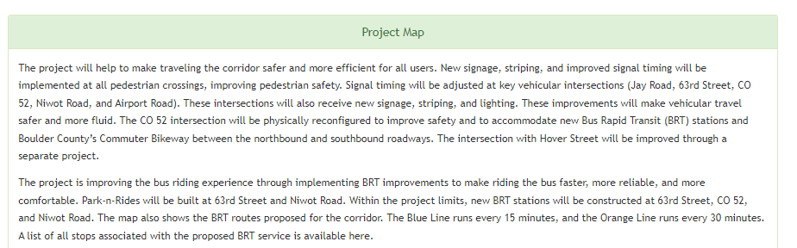

The 6th bullet beneath the Benefits accordion got messed up. The 6th and 7th bullet are the same thing. Correct text pasted below. Is the issue that it’s too much text for one line?
Integration between Bus Rapid Transit, Park-n-Rides, pedestrian crossings, and Boulder County’s Commuter Bikeway enables commuters to switch travel modes safely and reliably
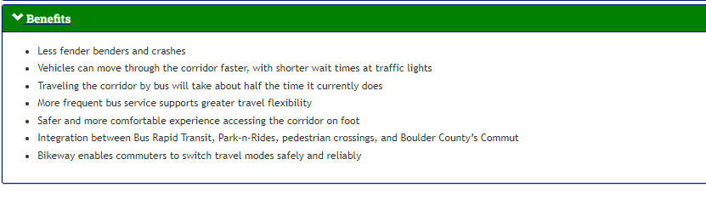
I like how you originally had the site where the project schedule was a text box at the top right of the homepage. Can you bring that back? I think the schedule gets lost as a blue box beneath the map.
When I click on the signup for project updates and the submit a question/comment boxes, nothing happens. Do I need to make these live through Dialog?
BUS RAPID TRANSIT
Change the text:
Queue bypass lanes are short, dedicated bus only lanes that will be implemented at key signalized intersections on the corridor (Jay Road, 63rd Street, Niwot Road, and Airport Road). When a bus approaches one of these intersections, it will pull into its dedicated bus only lane.
Our diagram is way too small. That is far more important than the video. Can you make our diagram a lot larger? Also, are you able to put a caption beneath it like “Click here to see the full size version” and then you can link to a PDF?
MOBILITY THROUGHOUT THE CORRIDOR
Update text
City of Longmont CO 119 and Hover Street
I think I provided you a fairly high quality image file for this map. Is there anything we can do to make it less grainy?

Remove the link on the text “CO 119 leadership structure” – I think that’s a link to nowhere.

Remove this text below:

Bold the T below
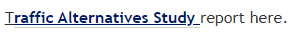

DOCUMENT LIBRARY
Add the link to the Traffic Alternatives Study on this page (you linked to the document on the previous page)

