Website Updates - https://www.codot.gov/projects/co119-mobility-design/overview
Tab 1: Project Overview TAB
By the year 2040, the Diagonal Highway between Boulder and Longmont is expected to see a 25% increase in vehicular traffic. Increased traffic can result in more congestion, delay, tailpipe emissions, and potentially more crashes. The Colorado Department of Transportation (CDOT) and the Regional Transportation District (RTD) are taking action to mitigate these outcomes and expand transportation options beyond private automobiles.
The CO 119 Safety and Mobility Project, a joint project between CDOT and RTD, is designing improvements to make traveling through the corridor safer for all modes and transit travel faster and more reliable. The project is designed to integrate with other active multimodal projects on the corridor to ensure community members can safely and reliably travel throughout the corridor using their mode(s) of choice. Funding has been secured for implementation of the CO 119 Safety and Mobility Project, which is expected to go to bid for construction in fall 2023.

Project Improvements
- New signage, striping, and improved signal timing at all pedestrian crossings.
- Signal timing adjustments at key intersections (Jay Road, 63rd Street, CO 52, Niwot Road, and Airport Road).
- Physically reconfiguring the CO 52 intersection to improve safety and to accommodate new Bus Rapid Transit (BRT) stations and Boulder County’s Commuter Bikeway between the northbound and southbound roadways.
- Changing access at Airport Road and CO 119 to reduce crashes and to improve safety and traffic flow.
- Hover Street intersection will be improved through a separate project.

Tab 2: Bus Rapid Transit
Replace the video on this page with this one

Tab 3: Mobility in the Corridor
Move the video from the middle of the page to the top of the page like below:
Mobility in the Corridor
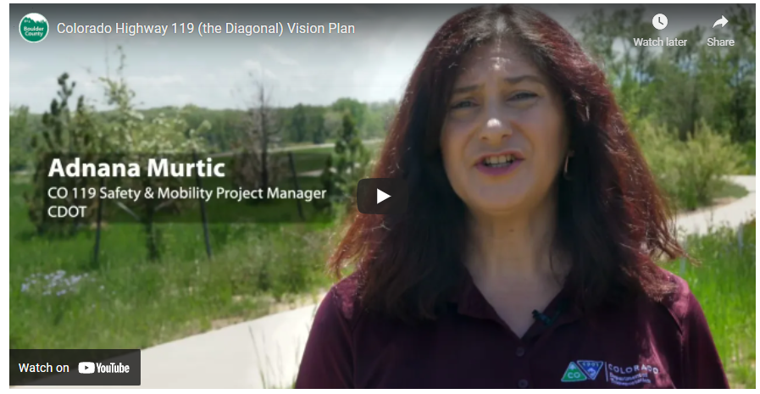
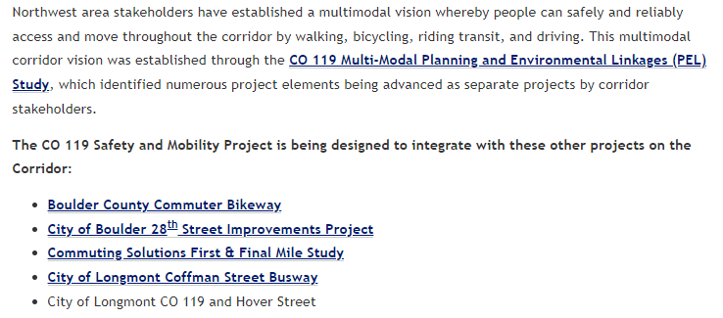

Tab 5: Provide Input

CO 119 Diagonal Highway Transportation Projects Virtual Community Meeting
June 27, 2022
5:30 – 7:00 PM
Register Here
Click here to learn more!

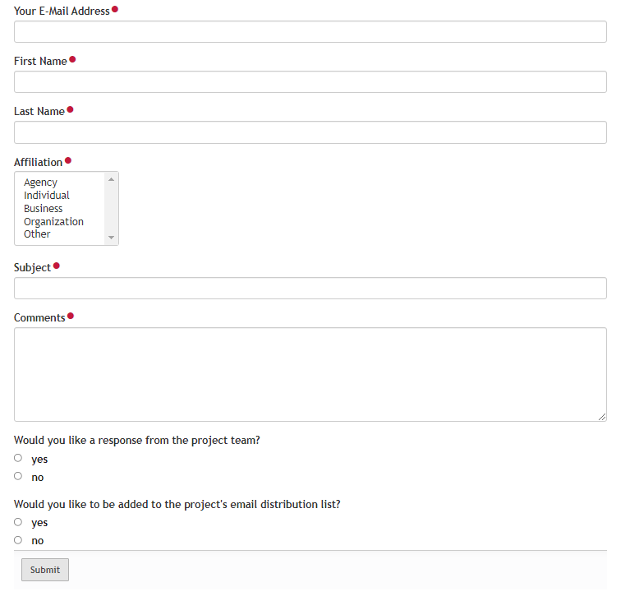
Boulder County, CDOT, and RTD have established a Community Advisory Committee for the Colorado Highway 119 corridor between Boulder and Longmont. Composed of ten community members who live and/or work near the corridor, the committee serves as a focus group for the development of Boulder’s Commuter Bikeway and CDOT’s and RTD’s CO 119 Safety and Mobility Project. The committee anticipates meeting eight times between fall 2021 and spring 2023, and ensures the projects are shaped by diverse voices from a variety of community member perspectives, including people of color, people with mobility challenges, people of all ages and abilities, people who rely upon transit, the strong and confident bike commuter, and people interested in bicycling but who are uncomfortable bicycling on roads.

Tab 6: June Community Meeting
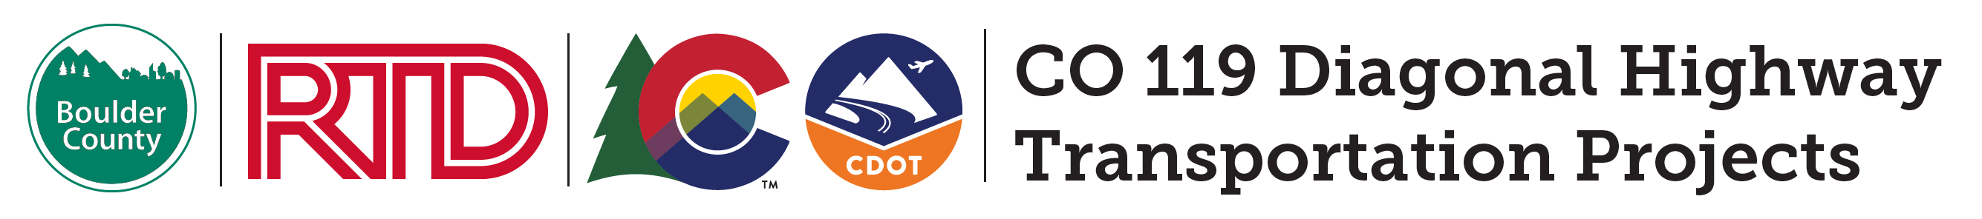
CO 119 Diagonal Highway Transportation Projects
Virtual Community Meeting
June 27, 2022
5:30 – 7:00 PM
Register Here
Boulder County, Colorado Department of Transportation, and the Regional Transportation District are jointly hosting a community meeting to share the preliminary design plans for the CO 119 Safety and Mobility Project and CO 119 Bikeway Design Project. Design elements include bus queue bypass lanes, Bus Rapid Transit (BRT) stations, Park-n-Rides, a commuter bikeway, improved pedestrian crossings, and intersection improvements, including physically reconfiguring CO 52 and changing access at Airport Road and CO 119. During the meeting, the project team will present the design plans and show how the two projects work together to improve safety and enhance multimodal connectivity on the corridor.

What to expect? This Zoom meeting will be held in English with simultaneous Spanish interpretation. Attendees will have opportunities to submit questions and comments in the meeting chat box. Attendees can also submit comments afterwards through the online comment form.

Need Assistance? Please contact aphillips@bouldercounty.org or call 303-524-8467.

Unable to attend the meeting? The meeting recording and presentation materials will be posted on this site for the community to review. The comment form on this sill will be open through July 11. Afterward, the project teams will review the comments and questions and provide responses in a Questions & Answers document. We will post the Q&A document to this website and email it to meeting attendees and commenters.
Want to make sure you’re in the know? Subscribe to the 119 Bikeway Design Project and Safety and Mobility Project mailing lists to receive project updates.

About the Projects:
Boulder County, CDOT, and RTD are closely coordinating the dual transportation projects on the Diagonal Highway to improve mobility for Boulder, Longmont, and adjacent communities. User-friendly connections between the commuter bikeway, improved pedestrian crossings, bus queue bypass lanes, BRT stations, and Park-n-Rides will provide a variety of new transportation options in the CO 119 corridor that enhance safety, accessibility, and equity, while reducing climate change and air quality impacts.

Watch this video to learn about the improvements proposed for the Diagonal Highway.

EMBED THIS VIDEO: https://www.youtube.com/watch?v=e8tYHDvqfrY

Project Map
The projects’ southern boundary is Foothills Parkway in Boulder. The northern boundary is Hover Street in Longmont. The planned BRT service extends beyond the corridor from downtown Boulder to Colorado Highway 66 north of Longmont.
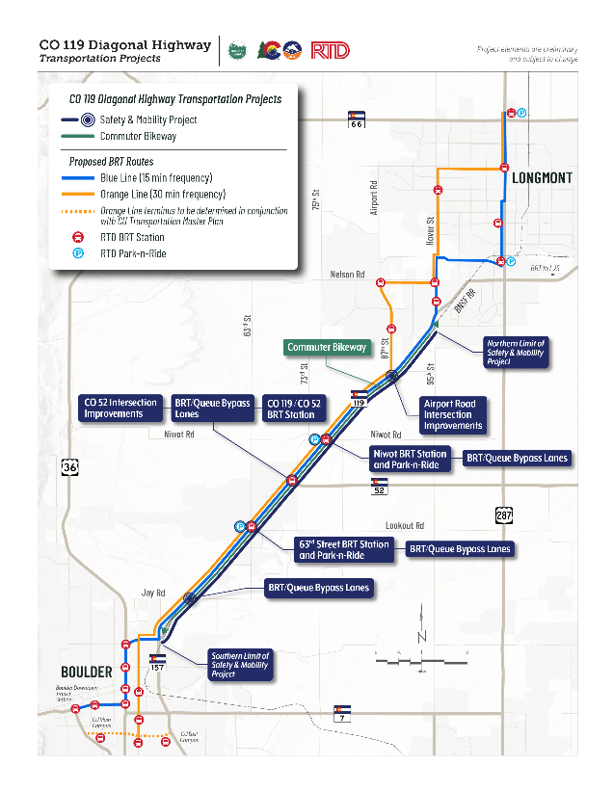
The CO 119 Bikeway and CO 119 Safety and Mobility projects are the result of the 2014 Northwest Area Mobility Study (NAMS) and the 2019 Multi-Modal Planning and Environmental Linkages Study (PEL).

Comment Form
This comment form will be available through July 11. Following the community meeting, the project teams will review the comments and questions received through this web form. We will develop responses in a Questions & Answers document and post it to this community meeting website and the individual project websites. We will also email the document to meeting attendees and people who submitted questions.
Name
Email
Comment Subject [with drop-down options]
[ ] Roadway
[ ] Bus Rapid Transit and/or Park-n-Rides
[ ] Commuter Bikeway
[ ] Other
Comment/Question

Sign up for Project Email Lists
[ ] CO 119 Safety and Mobility Project
[ ] CO 119 Commuter Bikeway

