CO 119 Safety & Mobility Improvement Project - Design Phase

Project Overview
By the year 2040, the Diagonal Highway between Boulder and Longmont is expected to see a 25% increase in vehicular traffic. Increased traffic can result in more congestion, delay, tailpipe emissions, and potentially more crashes. The Colorado Department of Transportation (CDOT) and the Regional Transportation District (RTD) are taking action to mitigate these outcomes and expand transportation options beyond private automobiles.
The CO 119 Safety and Mobility Improvements Project, a joint project between CDOT and RTD, is designing improvements to make traveling through the corridor safer for all modes and transit travel faster and more reliable. The project is designed to integrate with other active multimodal projects on the corridor to ensure community members can safely and reliably travel throughout the corridor using their mode(s) of choice. Funding has been secured for implementation of the CO 119 Safety and Mobility Improvements Project, which is expected to go to bid for construction in fall 2023.

Mobility in the Corridor

The CO 119 Safety and Mobility Improvements Project is being designed to integrate with these other projects on the Corridor:
​Community Advisory Committee
.
Boulder County, CDOT, and RTD have established a Community Advisory Committee for the Colorado Highway 119 corridor between Boulder and Longmont. Composed of ten community members who live and/or work near the corridor, the committee serves as a focus group for the development of Boulder’s Commuter Bikeway and CDOT’s and RTD’s CO 119 Safety and Mobility Improvements Project. The committee anticipates meeting eight times between fall 2021 and spring 2023, and ensures the projects are shaped by diverse voices from a variety of community member perspectives, including people of color, people with mobility challenges, people of all ages and abilities, people who rely upon transit, the strong and confident bike commuter, and people interested in bicycling but who are uncomfortable bicycling on roads.

Early Planning Studies
In reviewing the PEL Study, the Federal Highway Administration and Federal Transit Administration determined that a detailed traffic analysis is necessary before design could begin on the safety and highway capacity management improvements associated with the CO 119 Safety and Mobility Improvements Project. To meet this requirement, the Colorado Transportation Investment Office (CTIO) (previously HPTE) commissioned the Traffic Alternatives Study.
Traffic Alternatives Study
Recommendation:
Intersection Improvements and Queue Bypass Lanes are recommended to be advanced for design and implementation through the CO 119 Safety and Mobility Improvements Project.
Read the full Traffic Alternatives Study report here.
Stakeholder Collaboration:
Throughout the Traffic Alternatives Study, CTIO engaged all planning partners in the corridor including Boulder County, City of Boulder, City of Longmont, Commuting Solutions, Federal Highway Administration, RTD, and CDOT. Each of the corridor planning partners provided input and helped to guide the study process. The study’s findings were reviewed and discussed by the CO 119 leadership structure. This collaborative process led to the concurrence of the recommendations by all planning partner stakeholders. This level of collaboration provides a solid foundation for the CO 119 Safety and Mobility Improvements Project to move forward to design.

Provide Input
CO 119 Diagonal Highway Transportation Projects Virtual Community Meeting
June 27, 2022
CDOT, RTD, and Boulder County held a virtual community meeting to show preliminary design plans for the CO 119 Safety and Mobility Improvements Project and CO 119 Bikeway Design Project.
Watch the meeting recording.
https://youtu.be/odwfMRJHvkg
Meeting Presentation
--------------------------------------------------------------------------------------------------------
CDOT and RTD invite you to sign-up to receive project emails that will provide information on project developments and public engagement opportunities. You are also welcome to submit a comment or question and a member of the project team will follow up with you.
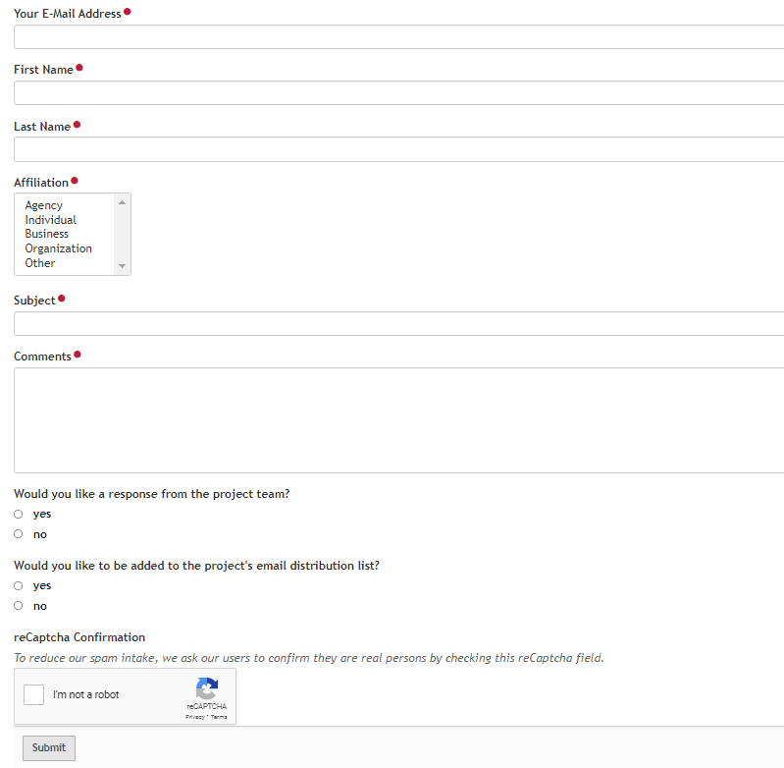

Preliminary Design Community Meeting

CO 119 Diagonal Highway Transportation Projects Virtual Community Meeting
June 27, 2022

Boulder County, CDOT and RTD held a virtual community meeting to share preliminary design plans for the CO 119 Safety and Mobility Improvements Project and CO 119 Bikeway Design Project.
Watch the meeting recording.
https://youtu.be/odwfMRJHvkg
Meeting Presentation
Bikeway Alignment
Download this KMZ file and view it in Google Earth to see the current proposed alignment for the CO commuter bikeway. You must have Google Earth to view the file.
Provide Input.
Community members are encouraged to ask questions and provide feedback on the preliminary design plans shared through the community meeting.
The Preliminary Design Comment Form will be open through July 18. Afterward, the members of the Project Team will review the comments and questions and develop a Questions & Answers document. We will post the Q&A document to this website and email it to meeting attendees and commenters.
Want to make sure you’re in the know? Subscribe to the CO 119 Bikeway Design Project and CO 119 Safety and Mobility Improvements Project mailing lists to receive project updates.

About the Projects:
Boulder County, CDOT and RTD are closely coordinating the dual transportation projects on the Diagonal Highway to improve mobility for Boulder, Longmont and adjacent communities. User-friendly connections between the commuter bikeway, improved pedestrian crossings, bus queue bypass lanes, BRT stations and Park-n-Rides will provide a variety of new transportation options in the CO 119 corridor that enhance safety, accessibility and equity, while reducing climate change and air quality impacts. The projects are the result of the 2014 Northwest Area Mobility Study (NAMS) and the 2019 Multi-Modal Planning and Environmental Linkages Study (PEL).

Preliminary Design Comment Form
Top of Form
This comment form will be available through July 18 Afterward, the members of the Project Team will review the comments and questions and develop a Questions & Answers document. We will post the Q&A document to this website and email it to meeting attendees and commenters.

Bottom of Form

