NEWS FROM:
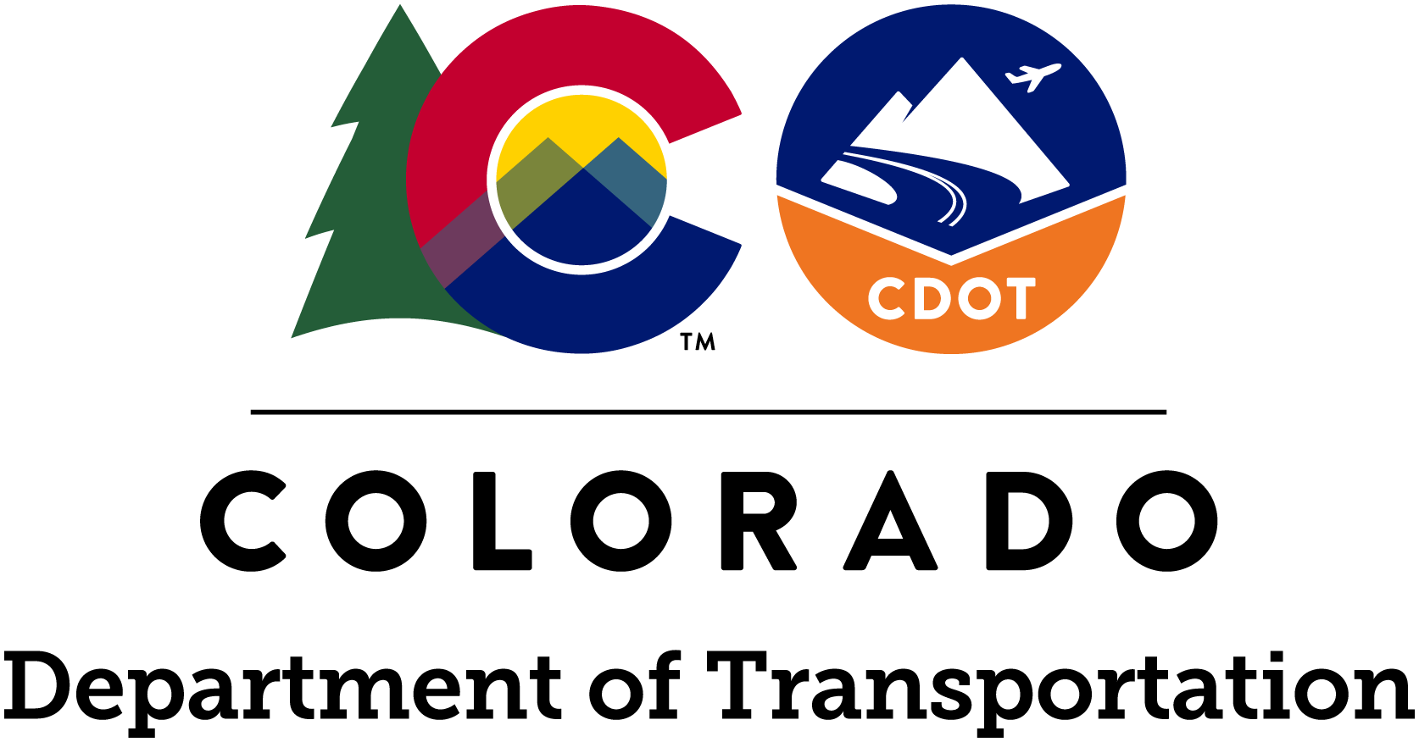

www.codot.gov
www.facebook.com/coloradodot
@coloradodot

Jared Fiel, Region 4 Communications Manager
970.350.2217| jared.fiel@state.co.us

June 15, 2021
Curb Ramp Improvements to begin at the beginning of July
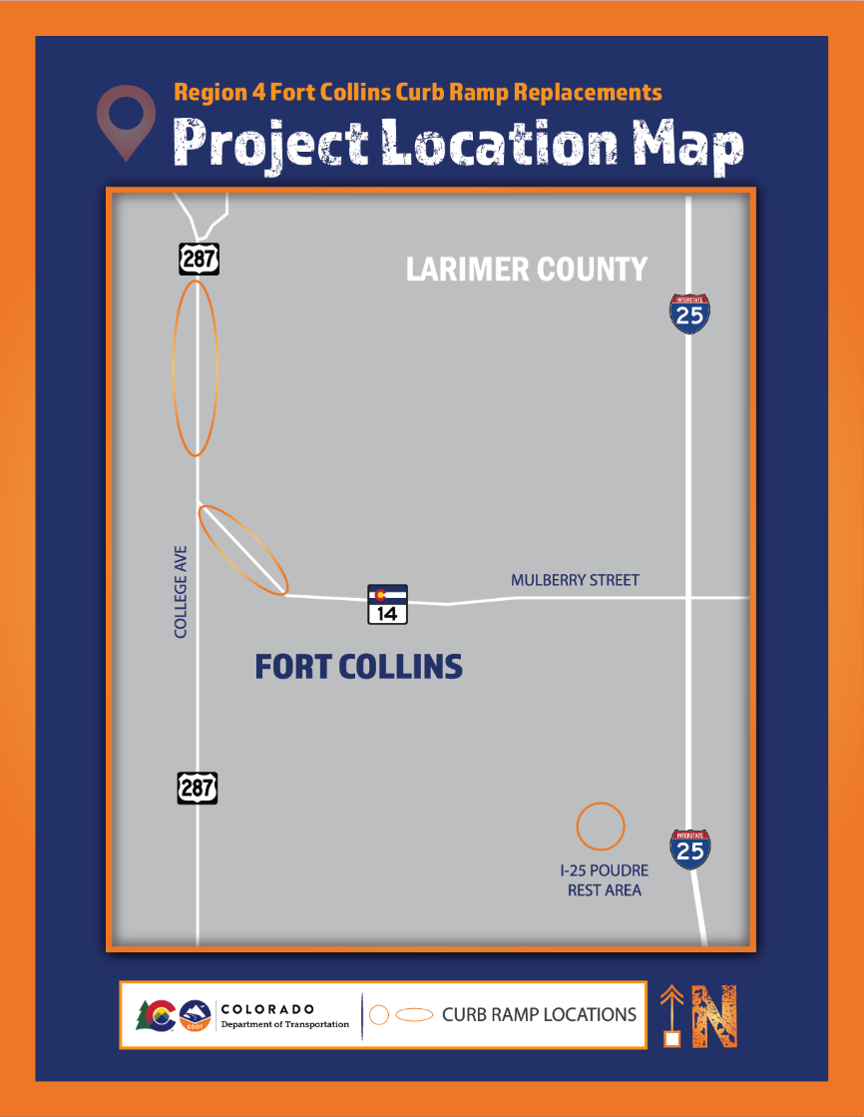
LARIMER COUNTY — Beginning in July, the Colorado Department of Transportation will begin work to improve pedestrian walkways with the installation of American Disabilities Act (ADA) complaint curb ramps at various locations along SH 14, US 287 and the Prospect Rest Area off I-25 in the Fort Collins area.
“Improving the sidewalks and curb access in eastern Colorado greatly improve multimodal access,” said Regional Transportation Director Heather Paddock.
CDOT’s Executive Director Shoshana Lew agrees. “Complying with ADA standards will make certain all members of the community—whether on foot, wheelchair or bicycle—can easily and readily use highway crossings and intersection crosswalks.”
Curb ramps are intended to provide pedestrians access between the sidewalk and street with ease when a vertical change in elevation is present. For those with disabilities, curb edges can be hazardous and requirements are put in place to help prevent dangerous situations such as people falling out of wheelchairs, or while using a cane or walker.
PROJECT SCHEDULE
- Work throughout this corridor is scheduled to begin July 6, 2021 and last through mid-August
- Daytime lane closures will be Monday through Friday, from 8 a.m. to 5 p.m.

TRAVEL IMPACTS
Anyone traveling this corridor can expect throughout the project:
- Construction work Monday through Friday, during the hours of 8 a.m. to 5 p.m.
- Occasional single right lane closures
- Sidewalk closures at some locations for pedestrians

PROJECT CONTACT INFORMATION
- Project hotline –
- Project email –
- Project website –

Travelers are urged to “know before you go.” Gather information about weather forecasts and anticipated travel impacts and current road conditions prior to hitting the road. CDOT resources include:
- Road conditions and travel information: www.COtrip.org
- Sign up for project or travel alerts: bit.ly/COalerts
- See scheduled lane closures: codot.gov/travel/scheduled-lane-closures.html
- Connect with us on social media: Twitter @coloradodot and Facebook facebook.com/coloradodot

ABOUT CDOT
CDOT’s Whole System-Whole Safety program has one simple mission — to get everyone home safely. Our approximately 3,000 employees work tirelessly to reduce the rate and severity of crashes and improve the safety of all modes of transportation. The department manages more than 23,000 lane miles of highway, more than 3,000 bridges and 35 mountain passes. CDOT also manages grant partnerships with a range of agencies, including metropolitan planning organizations, local governments and airports. It also operates Bustang, the state-owned interregional express bus service. Gov. Jared Polis has charged CDOT to further build on the state’s intermodal mobility options.

# # #

