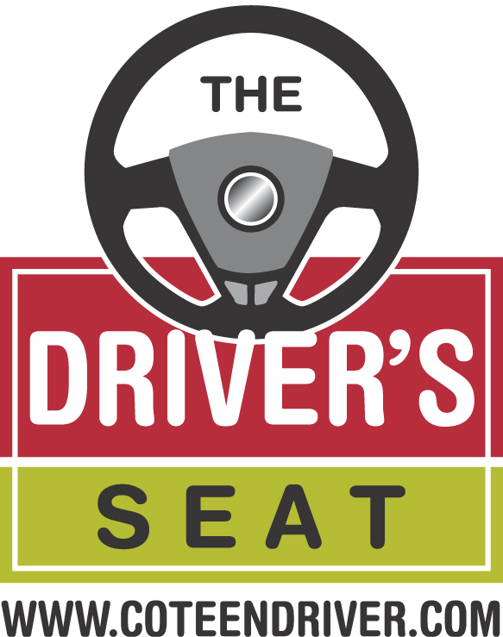
TEEN DRIVING FACT SHEET

Winter Driving Tips

Winter Driving

- Always keep close to a full tank of gas. The added weight can provide better traction and gives you a bigger margin of error if you get stuck and have to keep the engine running periodically to keep warm.

- Remember that 4-wheel drive does not mean 4-wheel stop. A 4-wheel drive vehicle will not stop any better in icy conditions.

- In poor visibility or even whiteout conditions, don't drive fast. High speeds in poor or no visibility can lead to large chain-reaction crashes.

- Avoid passing snowplows or sanding trucks. The road in front of them is probably worse.

- Allow more time to get where you’re going, so you can drive according to the conditions.

- Slow down. Bridges and overpasses freeze first; reduce speed and avoid sudden changes in direction.

- Keep windows clear. Make sure you have plenty of windshield wiper fluid.

- Keep your speed steady and slow – but not so slow that your car gets stuck in deeper snow.

- Use brakes cautiously. Abrupt braking can cause brake lock-up and cause you to lose steering control.

