REVISION OF SECTION 614
MICROWAVE VEHICLE RADAR DETECTOR

Section 614 of the Standard Specifications is hereby revised for this project to include the following:

DESCRIPTION

This work shall consist of furnishing and installing microwave vehicle radar detectors in accordance with these Special Provisions at the locations shown on the Plans. Contractor shall order the Wavetronix SmartSensor HD, model number WX-SS-H125, configuration software, mounting hardware, and compatible Click! DIN rail mountable components

MATERIALS (Pole Mounted Within 40’ of Traffic Control Cabinet)

The Microwave Vehicle Radar Detector (MVRD) shall include the radar detector unit, 20’ standard combination power/data cable with connector, required length of un-terminated Belden 9330 or approved equal 4 pair separately shielded 22 AWG cable to reach from pole mounted communications cabinet to traffic control cabinet, data line surge suppressor, pole mount hardware, communications cabinet, and configuration software.

The radar detection unit shall be a non-intrusive device using frequency modulated continuous wave radar technology for the gathering of vehicle information including traffic volume, lane occupancy, individual and average speed, vehicle classification, and presence. It shall have auto configuration capabilities to simultaneously identify up to ten highway lanes with the ability to detect over center median barriers and accurately detect partially occluded vehicles. Weather shall not impact the radar detection of the unit. Wind or temperature change shall not cause the device’s original field installation configuration to alter over time. The radar detection unit shall include the manufacturer’s recommended power/communication cable. The radar detection unit shall meet the following minimum requirements:

(1) Installation Type: Side Fire or Forward Fire installation
(2) Detection Zones: Up to 10 Lanes Simultaneously
(3) Detection Range: 3 to 250 feet
(4) Detection Zone Resolution: 1 foot
(5) Time Resolution: 2.5 msec
(6) Elevation 3 dB Beamwidth: 65º
(7) Azimuth 3 dB Beamwidth: 7º
(8) Operating Frequency: 24.0 to 24.25 GHz (K-Band)
(9) Communications: RS-232 and RS-485
(10) Power: 8.0 Watts at 9 to 36 Volts DC
(11) Operating Temperature: -40 to +165ºF (Ambient)
(12) Humidity: Up to 95% Relative
(13) Shock: 10g 10ms Half Sine Wave

The communications cabinet shall be non-metallic Nema 4x enclosure or equivalent, measuring 8 x 6 x 4inches (H x W x D), and have a securable hinged door with weather proof seal to prevent the ingress of wind and water. The communications cabinet shall include an internal backplane with DIN rail and mounting bracket assembly for attachment to supporting pole.
-2-
REVISION OF SECTION 614
MICROWAVE VEHICLE RADAR DETECTOR

The DIN rail mountable components to be installed inside the communications cabinet shall include a WX-SC-403 Click 403 Bluetooth to Serial converter, and a WX-SC-200 Click 200 data line surge suppressor with hot swappable protected busses. The Data Line surge suppressor shall provide protection for RS-232, RS-485, and DC power to the radar detection unit. Wiring for the surge suppressor shall be by means of pluggable screw terminals and include unprotected as well as protected RS-232 and RS-485 communications connectors and shall have a minimum operating temperature range of -29 to 165˚F up to 95 percent relative humidity.

MATERIALS (mounted inside 334 traffic control cabinet)

There shall be a 19” bent rack mount Din rail, a Din rail mountable WX-SC-206 Click 206 .05 Amp re-settable circuit breaker and switch, a DIN rail mountable WX-SC-201 Click 201 AC to DC power converter. The power supply shall accept input voltage from 100 to 240 VAC at 45 to 65 Hz and provide 24 VDC output at 1Amp. The power supply shall have a minimum operating temperature range of -29 to 165˚F up to 95 percent relative humidity. The power supply shall provide for 100 percent power reserve for a minimum of 20 ms to protect against static voltage dips, transient failures of supply voltage, or continuous phase failures. There shall be a WX-SC-205 Click 205 AC lightening power line surge protector DIN rail mountable with hot swappable protected busses, and a WX-SC-200 Click 200 data line surge suppressor. The surge suppressor shall provide protection for RS-232, RS-485, and DC power. Wiring for the surge suppressor shall be by means of pluggable screw terminals and include protected and unprotected RS-232 and RS-485 communications connectors. The surge suppressor shall have a minimum operating temperature range of -29 to 165˚F up to 95 percent relative humidity. The necessary number of input file-mountable WX-SC-174 Click! 174 four-channel and/or WX-SC-172 Click! 172 two-channel contact closure (loop emulator) modules with required RJ-11 patch cords shall be provided to emulate 1 primary and 1 secondary loop for each mainline lane.

CONSTRUCTION REQUIREMENTS

Two conduit access holes, not to exceed 1.5 inches shall be made on the bottom of the communications cabinet. One of these holes is to be used for the power/communications cable in from the sensor and the other for the power/communications cable out to the traffic control cabinet. The access holes shall be positioned at a location to ensure the proper, safe routing of wiring entering the cabinet. 3/4 inch Type 201 stainless steel strap used in conjunction with Type 201 stainless steel buckles shall be used to mount the communications cabinet to the structure so that the top of the cabinet is approx 5 feet above surrounding grade. The communications cabinet shall be oriented such that anyone working in the cabinet has direct line of sight with oncoming traffic. The Contractor shall be responsible for any necessary modifications or additions needed to mount the communications cabinet to the structure.

0.75 inch Type 201 stainless steel strap used in conjunction with Type 201 stainless steel buckles shall be used to mount the radar detection unit at a height and angle determined by roadway off-set and detection distance in accordance with manufacturer’s recommendations and shall be properly grounded per the manufacturer’s specifications.

-3-
REVISION OF SECTION 614
MICROWAVE VEHICLE RADAR DETECTOR

The manufacturer’s recommended power/communication cable shall run on the interior of the mounting structure from the radar detection unit to the communications cabinet. A hole not to exceed 1.5 inches shall be made 12 inches below the radar detection unit to allow passage of the power/communications cable into the structure. The

Contractor shall ensure strain relief and drip loops in the power/communication cable before the cable enters the structure in accordance with manufacture’s recommendations. Two holes not to exceed 1.5 inches shall be made below the communications cabinet to allow the power/communications cables to pass from the interior of the structure to the interior of the communications cabinet. Flexible conduit shall be used to run cables from the structure to the communications cabinet.

The Contractor shall run and connect power from the structure to the 0.5A circuit breaker and power line surge protector in the 334 traffic control cabinet. The Contractor shall wire supply power, power supply, surge suppressors, breaker, and radar detection unit in accordance with the manufacture’s recommendations. The radar detection unit shall be wired to support RS-232 serial communications.

All holes shall be free of burs and sharp edges prior to the installation of all cable, conduit, and conduit nipples. All cable entrances in structures, conduits, and cabinets shall be sealed and waterproofed. All wiring and electrical connections shall be performed in conformance with the latest version of the NEC.

The Contractor shall configure the radar detection unit to detect all lanes, in accordance with the manufacture’s recommendations.

The units shall be environmentally hardened for outdoor use with a temperature range of -10 to +80 degrees centigrade and available in one, two or four RS-232 port units. Also included at this location, a 120 volt AC to 24 volt DC power supply shall be included. This unit shall have a slim line DIN mountable case and be mounted to DIN rail in the 334 traffic control cabinet. The Contractor shall provide units which are compatible with current Department devices installed at various locations.

METHOD OF MEASUREMENT

The Microwave Vehicle Radar Detector will be measured by the actual number of units installed and accepted, and will include warranty, testing, documentation, radar detection unit, power supply, power source termination, surge suppressor, pole-mounting hardware communications cabinet, installation hardware, all necessary wiring, communication cables, labor and all other items necessary to complete the work. Testing will be measured by verification of vehicle detection, speed and volume of all lanes in the northbound direction with 90% accuracy.

BASIS OF PAYMENT

The accepted quantities will be paid for at the contract unit price for the pay item listed below.

Payment will be made under:

Pay Item Pay Unit
Microwave Vehicle Radar Detector Each
-4-
REVISION OF SECTION 614
MICROWAVE VEHICLE RADAR DETECTOR 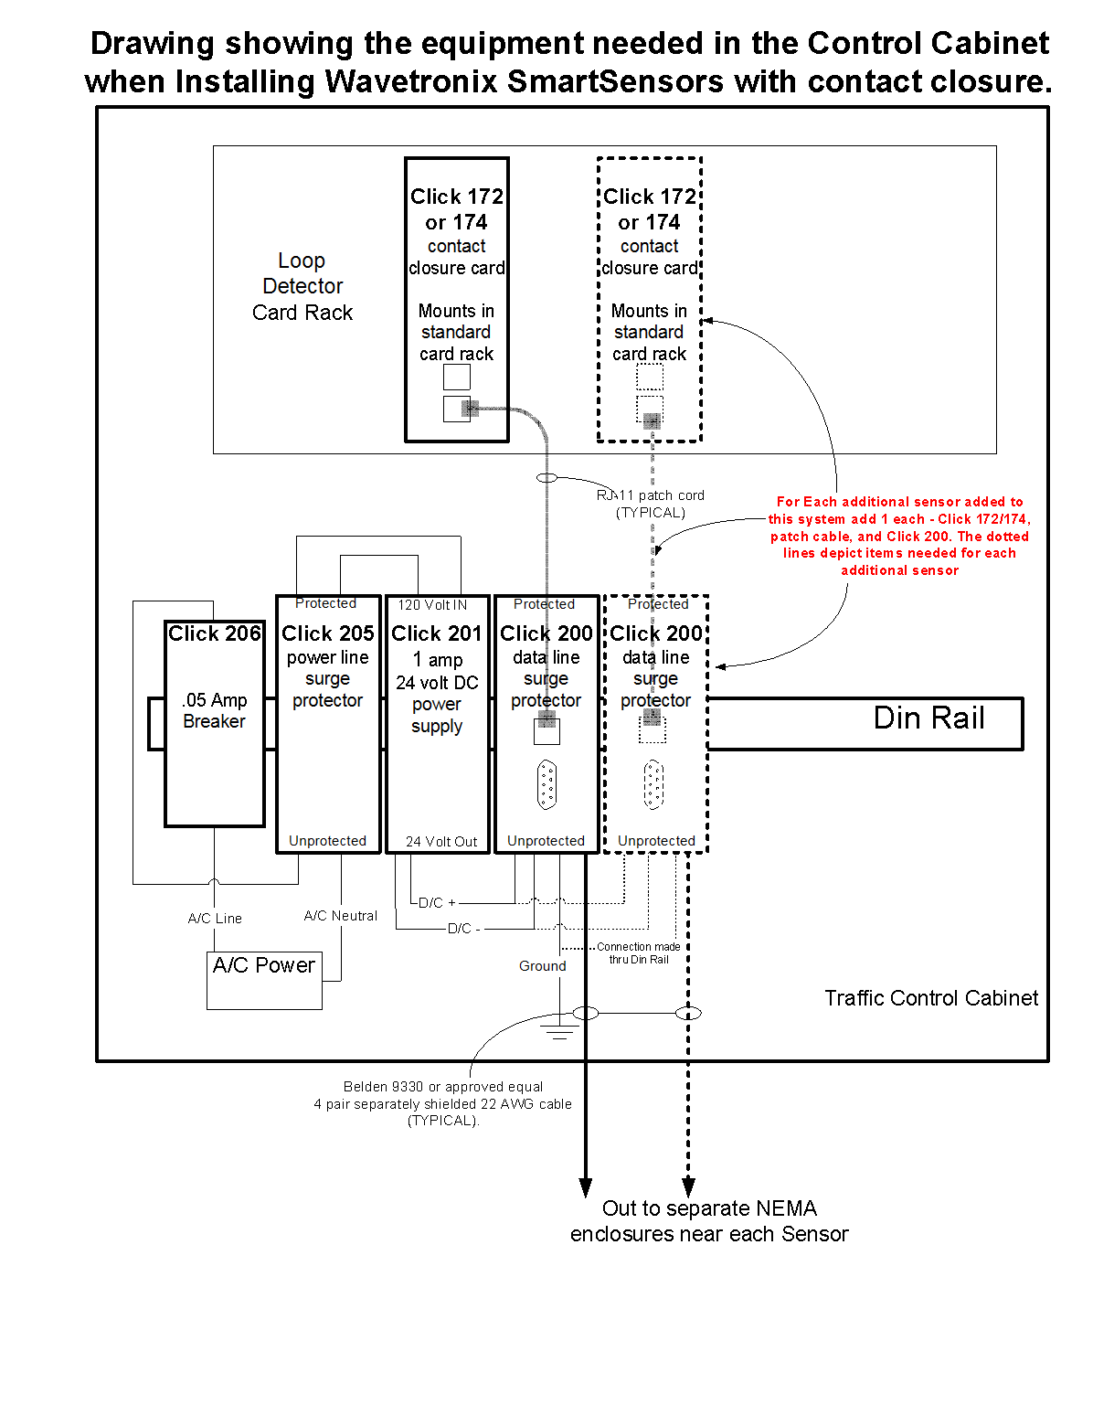
-5-
REVISION OF SECTION 614
MICROWAVE VEHICLE RADAR DETECTOR
